

Weekly KIRF Tasks

* **Week 1 -**  Make a poster of the facts for your bedroom wall or your fridge. Look at it every day!
* **Week 2 –** Make up a poem or a song of your facts. Use it to help you practise. Sing it on the way to school!
* **Week 3 –** See if you can write them down. Ask a parent to time it. Then do it again and beat your time.
* **Week 4 –** Test your parents or someone else in your family on their facts!
* **Week 5 –** Find examples of these facts in real life, such as on television, in shops or in newspapers. Every time you spot one – score a point. How many points can you score?
* **Week 6** – Teach these facts to someone who doesn’t know them. This could be a baby brother or sister, someone in your class, or maybe even someone else in your family!

By the end of this half term, you should know the following facts. The aim is to recall these facts **instantly**. You should also be familiar with using the key vocabulary.

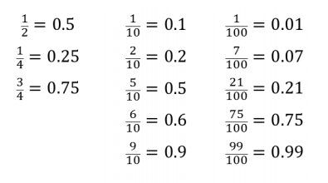

Children should be able to convert into decimals for 1/4s, 1/2s, 3/4s and any number of hundredths or tenths.

Key Vocabulary

Fraction

Hundredths

Tenths

Decimal

Key Instant Recall Facts

Target 25

I know decimal equivalents of fractions.