Year 1 | Home Learning | The Adventures of Bear and The King

This half term, choose one or many of the suggestions below. In class, we will share all entries. Winning entries will be shared in a Home Learning Gallery on Thursday 19th October, open to view for all parents at the end of the half term. Home Learning is due in Monday 9th October.

Fiction | Computing | Music
We are reading ‘Katie in London’. Can you create your own story about a place you have visited?  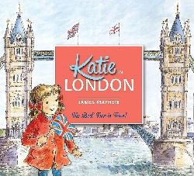 | We are exploring Technology around us. Draw or take photographs of all the technology you use in your home. | 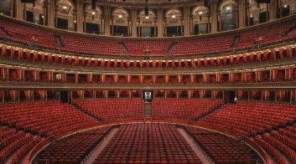  Royal Albert Hall is an iconic music venue in London. Can you research it? Could you find out what performances happen there?
STEM | ROOTS | Art
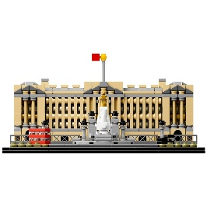  Can you build a famous London landmark such as Buckingham Palace? You could use lego or junk modelling. | Share a moment where you have followed one of our ROOTS. You could share a photo, drawing, video or a piece of writing. | 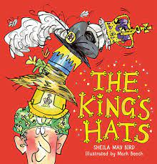  Inspired by the King’s Hats, can you design your own hat for the King?
Cooking | PE | Non-Fiction
The Victoria sponge cake was named after Queen Victoria (a past queen). Try making this delicious cake with your family.  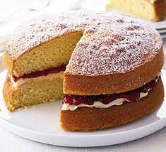 | 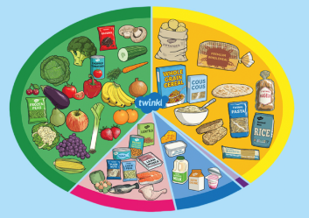  Create a Healthy food plate! What are your favourite healthy foods? You could draw, paint, or build. | Can you write a letter to King Charles III? What questions would you like to ask him?  