Year 6 | Home Learning | Post-War Britain

This half term, choose one or many of the suggestions below. In class, we will share all entries. Winning entries will be shared in a Home Learning Gallery open to view for all parents at the end of the half term.

Fiction | Computing | Music
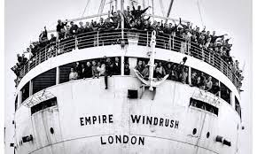  Write a diary entry from the point of view as someone coming to Britain for the first time on the Windrush. | Create a Google Slides presentation about Floella Benjamin. Try to add in pictures, animations and slide transitions. | Music taste dramatically began to change after WW2. Can you create a timeline of musical tastes starting in the 1950s and ending with today’s music taste?
STEM | Poetry | Art
During post-war Britain, lots of houses were built. Can you test which sustainable materials would be best suited for a new house? You could conduct a fair test on which materials would be durable. | 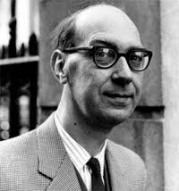  Philip Larkin, one of the most famous post-war poets, was influenced heavily by the First and Second World War. Can you learn one of his verses from “Going, going” and perform it? | 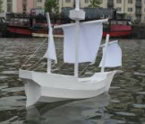  Create your own boat using everyday materials that floats. This could be based on one of the ships which brought people over during the Windrush.
Cooking | PE | Non-Fiction
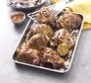  Looking at the Windrush generation, can you cook any food inspired by the Caribbean? Maybe some jerk chicken, curried goat or maybe try some plantain? | Children in post-war Britain did not have access to much technology. Can you put down your tech and create your own game. This could be inspired from board games such as Monopoly or even card games such as “Go fish”. | Using the game you have created for your PE home learning, write a step-by-step guide on how to play it.

