Home learning Challenge
With Great Linford Primary School opening its very own board game café, we are very excited for our design your own board game competition.
In addition to earning a home learning certificate, you will also have the opportunity to play your board game with Miss Lovelock and Miss Kerrigan.
Be creative…
 | Criteria we would look for… | Examples
Beginning | Create a basic board or card game that you could play with other people. You may also wish to make a logo and box for your game to come in. | - Dominos  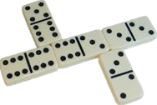  - Snakes and Ladders
Secure | Create a basic board or card game, which relates to your topic that you could play with other people. You may also wish to make a logo and box for your game to come in. | - Chocolate brands snap  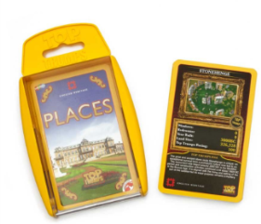  - Rivers Top Trumps
Greater Depth | Create a more complex board game which relates to your topic, as well as providing a how to play and rules book. You may also wish to make a logo and box for your game to come in. | - Catan Explorers edition  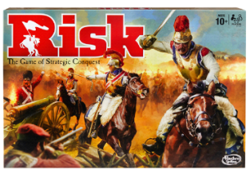  - Junior Risk- the Anglo-Saxon edition

