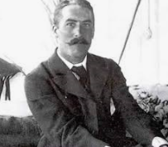
Year 3 Learning Challenge Spring 1
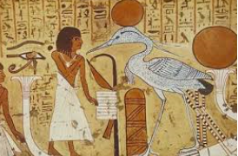

Poem: Along the Nile by Henry Abbey
Art Work: see example on right! A piece of Ancient Egyptian wall art
Person: Howard Carter- archaeologist
Music: Land of the Pharaohs-Derek and Brandon Feictherhttps://www.youtube.com/watch?v=TCI8dlZf8aE

 | Poem | Art Work | Person | Music
Beginning | Learn it off by heart | Find out 10 facts/different kinds of ancient Egyptian wall paintings | Draw a portrait of the person | Listen to the piece of music and say what you like about it.
 | Find another poem by the same poet | Discuss how it is different to other styles of art you have encountered | Produce a timeline of their life | Identify the instruments.
Secure | Create a performance as part of a pair/group | Draw a picture in a similar style | Produce a poster to advertise their achievements | Research the setting- why is it called Land of the Pharaohs?
 | Write a short biography about the poet | Transform the medium of the wall painting: use collage instead of painting | Write a letter asking them about their life | Attempt to recreate the piece of music
Greater Depth | Write your own poem inspired by the topic | Use the image as a stimulus for a piece of descriptive writing. | Explain how the world would be without this person | A mind map of different emotions you feel at various points in the piece
 | Compare and contrast two poems by the poet | Describe the wall painting: what it represents, how it makes you feel, what it is based on. | Give five reasons for and against why they should be in ‘The Hall of Fame.’ | Produce a piece of art/collage based on how the music makes you feel.

Along the Nile

by: Henry Abbey (1842-1911)

We journey up the storied Nile;
The timeless water seems to smile;
The slow and swarthy boatman sings;
The dahabëah spreads her wings;
We catch the breeze and sail away,
Along the dawning of the day,
Along the East, wherein the morn
Of life and truth was gladly born.

We sail along the past, and see
Great Thebes with Karnak at her knee.
To Isis and Osiris rise
The prayers and smoke of sacrifice.
'Mid rites of priests and pomp of kings
Again the seated Memnon sings.
We watch the palms along the shore,
And dream of what is here no more.

