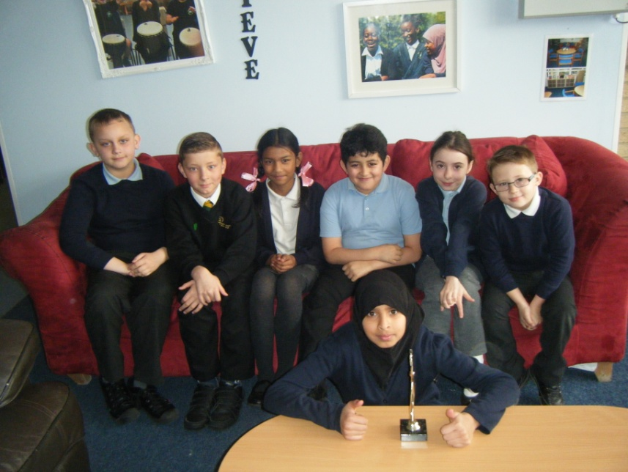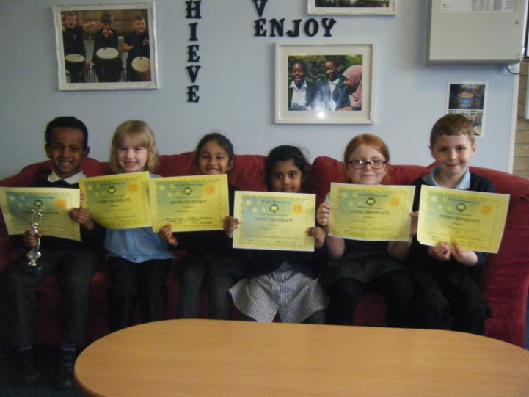```````````````

Name:

Laura Scoggins

Position:

Year 3 teacher

YR 3: Joshua McComish

YR 4: Rosella Sicorello and Younes Chadili

YR 5: Khadija Tariq and Rachel Johnson Rock

YR 6: Titas Karasauskas and Harrison Hewitt

Hello! I’m Laura Scoggins the YR 3 teacher of Carter class. I’ve been teaching at GLPS for nearly two years, as well as having done my placement here. I love working here as we are a family and everyone looks after each other. Also, I am given the opportunity to be creative, which really makes me enjoy my work.

My favourite subjects to teach are art and history. I’ve wanted to be a teacher since I was a little girl. I used to line all my teddy bears up and give them each an exercise book and teach them lessons!

In my spare time I love to bake and sew. I’m also a massive Disney fan and am very excited to visit Walt Disney World Resort in Florida in the summer! Cinderella is my favourite, but I can’t wait to meet all of the characters.

Foundation: Jamal Mohamed and Serine Lalu

YR 1: Kyla Cape and Samriddhi Goyal

YR 2: Joshua Hohenberg and Alexis Deborah Nicole Dell

This week, we are celebrating the achievements of 13 Aspire winners! These winners will attend an afternoon tea with Miss Lovelock as a treat!

**Golden Leaves**

Each week, class teachers will choose a Golden Leaf winner which will represent our root of ‘overcoming challenges’ this term and the winners will have their names in the newsletter. Golden Leaves with the winner’s names on will also appear on the tree in the school entrance.

* Owls: **Sam Islania** for being brave and using a big voice using circles.
* Squirrels: **Eddie Wangusi** as he finds writing challenging but is doing his best to overcome it.
* 1HT: **Tamrah Mohammed** who was able to double two-digit numbers!
* 1RH: **Callum Netley** for persevering with own challenges and helping others overcome theirs.
* 2SP: **Abdul Mohamed Nisvi** who was able to write three descriptive sentences about science.
* 2SS: **Charlie Lawrence** who overcame every fraction challenge Miss Scott gave him.
* 3LS: **Joshua McComish** who was the first in the class to complete the tricky maths activity.
* 3AM: **Godwin Asante** for being focused when faced with distractions from both YR 3 classes
* 4CC: **Amy Eldridge** for persevering until she overcomes her challenges.
* 4AK: **Alexander Evans** for meeting all of his expectations and dealing with changes well.
* 5JD: **Evan Cassin** for starting our school and term with a fresh mentality.
* 5LC: **Narththaney Suthasan** for settling into our school very well and learning our values.
* 6TR:

**ASPIRE – ACHIEVE - THRIVE – ENJOY**

Great Linford Primary School News - Issue 21

**Staff Profile**

**Aspire**

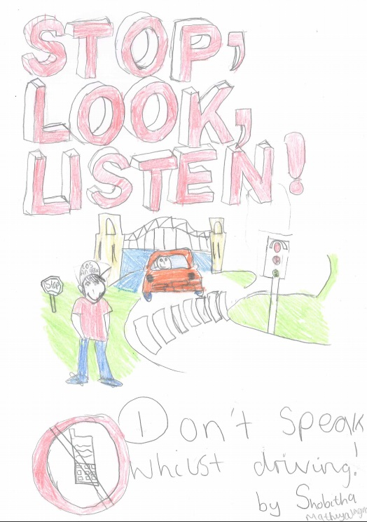

Our brave and wonderful Business Manager Mrs Mills will be running the London Marathon this year on Sunday 24th April. Mrs Mills is running on behalf of [Multiple Sclerosis Society](https://www.justgiving.com/mssociety), a charity that means a lot to herself, her family and around 100,000 people in the UK. Mrs Mills has been training very hard to prepare for the race.

If you would like to sponsor Mrs Mills for the 26.2 mile race you can visit [www.justgiving.com](http://www.justgiving.com) and type ‘Laurie Mills’ in the search box. The full link can be found on the website as a recent blog. The target for donations is £250, and any donations would be greatly appreciated!

We wish Mrs Mills the best of luck with her training, fundraising and the race itself.

**London Marathon Sponsorship**

**British Values Day**

Monday 25th April will be British Values Day here at GLPS, and each class will be busy focusing on aspects of British culture and values. **On this day, children are encouraged to dress in red, white and blue clothing.** The diversity of being British will be explored, with YR 2 focusing on diversity of faith and YR 3 looking at diversity of foods. Social structures such as the law will be studied by YR 1, functions of parish councils by YR 4, with YRs 5 and 6 studying the British Government and our value of democracy. Owls and Squirrels class will be visiting Dragon Park to have a picnic and to tidy the environment around us. All of the above themes will be linked with our school roots.

**Shobitha**

**Mathiyalagan**

**Winning Road Safety Poster by**

We hope to achieve our target attendance of 97% this term.

Overall, school attendance for the last week of term was a low 90.5%. Mr Dixon and Miss Parish were joint winners of Spring term with an attendance of 96.5%.

10th= Mr Rowlands 87.2%

11th= Miss Crofts 82.2%

12th = Miss Maisuria 82.1%

13th = Miss Scoggins 81.0%

**Squirrels**

98.7%

**Owls**

95.3%

**Miss Scott**

99.0%

4th = Miss Kerrigan 95.1%

5th = Miss Parish 93.8%

6th = Miss Clark 93.5%

7th = Miss Thompson 92.9%

8th = Mrs Humphris 89.3%

9th = Mr Dixon 88.9%

18th Apr Clubs start

18th Apr FAST final review with whole team and parents: 9am

19th Apr ‘Fun with Maths’ course for those who have booked a place: 9am – 11:15am

19th Apr Linford Leaders meeting: 2pm – 2:20pm

19th Apr Year 6 Transition workshop: 3:30pm

20th Apr FS1 Curriculum Tea: 9am – 10am

**Attendance**

**Dates for the diary**