Michael Recycle by Ellie Bethel
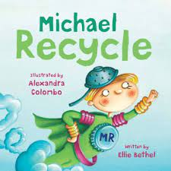

Michael Recycle tells the adventures of a young superhero whose power allows him to teach people about recycling.
There once was a town
Called Abberdoo-Rimey,
Where garbage was left
To grow rotten and slimy.
It never smelled fresh.
The air was all hazy.
But the people did nothing.
They got rather lazy.

But the townspeople are called to attention when a streak of green crash-lands in the town dump! It’s not a bird, nor a plane, but a new kind of superhero—Michael Recycle, who has a plan to save Abberdoo-Rimey. . . and the world!

Fresh and funny, Michael Recycle will entertain young and old while gently imparting an important message about recycling and environmental awareness.

