January 2019
ASPIRE – ACHIEVE – THRIVE – ENJOY
A Happy New Year to our GLPS Families
Christmas Carol Concert  Although it seems so long ago now, our Key Stage 2 children were well and truly into the Christmas spirit on our trip to St Andrews church during the last week of term. Our wonderful choir performed 'Once in Royal David's City' and then we all sang songs that we had practised for some weeks.  Armed with their confident voices, some brave children from each year group stood up and told the Christmas story. This was followed by Reverend Chucks and Miss Lovelock saying a few words and prayers.  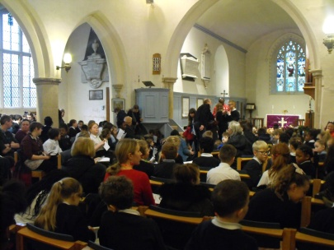  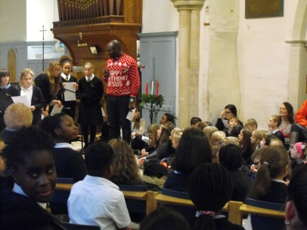  The afternoon ended with a rendition of ‘Christmas Conga’, complete with dance moves, which the parents had good fun joining in with! A great afternoon was had by all. |  |  | Fantastic Fossils  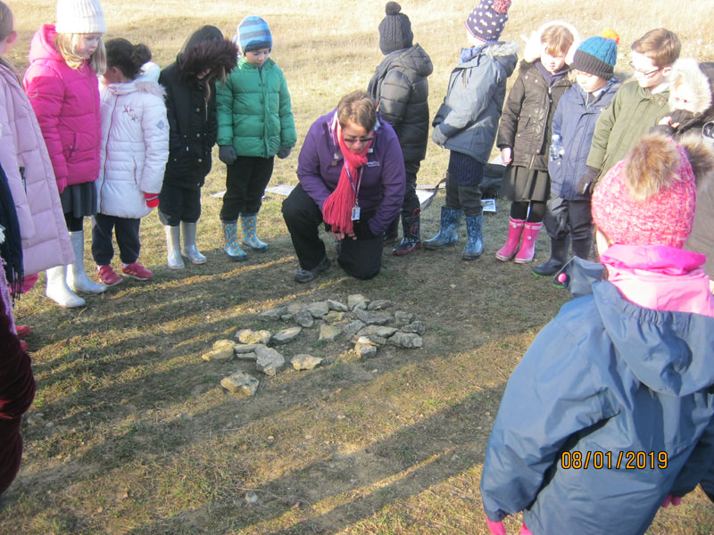  Year 2 had a fantastic trip today to the Stonepit Field hunting for fossils! We began our exciting day by walking through the local area to meet our hosts from the Parks Trust. We arrived at the field and got straight to work on our activities.  First, we created a life-size timeline showing when the world began and where the dinosaurs lived compared to present day. Then, we moved on to hunt for our own fossils in the field which we were able to take home. Some of us found fossils that were really clear to see.  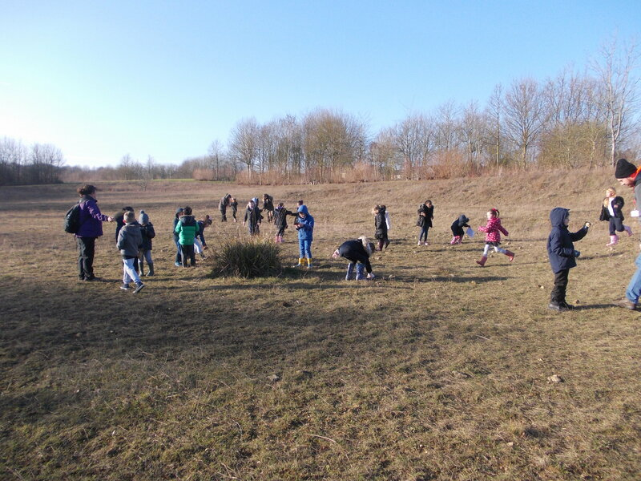  Finally, we practiced our science skills, classified some rocks around the field and learnt about the three different types of rocks. What a fantastic day!  This week we will be writing a recount of our trip to the field during our project lessons and using our fossils we found to inspire some writing and art.
Science Quality Mark  After working extremely hard to improve the science curriculum at GLPS, we have been awarded the Primary Science Quality Mark. This is a national award of excellence recognising our efforts in teaching and learning.  Jane Turner, PSQM National Director said: “Gaining a Primary Science Quality Award is a significant achievement for a school. The profile and quality of science teaching and learning in each awarded school is very high. Children are engaging with great science both in and outside the classroom, developing positive attitudes towards science as well as secure scientific understanding and skills. Science subject leaders, their colleagues, head teachers, children, parents and governors should be very proud.”  Well done to everyone at GLPS for their efforts in working together to achieve such a prestigious award. |  |  | A Mysterious Visitor  Owls and Hedgehogs were very excited to find that over the Christmas holidays our classroom had a visitor! We came in on Monday to discover footprints on the classroom floor. After some investigating, we realised that we had had a visit from a stegosaurus, who had left us a fact file about themselves from which we discovered lots of interesting facts.  They also left us an egg in a nest which we have to look after and we are hoping it begins to hatch soon. The children have also been creating their own fossil pictures and writing facts about dinosaurs. We have had a great first week back and are looking forward to finding out more about different types of dinosaurs.  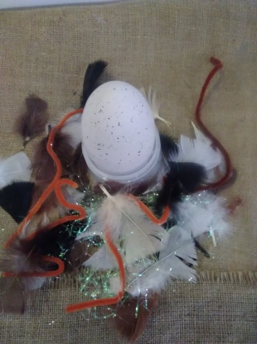
Congratulations to Aspiring Young Poet  Congratulations to Thurab in Year 6 for being shortlisted and commended in the Young Poets Network Bletchley Park competition. To celebrate the role of the Bletchley Code Breakers, a competition was launched. The mission: to write a poem in code. The judges comments and published poem can be seen at http://ypn.poetrysociety.org.uk/uncategorized/hidden-messages/ |  |  | Upcoming Events:  14th Jan After School Clubs start.  (Clubs run for 5 weeks)  14th Jan Year 1 - Phonics Information Session  (9am or 3.30pm)  16th Jan Year 1 MK Museum trip (Cedar class)  17th Jan Year 1 MK Museum trip (Rowan class)  22nd Jan EYFS, Years 1 and 2 Literacy Open Morning  (9am in school hall)  29th Jan Whole School Parent Jigsaw info session  (3.30pm or 5.30pm)  30th Jan Books at Bedtime (4pm)
Are you eligible for Free School Meals?  You may have heard of Pupil Premium. If you are eligible for Pupil Premium, you will be entitled to Free School Meals and half price after school clubs. Pupil Premium is means tested and your entitlement will depend on the income and particular benefits you are in receipt of. There is also Pupil Premium entitlement for children in care of families who have parents in the armed forces.  How to check if you are entitled to Pupil Premium  A Portal has been launched to help you find out if your child qualifies for free school meals. Please visit it to sign up, even if your child is in Foundation, Year 1 or Year 2 and receiving universal free school meals, or if you have applied before and do not think you are eligible. In doing so, you will help us find out whether we can claim pupil premium for your child. This is additional funding to spend on resources such as extra staff, books or school trips for eligible children.  The Portal is quick and easy to use and can be accessed via a smartphone or hand-held device. If you qualify, you will receive a reference number that you simply bring in and show us at school to start receiving free meals. Please register at: https://emsonline.milton-keynes.gov.uk/CitizenPortal_LIVE |  | Forest School  As the cold weather continues, children in EYFS and KS1 will still be going out for their weekly Forest School session.  This half term, we will be helping the birds through the Winter by making bird feeders and learning how to identify some of the different birds, ready to take part in the RSPB Big Birdwatch. Then, we'll be warming up with some hot chocolate too!  Please can you remember how important it is to support your child by making sure they have suitable warm and dry clothing and a change of shoes, such as wellies, on their Forest School days.  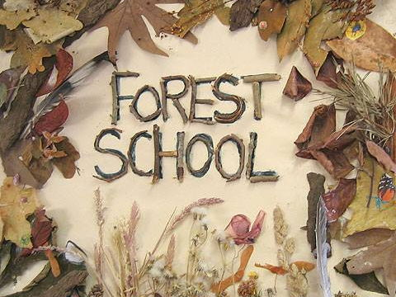
Time to make a Digital Resolution  A simple and effective way to get involved with your children and their lives online is through discussion. By maintaining an open dialogue with your child and encouraging them to talk to you about their internet use, parents can help children access the amazing resources the internet has to offer whilst keeping them safe online. A family agreement is a great way to start a conversation with your whole family about how you all use the internet and discuss together how to behave in a positive way when online at home, at school or at a friend’s house. Childnet.com has a great family agreement which provides a list of things to consider when creating a family agreement and some examples. The family agreement template provides a framework that will help families set clear expectations for positive and safe internet use. |  | Christmas Fair  A huge thank you to everyone who helped make our Christmas Fair such a success. From the wonderful people who gave their time to help organise, fantastic donations from our families and local businesses, our wonderful choir and musical performers and to everyone who supported by attending and having a great afternoon. We raised a grand total of £ 770!  Attendance  For week ending 11 January attendance was 95.9%  Whole school attendance so far is 95.9%  The classes with the highest attendance last week were Rowan Class (Year 1) and Cedar Class (Year 1) with 100% each. Well done Year 1!

