Pupil premium strategy statement

This statement details our school’s use of pupil premium (and recovery premium for the 2022 to 2023 academic year) funding to help improve the attainment of our disadvantaged pupils.

It outlines our pupil premium strategy, how we intend to spend the funding in this academic year and the effect that last year’s spending of pupil premium had within our school.

School overview
Detail | Data
School name | Great Linford Primary School
Number of pupils in school | 342
Proportion (%) of pupil premium eligible pupils | 30%
Academic year/years that our current pupil premium strategy plan covers | 2021/2022, 2022/2023 and 2023/2024
Date this statement was published | Dec 22
Date on which it will be reviewed | March 2023
Statement authorised by | Tara Lovelock Head Teacher
Pupil premium lead | Tara Lovelock Head Teacher
Governor / Trustee lead | Barry Humphris
Funding overview
Detail | Amount
Pupil premium funding allocation this academic year | £147,950
Pupil premium funding carried forward from previous years (enter £0 if not applicable) | £ 0.00
Total budget for this academic year  If your school is an academy in a trust that pools this funding, state the amount available to your school this academic year | £164,770

Part A: Pupil premium strategy plan

Statement of intent
When making decisions about using Pupil Premium funding it is important to consider the context of the school and the subsequent challenges faced. Research conducted by the EEF should then be used to support decisions around the usefulness of different strategies and their value for money.

Our intention is that all pupils, irrespective of their background or the challenges they face, make good progress and achieve high attainment across all subject areas. The focus of our pupil premium strategy is to support disadvantaged pupils to achieve that goal, including progress for those who are already high attainers.

The activity we have outlined in this statement is also intended to support their needs, regardless of whether they are disadvantaged or not.

The barriers to learning for disadvantaged children are GLPS are:
less support at home, weak language and communication skills, lack of confidence, more frequent behaviour difficulties and attendance and punctuality issues. There are also complex family situations that prevent children from flourishing. The challenges are varied and there is no ‘one size fits all’.

Our Approach High-quality teaching is at the heart of our approach, with a focus on areas in which disadvantaged pupils require the most support. This is proven to have the greatest impact on closing the disadvantage attainment gap and at the same time will benefit the non-disadvantaged pupils in our school. We ensure that all teaching staff are involved in the analysis of data and identification of pupils, so that they are fully aware of strengths and weaknesses across the school.

Our approach will be tailored to needs of groups of children and the needs of individual children, based in robust diagnostic assessment, and not generalisations about the impacts of being disadvantaged. Our objectives are: ➢ To narrow the attainment gap between disadvantaged and non-disadvantaged pupils.
➢ To adopt a whole school approach to raise expectations and outcomes for all disadvantaged pupils, so all disadvantaged pupils in school make or exceed nationally expected progress rates.
➢ To support our children’s health and wellbeing to enable them to access learning at an appropriate level.
➢ Act early to intervene at the point the need is identified. To achieve these objectives: In order to achieve our objectives, we have integrated a range of support and high quality provision to support our pupils.
This includes:
➢ That quality first teaching remains a priority in school with CPD matched to staff needs
➢ Provide all staff time to work with subject leaders to identify key areas of learning with each unit of work.
➢ To keep small classes in KS1.

Challenges

This details the key challenges to achievement that we have identified among our disadvantaged pupils.
Challenge number | Detail of challenge
1 | A high number of vulnerable families and pupils with emotional and social needs – significantly high safeguarding requirements
2 | Low parental engagement and a perceived lack of value/importance in education
3 | Pupils often have limited life experiences
4 | A large proportion of pupils have limited vocabulary skills (speaking & reading skills) and a poor early reading experiences
5 | General (non Covid-19 related) absence and persistence absentee levels
6 | White British pupil groups with low attainment and slow progress

Intended outcomes
This explains the outcomes we are aiming for by the end of our current strategy plan, and how we will measure whether they have been achieved.
Intended outcome | Success criteria
Quality first teaching delivered by all teaching staff, tailored CPD in place to help staff plan and sequence the curriculum so that it builds on previous knowledge and to clearly defined end points. | Teachers able to identify the main learning (composite) and the component parts for each lesson. Children are clear on the sequence of learning and where it sits.
For parents and carers to have increased confidence and engagement in supporting learning at home. Through listening to reading, supporting with phonics, home learning and supporting with any on-line learning, in order to support the academic progress of their child | Offer more parent workshops to enable parents to support their children. Contact parents of children who have been identified as target children for phonics and reading. Provide the families and children with the targets, skills and resources to support at home. On-line google classroom provides more opportunities to engage children and their families at home. (TTRS, Doodle Maths, and Accelerated reader).
For Pupil Premium children to close the gap with the Non-Pupil Premium group in Writing and Phonics | The gap in attainment is reduced and the Pupil Premium children feel more confident about Writing, particularly their basic skills.
For the gap to narrow in attendance between the Pupil Premium and Non-Pupil Premium groups. The number of Pupil Premium children with attendance below 96% to decrease | Support from LA attendance officer and Family Champion to ensure all children are attending school.  Parent’s of children who fall below our school attendance target engage with the Family Champion and Attendance Officer, and support given where needed.

Activity in this academic year
This details how we intend to spend our pupil premium (and recovery premium funding) this academic year to address the challenges listed above.

Teaching (for example, CPD, recruitment and retention)
Budgeted cost: £65,956
Activity | Evidence that supports this approach | Challenge number(s) addressed
CPD for subject leaders and teaching staff – effective quality first teaching | High quality teaching EEF  https://educationendowmentfoundation.org.uk/supportfor-schools/school-improvement-planning/1-high-qualityteaching  EEF Using Pupil Premium effectively - https://educationendowmentfoundation.org.uk/guidancefor-teachers/using-pupil-premium  The Sutton Trust report 2011 | 4&6
Teacher CPD on feedback to provide most impact on next steps for children.  Implementation of standardised diagnostic assessments – to aid feedback to ensure pupils receive the correct support. Implementation of quizzes to test retention and inform teaching – providing instant feedback for pupils. | EEF (6+MONTHS) Feedback Education Endowment Fund Foundation.  Feedback studies tend to show high effects on learning. However, there are a wide range of effects and some studies show that feedback can have negative effects and make things worse. There are positive impacts from a wide range of feedback approaches – including when feedback is delivered by technology or peers. Impacts are highest when feedback is delivered by teachers. It is particularly important to provide feedback when work is correct, rather than just using it to identify errors. Many studies of feedback also include other practices. For example, mastery learning approaches combine feedback with additional support for pupils that are falling behind, while approaches like formative assessment also include work to understand specific gaps in learning that need to be addressed and how the teacher wants the pupil to progress. Feedback has effects across all age groups. Research in schools has focused particularly on its impact on English, mathematics | 4&6
Booster Reading training for LSAs | EEF Reading Comprehension Strategies 1. Reading comprehension strategies are high impact on average (+6 months). Alongside phonics it is a crucial component of early reading instruction. 1, 2 7 2. It is important to identify the appropriate level of text difficulty, to provide appropriate context to practice the skills, desire to engage with the text and enough challenge to improve reading comprehension. 3. Effective diagnosis of reading difficulties is important in identifying possible solutions, particularly for older struggling readers. Pupils can struggle with decoding words, understanding the structure of the language used, or understanding particular vocabulary, which may be subject-specific. 4. A wide range of strategies and approaches can be successful, but for many pupils they need to be taught explicitly and consistently. 5. It is crucial to support pupils to apply the comprehension strategies independently to other reading tasks, contexts and subjects. | 2,4&6
RWI Training  And RWI resources | Phonics approaches have been consistently found to be effective in supporting younger pupils to master the basics of reading, with an average impact of an additional five months’ progress. Research suggests that phonics is particularly beneficial for younger learners (4−7 year olds) as they begin to read. Teaching phonics is more effective on average than other approaches to early reading (such as whole language or alphabetic approaches), though it should be emphasised that effective phonics techniques are usually embedded in a rich literacy environment for early readers and are only one part of a successful literacy strategy. | 2,4&6
Embed opportunities to talk and discuss learning across the curriculum, including dialogic activities – to support and consolidate key learning, understanding and vocabulary. Nelly Assessments to highlight areas of need. | EEF (6+MONTHS) Oral Language Intervention There is evidence to suggest that pupils from lower socioeconomic backgrounds are more likely to be behind their more advantaged counterparts in developing early language and speech skills, which may affect their school experience and learning later in their school lives. Given that Oral language interventions can be used to provide additional support to pupils who are behind their peers in oral language development, the targeted use of approaches may support some disadvantaged pupils to catch up with peers | 2,4&6
Smaller class sizes in KS1 and for Year 6 to raise the progress and attainment of children in Phonics Maths, Reading and Writing. | Reducing class size has a small positive impact of +2 months on average Reducing Class Size | Education Endowment Fund | EEF and can improve the quality of feedback given to make progress (+7 months): Feedback | Education Endowment Fund | EEF | 4&6

Targeted academic support (for example, tutoring, one-to-one support structured interventions)
Budgeted cost: £64,305
Activity | Evidence that supports this approach | Challenge number(s) addressed
Targeted support for PP children – and those with lower attainment – through smaller teaching groups (Y6 additional teacher) and additional interventions in other year groups | Tuition targeted at specific needs and knowledge gaps can be an effective method to support low attaining pupils or those falling behind in small groups: Small group tuition | Toolkit Strand | Education Endowment Foundation | EEF | 4&6
Additional phonics sessions targeted at disadvantaged pupils who require further phonics support. | Phonics approaches have a strong evidence base indicating a positive impact on pupils, particularly from disadvantaged backgrounds. Targeted phonics interventions have been shown to be more effective when delivered as regular sessions over a period up to 12 weeks:  Phonics | Toolkit Strand | Education Endowment Foundation | EEF | 2,4&6

Wider strategies (for example, related to attendance, behaviour, wellbeing) Budgeted cost: £ 34,509
Activity | Evidence that supports this approach | Challenge number(s) addressed
Embedding principles of good practice set out in the DfE’s Improving School Attendance advice. This will involve training and release time for staff to develop and implement new procedures, as part of their learning mentor role. | The DfE guidance has been informed by engagement with schools that have significantly reduced levels of absence and persistent absence. | 1,2&5
Family Champion and Play therapy support and interventions in place for children to raise their social and emotional wellbeing, including an investment in of the Mental Health Support Team | There is extensive evidence associating childhood social and emotional skills with improved outcomes at school and in later life (e.g. improved academic performance, attitudes, behaviour and relationships with peers  EEF_Social_and_Emotional_Learning.pdf (educationendowmentfoundation.org.uk) | 1,2&5
Regular updates with families, workshops, attendance panels, care packages and Family Champion Support for vulnerable families (to include accessing and signposting families to appropriate external agencies) | Supporting families and parents has a positive impact on children’s attainment, leading to +3 months in learning gains over the year.  Working with parents to support children’s learning EEF guidance | 1,2&5
Funding support for life opportunities | 50% off residentials, wrap around care. and school trips / visitors. All children who want to are able to attend all of these opportunities. Life skills fully funded in the afternoons for PP children. | 1,2&3
Total budgeted cost: £ 164,770

Part B: Review of outcomes in the previous academic year

Pupil premium strategy outcomes
This details the impact that our pupil premium activity had on pupils in the 2021 to 2022 academic year.
80 Disadvantaged children currently in school were with us last year
(22 mobile disadvantaged children have joined but have no prior year data with us)
18% of these 80 Disadvantaged children made accelerated progress in Writing
21% of these 80 Disadvantaged children made accelerated progress in Reading
18% of these 80 Disadvantaged children made accelerated progress in Maths
86% of these 80 Disadvantaged children made at least expected progress in Writing
89% of these 80 Disadvantaged children made at least expected progress in Reading
84% of these 80 Disadvantaged children made at least expected progress in Maths
De Montfort university's communications team are writing up a press-release on the outcomes of the breakfast study, which was overwhelmingly positive, that will be released in the next few days. The key message of the study is summarized in the graphic below, which shows that "providing regular breakfast to children who may otherwise not have a meal before the start of the school day contributes to improved learning outcomes; more specifically, the study shows that it can help 'close the gap' between disadvantaged pupils and the whole school"
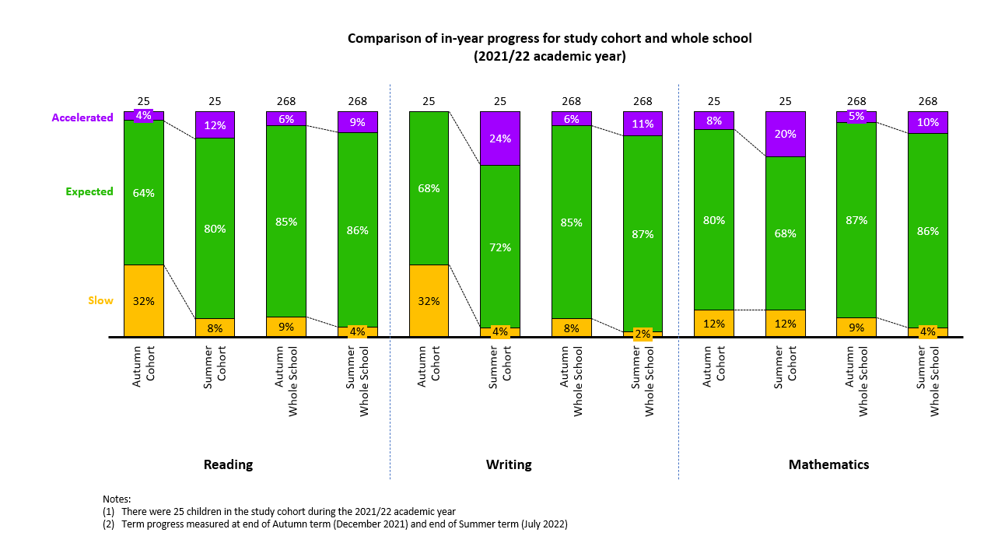
KS2 SATs 21-22
54.5% Disadvantaged children achieved the expected standard in Writing.
 | 2019 EXS | 2022 EXS | +/-
GLPS Disadvantaged | 77% | 54.5% | -22.5
National Disadvantaged | 68% | 55% | -13
GLPS All | 82% | 68% | -14
National All | 78% | 69% | -9

13.6% Disadvantaged children achieved the greater depth standard in Writing.

Impact of SEND
40.9% Disadvantaged children were SEND
44.4% of the Disadvantaged & SEND children achieved the expected standard in Writing
61.5% of Disadvantaged & non-SEND children achieved the expected standard in
Writing

Externally provided programms
Please include the names of any non-DfE programmes that you purchased in the previous academic year. This will help the Department for Education identify which ones are popular in England
Programme | Provider

Service pupil premium funding (optional)
For schools that receive this funding, you may wish to provide the following information:
Measure | Details
How did you spend your service pupil premium allocation last academic year? | N/A
What was the impact of that spending on service pupil premium eligible pupils? | N/A

Further information (optional)
Our pupil premium strategy will be supplemented by additional activity that is not being funded by pupil premium or recovery premium.
That will include:
• utilising a DfE grant to train a senior mental health lead. The training we have selected will focus on the training needs identified through the online tool: to develop our understanding of our pupils’ needs, give pupils a voice in how we address wellbeing, and support more effective collaboration with parents.
Planning, implementation, and evaluation In planning our Pupil Premium strategy
We examined the gaps and needs of our children– this included our assessment data from 2021-22, discussions with teachers, observations of children, scrutinies of books and pupil interviews. In implementing the strategy, we explored a range of EEF guidance and information from the DfE to help us identify the pupils’ needs and which activities would have the most impact on our children. We are keen to use a range of evidence to support the approaches which we use in school, which is something the EEF guidance and documents have been useful as a reference point. We will be evaluating the impact of actions from the strategy at different points – we understand that it is important to do this regularly and make suitable adjustments to the plan to secure better outcomes for pupils.

