Year 3 | Home Learning | The Stone Age

Try a challenge!
Can you complete 3 in a row in any direction as part of your home learning presentation or can you complete all 9 activities?

In class, we will share all entries. Winning entries will be shared in a Home Learning Gallery open to view for all parents at the end of the half term.

Writing | Computing | Music
Write a short ‘meeting tale’ of your own based on our text  ‘Stone Age Boy’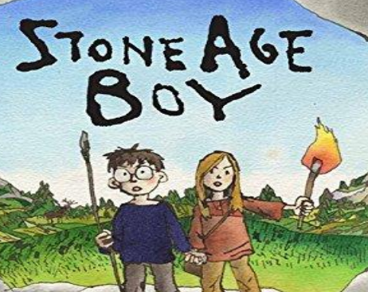 | Can you create an information leaflet about:  Stone Henger  Skara Brae  Starr Carr  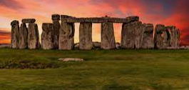 | Use different outdoor materials to create your own ‘instruments’.  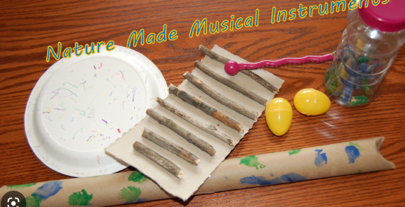
STEM | ROOTS | Art/DT
Build a boat that floats and can carry the hunter-gatherers down the river.  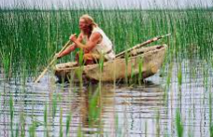 | Take a photo or draw a picture of yourself following out ROOTS. This could be a photo of you helping someone around the house, taking care of a sibling or being respectful.  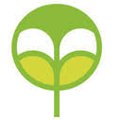 | Create your own Stone Age model of a ‘round house’ with sticks and/or straw  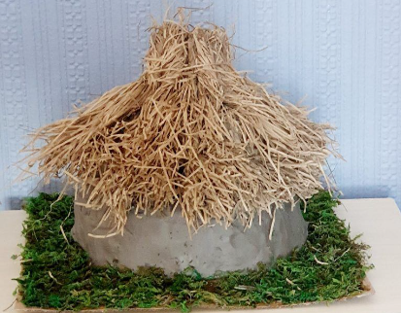
Poetry | PE | Cooking
Watch ‘I was born in the Stone Age’ by Michael Rosen and write your own version.  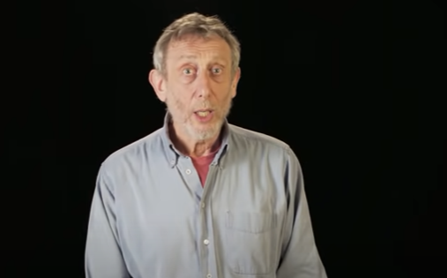 | Create your own ‘spear’ and practice throwing it at a target.  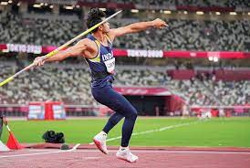 | Make a ‘Stone Age Stew’ or have a go at ‘gathering’ some fruit or vegetables.  