Year 3 Knowledge Organiser | ‘Would you prefer to live in the Stone Age, Bronze Age or Iron Age?’ | Focus: History
Key Vocabulary | Chronology
archaeologist A person who learns about the past by recovering buildings, graves and objects from the past.  AD Anno Domini- shows dates after the birth of year 0 (the birth of Jesus).  BC Before Christ (before Jesus was born)  bartering Trading by swapping one item for another  hunter gatherer People who move around hunting and collecting food.  settlement Place where people live together in a community.  trade Buying or selling objects that are made or grown.  tribe People that lived together usually led by a chief or king.  Neolithic A time of history called the New Stone Age.  artefacts Objects of historical interest made by humans.  limitations Archaeological evidence does not give us all the answers. | 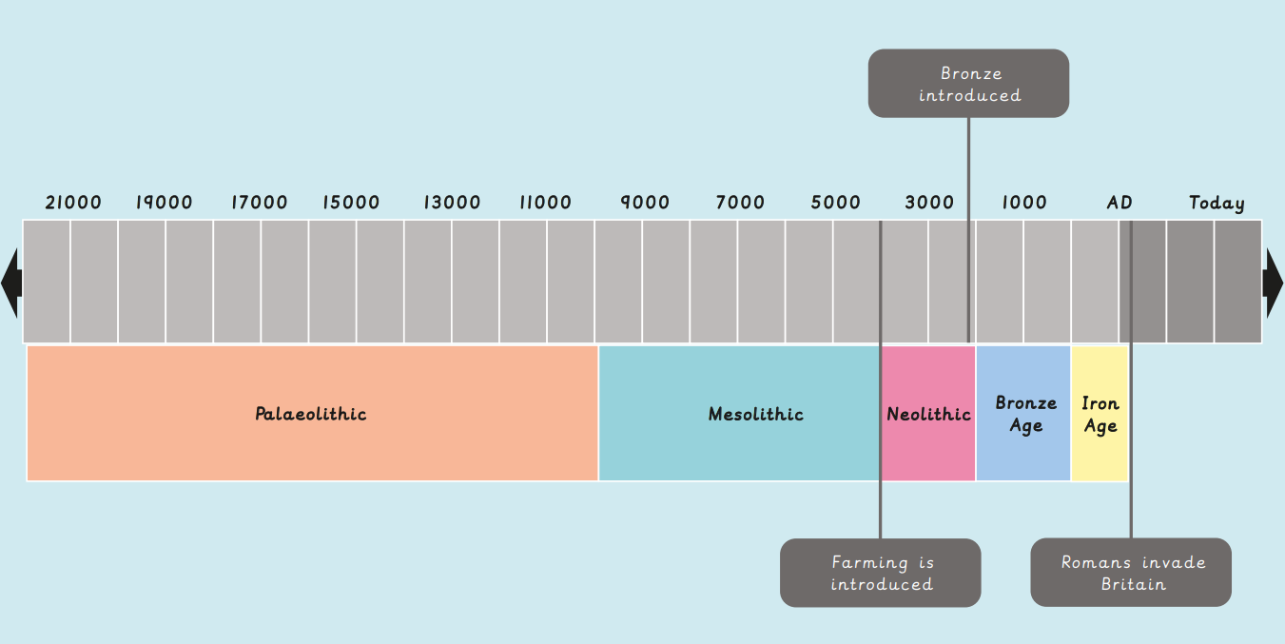
Settlements | Trade | The Amesbury Archer
In the Neolithic period, people started to live in groups together as communities. One example of this is Skara Brae.  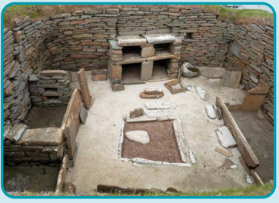  By the Iron Age, people were living in groups called tribes led by a chief or king. These were often around hill forts which were built to defend the tribe.  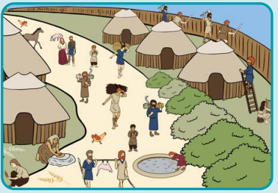 | 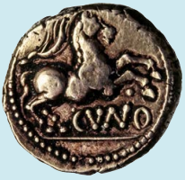  - Goods like bronze and copper were exchanged for other items.  - Trade between Britain and Europe increased during the Iron Age.  - To start with, bartering was used to exchange goods, but the arrival of the first coins ended this. | 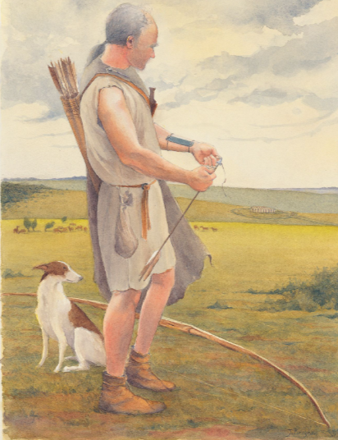  It is believed that he was a trader.  The first gold ever discovered in Britain was in his grave.  He came from Europe and it is thought that he brought bronze over with him.  