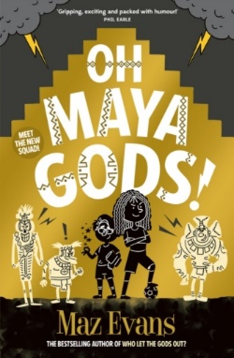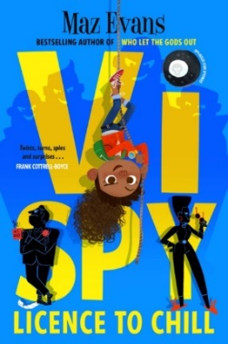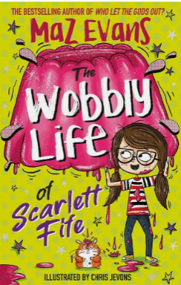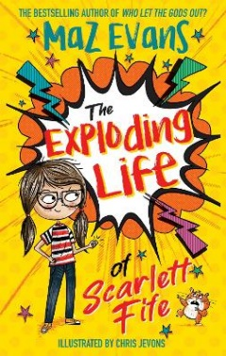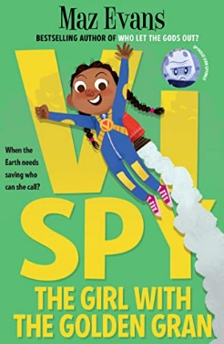

Author: Maz Evans

Other books by the same author:

Illustrator:

Aleksei Bitskoffs

Themes:

* Humour
* Good versus evil
* Mental health
* Greed
* Poverty

Genre:

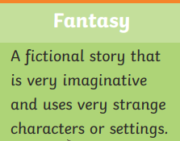

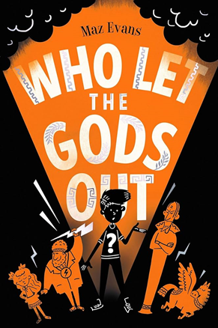

Plot summary:

When a shooting star crashes to earth, it lands Eliot smack bang in the path of Virgo - a young Zodiac goddess on a mission. But when the pair accidentally release Thanatos, a wicked death daemon imprisoned beneath Stonehenge, they've got nowhere to turn for help but to the old Olympian gods.

Set:

Home Farm, Brysmore School, Stonehenge, Elysium, London, River Styx