Friday 21st October 2016

House Spelling Bee Competition 2016
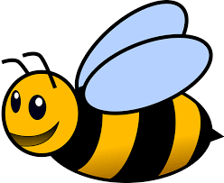

What is it?
As part of our work to promote high standards of spelling throughout the school we will be holding our first ever House Spelling Bee after half term. We feel that this will be a motivating and fun way to celebrate the achievements of all the children and promote good spelling; a key tool needed throughout life.

What can I do to help?
Please help your child to learn as many of the words on this list as possible. Some are easy and some are harder. Remember, the more they learn the more points they will earn for their house. The top spellers in each class will be entered into our grand final with prizes for the winners.
We believe that this structure gives all children the opportunity to earn points for their house and take part in what should be a fun event, whilst also reinforcing important work on Spelling.

Strategies:
Remember to try a variety of different strategies to learn them and add any new ideas to our Facebook page or website. You could try:
- Singing them
- Writing them out
- Making silly sentences
- Making an acrostic poem
- Writing them backwards
- Using one of the spelling activities from the spelling homework.
Regards,
Mr Rowlands and the Heads of House
