Monday 7th March 2022
OL: Can I deconstruct the WAGOLL? Can I identify techniques for building atmosphere?
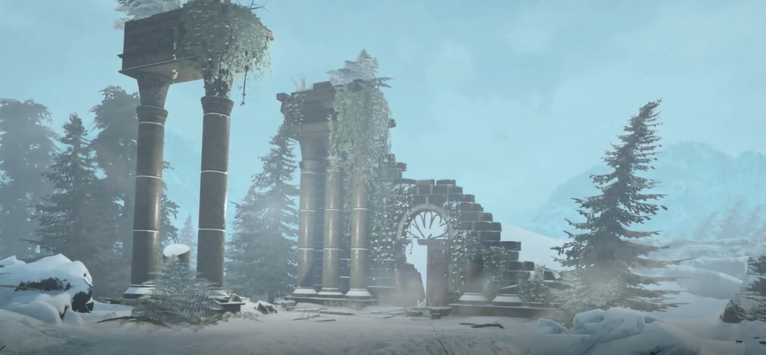
The snowstorm swallowed the rocky mountain slopes, muffling the world in white silence. Long ago, doom-filled clouds - bloated with hatred – had gathered in the sky before unleashing its torrent of icy soldiers onto the helpless landscape below. Lacerating winds whipped across the slopes trying to vengefully rip the crumbling remains from their trembling foundations. The wind’s icy fangs tore at the pillars that seemed to lean forlornly into the wintery storm. Earlier that day, tiny animal paws had crunched through the powdered snow creating footprints which were now slowly being re-invaded. A thick ice covered the footpath that used to lead up the mountainous region to a once welcoming building.

Inside the crumbling walls of the building, armies of snowflakes had begun amassing their numbers in treacherous mounds. Exposed window frames beckoned the bitter wind through their gaping holes while the scattered remains of broken shards of glass were hunted down and devoured by the snow. Winter’s deadly grasp had torn down the majestic chimney, hurling it across the floor of the dining room and strangling the remains of a fireplace with glistening ice crystals. Shattered roof tiles lay in icy graves across the barely-seen flooring. Splintered wooden beams from a door had been dragged from its home and thrown into an exhausted heap leaning against a half-crumbled wall.

Beyond the disintegrating walls, triumphant howls could be heard as the wind swirled through the branches before crashing against the stone walls. Weathered trees groaned under the weight of the snow. Creak: somewhere behind the snowy curtain, a cracking sound followed as a branch collapsed from an unseen height and shattered a pool of ice. The noise echoed for just a moment before it was lost beneath the screaming wind.
Can you identify the structure of this setting description?
Paragraph 1
Paragraph 2
Paragraph 3

Challenge: How is personification being used in this piece of writing?

Can you identify the structure of this setting description?
Paragraph 1
Paragraph 2
Paragraph 3

Challenge: How is personification being used in this piece of writing?

Can you identify the structure of this setting description?
Paragraph 1
Paragraph 2
Paragraph 3

Skills: Learning ladder | Colour underline
Adjectives (describing words)
Adverbs (how it happens. Often –ly)
Fronted adverbials (when, where, how?)
Subordinating conjunctions (until, because, as, if)
Relative clauses (who, which, that)
Punctuation: Learning ladder | Colour underline
Dashes to add extra detail or clarity
Colon to introduce extra information
Literary Skills: Learning ladder | Colour underline
Personification (human characteristics to an object)
Metaphor (describing something as something it isn’t)

Skills: Learning ladder | Colour underline
Adjectives (describing words)
Adverbs (how it happens. Often –ly)
Fronted adverbials (when, where, how?)
Subordinating conjunctions (until, because, as, if)
Relative clauses (who, which, that)
Punctuation: Learning ladder | Colour underline
Dashes to add extra detail or clarity
Colon to introduce extra information
Literary Skills: Learning ladder | Colour underline
Personification (human characteristics to an object)
Metaphor (describing something as something it isn’t)

Skills: Learning ladder | Colour underline
Adjectives (describing words)
Adverbs (how it happens. Often –ly)
Fronted adverbials (when, where, how?)
Subordinating conjunctions (until, because, as, if)
Punctuation: Learning ladder | Colour underline
Dashes to add extra detail or clarity
Colon to introduce extra information
Literary Skills: Learning ladder | Colour underline
Personification (human characteristics to an object)

Skills: Learning ladder | Colour underline
Adjectives (describing words)
Adverbs (how it happens. Often –ly)
Fronted adverbials (when, where, how?)
Subordinating conjunctions (until, because, as, if)
Punctuation: Learning ladder | Colour underline
Dashes to add extra detail or clarity
Colon to introduce extra information
Literary Skills: Learning ladder | Colour underline
Personification (human characteristics to an object)

Skills: Learning ladder | Colour underline
Adjectives (describing words)
Adverbs (how it happens. Often –ly)
Fronted adverbials (when, where, how?)
Subordinating conjunctions (until, because, as, if)
Punctuation: Learning ladder | Colour underline
Dashes to add extra detail or clarity
Colon to introduce extra information

Skills: Learning ladder | Colour underline
Adjectives (describing words)
Adverbs (how it happens. Often –ly)
Fronted adverbials (when, where, how?)
Subordinating conjunctions (until, because, as, if)
Punctuation: Learning ladder | Colour underline
Dashes to add extra detail or clarity
Colon to introduce extra information

Skills: Learning ladder | Colour underline
Adjectives (describing words)
Adverbs (how it happens. Often –ly)
Fronted adverbials (when, where, how?)
Subordinating conjunctions (until, because, as, if)
Punctuation: Learning ladder | Colour underline
Dashes to add extra detail or clarity
Colon to introduce extra information

