

Weekly KIRF Tasks

* **Week 1 -**  Make a poster of the facts for your bedroom wall or your fridge. Look at it every day!
* **Week 2 –** Make up a poem or a song of your facts. Use it to help you practise. Sing it on the way to school!
* **Week 3 –** See if you can write them down. Ask a parent to time it. Then do it again and beat your time.
* **Week 4 –** Test your parents or someone else in your family on their facts! Make up tricky questions to catch them out.
* **Week 5 –** Spot fractions, decimals and percentages in real life! Score 1 point every time you spot a fraction, 2 points for a decimal and 3 points for a percentage. See how many points you score by looking in shops, newspapers and on the television.
* **Week 6** – Teach these facts to someone who doesn’t know them. This could be a baby brother or sister, someone in your class, or maybe even someone else in your family!

By the end of this half term, you should know the following facts. The aim is to recall these facts **instantly**. You should also be familiar with using the key vocabulary.

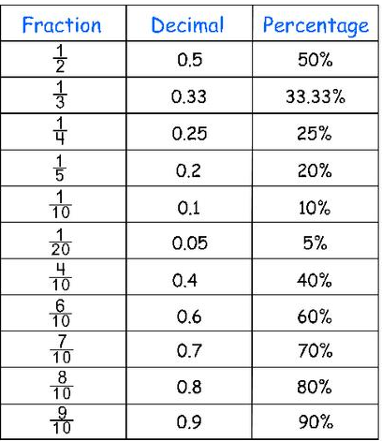

Children should be able to convert between decimals and fractions for 1/2, 1/4, 3/4 and any number of tenths and hundredths.

Key Vocabulary

Tenths

Hundredths

Decimal

Fraction

Percentage

Key Instant Recall Facts

Target 34

I can convert between fractions, decimals and percentages.