ABOUT THE FOOD BANK

The Food Bank relies entirely on donations of food and money from local schools, churches, businesses, organisations and individuals and every single item or penny given makes a difference. Businesses, Churches and Community Groups can all get involved helping The Food Bank in a variety of ways. Our warehouse and serving centres are manned by volunteers from the local area.
How Does The Food Bank Work?
Referral Agencies identify families and individuals who need our support and issue a voucher entitling them to a food parcel. Food parcels can be picked up from one of our serving sessions located around the city. Clients can receive a food parcel x5 times within a rolling 12 month period. (Although we are flexible in some cases when clients need further help.)

I NEED HELP
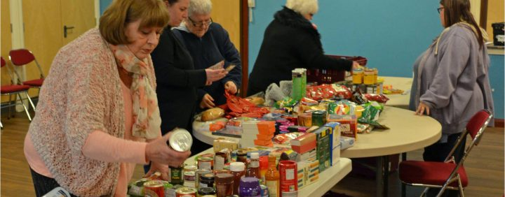

Need a Voucher?
If you need an emergency food voucher, please click here to find a list of our partnering agencies who will be able to issue one of our emergency food vouchers.

I already have a Food Voucher
Please call Tel: 01908 322 800
You can redeem your voucher at any of the following locations:
MON 10:30 – 11:30 – Crosslinks Centre, Water Eaton Church Centre, Drayton Road, Bletchley, MK2 2RR
MON 14:00 – 15:00 – Christian Centre, Strudwick Drive, Oldbrook, Milton Keynes, MK6 2TG
TUE 11:10 – 11:30 – Great Linford Parish Council Offices, St Leger Drive, Great Linford, MK14 5HA
TUE 11:40 – 12:00 – Foodbank Van, Lovat Hall Baptist Church Car Park, Newport Pagnell, MK16 0EJ
TUE 13:30 – 15:00 – Kings Community Centre, Creed Street, Wolverton, MK12 5LY
TUE 14:30 – 15:30 – Moorlands Centre, Dodkin, Beanhill, MK6 4LP
WED 10:30 – 11:30 – Melrose Avenue Resource Centre, Frank Moran Centre, Melrose Avenue, Bletchley, MK3 6HT
WED 13:30 – 14:30 – New Life Church MK, Ridgeway Centre, Featherstone Road, Wolverton Mill South, MK12 5TH
THU 11:00 – 12:00 – Christian Centre, Strudwick Drive, Oldbrook, Milton Keynes, MK6 2TG
FRI 10:30 – 11:30 – St Andrews Baptist Church, St Andrews Road, Bletchley, MK3 5R
FRI 14:00 – 15:00 – Church of Christ the Cornerstone, 300 Saxon Gate West, Central Milton Keynes, MK9 2ES
SAT 09:30 – 11:00 – St George’s Church, St Georges Way, MK12 5EX

