Year 5 Learning Challenge
Poem: Rocket Boy by Celia Gentles Person: Buzz Aldrin
Art Work: Starry Night by Van Gogh Music: Gustav Holst Planet Suite (Classical)

 | Poem | Art Work | Person | Music
Beginning | Learn it off by heart | Find out 10 facts about the painting/artist | Draw a portrait of the person | Listen to the piece of music and say what you like about it.
 | Find another poem by the poet | Produce a collage of other paintings by the artist | Produce a timeline of their life | Identify the instruments.
Secure | Create a performance as part of a pair/group | Draw a picture in similar style | Produce a poster to advertise their achievements | Research the life of the musician(s).
 | Write a short biography about the poet | Transform the medium of the painting: use collage instead of painting | Write a letter asking them about their life | Attempt to recreate the piece of music
Greater Depth | Write your own poem inspired by the topic | Use the image as a stimulus for a piece of descriptive writing. | Explain how the world would be without this person | A mind map of different emotions you feel at various points in the piece
 | Compare and contrast two poems by the poet | Describe the painting: what it represents, how it makes you feel, what it is based on. | Give five reasons for and against why they should be in ‘The Hall of Fame.’ | Produce a piece of art/collage based on how the music makes you feel.
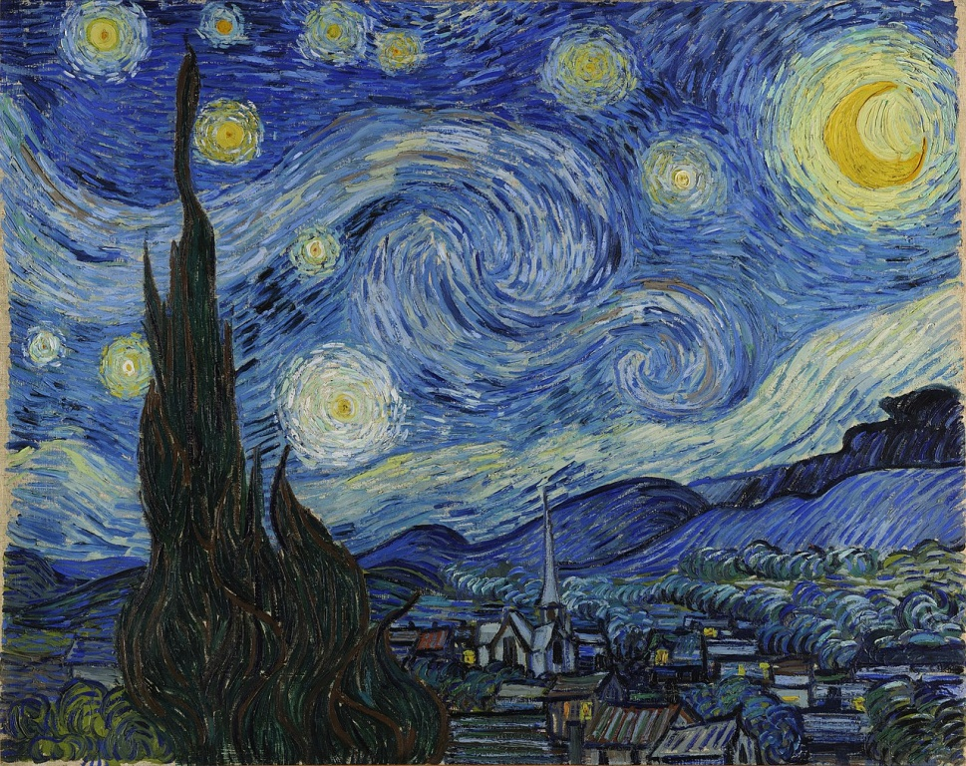
Rocket Boy
At night
I am captain
Of an alien crew,
On my red and silver rocket
Speeding

Through stars.
Behind closed eyes
I, the bold explorer,
Fly past pulsing purple planets,
Spinning

With rings
Emerald moons.
I dodge space dust, comets,
Bronze and gold starbursts, exploding
White dwarfs Van Gogh – Starry Night

At night
I am captain of an alien crew
Til I’m sucked inside the black hole
Of sleep.

