Charlotte’s Web by E. B White
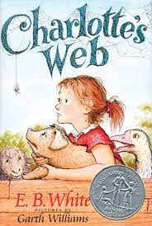

This is the story of a little girl named Fern who loved a little pig named Wilbur and of Wilbur's dear friend, Charlotte A. Cavatica, a beautiful large grey spider. With the unlikely help of Templeton the rat, and a wonderfully clever plan of her own, Charlotte saves the life of Wilbur, who by this time has grown up to be quite a pig.

