Behaviour policy

Reviewed: March 2019

Behaviour and Discipline Policy

1. Purpose
At Great Linford, we believe everyone is entitled to:
Aspire, Thrive, Enjoy, Achieve
The purpose of our behaviour policy is to ensure that all members of our school community are able to do this and reach their maximum potential, by recognising and protecting their rights.

We believe that every member of the school community has the right to:
- Be themselves - their unique identity and talents being recognised, valued and developed, in order for them to ASPIRE
- Feel safe and cared for, in order for them to THRIVE
- Feel happy and treated with respect and dignity, in order for them to ENJOY
- Learn, in order for them to ACHIEVE
These rights are non-negotiable and it is everybody’s responsibility to ensure that these rights are met.

2. Aims
Our policy aims to:
- Support all children and adults in our family in working together to establish and sustain a culture of responsibility and co-operation.
- Promote good relationships and positive behaviours so that people can learn together, with the common purpose of allowing everyone to succeed. We believe strong working relationships are at the heart of all learning.
- Develop children’s emotional intelligence, to help them manage their own feelings and actions and understand those of others, promoting tolerance.
- Create calm and consistent working environments where everybody feels happy and safe.
- Enable children to become positive, confident, responsible and increasingly independent and resilient members of both the school and the wider community.

3. Our School Values
Our school values are the mechanism through which our responsibilities for protecting one another’s rights are translated into actions. Values are principles that drive behaviour. They influence our actions, attitudes, our relationships with ourselves and others and become our framework for living.
A tree has always been our logo and represented Great Linford Primary School. We have used the tree as an image to represent our Great Linford family and one is displayed in every classroom. It’s roots show our school values which underpin our ethos. They represent our belief that these values are our anchors which ground us and without them our school community, represented by the leaves, would be unable to grow and flourish.
Our values spell out the acronym ROOTS and are as follows:
- Respect all people, animals and our environment
- Overcome challenges and never give up
- Open our minds to creativity and curiosity
- Take care of our bodies and minds to grow healthily
- Speak kindly and listen to others
Our values provide a clear awareness of acceptable behaviour, against which staff and students’ choices of behaviour are evaluated. They help reduce the option for inappropriate behaviour. Values are learned through a combination of practice and instruction. Students learn what values are, how to recognise them and how people react to them, equipping them with invaluable social skills and emotional intelligence. All members of our school community are expected to model these values.

4. Routines and expectations
These are the structures which we put in place to help children understand what our values look like in practice. They reinforce the smooth running of the classroom. The more habitual the routines become, the more likely they are to be used. The school day comprises a series of routines, particularly at times of transition, as listed below:-
- Morning Activities and Early Work
- Lining Up
- Classroom entry/exit
- Seating plans and student groupings
- Changing Between Lessons
- Initiating/sustaining whole class attention
- Class discussions
- Assembly
- Giving out/collecting in resources
- Appropriate noise levels at appropriate times
- Tidying up
- Sending children to the locker areas or to the toilet
- Playtimes
- Community circles
- Moving around the school
- Afternoon registration
- Independent activities
- Group work
- End of the Day
Clear expectations are set by the teacher and routines are developed with the children at the beginning of the academic year to ensure our school values are put into practise. The use of checklists for whole school routines ensures consistency across all classes.
5. Behaviour management strategies
We believe in the importance of a consistent approach used by all members of our school community. Values based preferred practises which fulfil the purpose and aims of this policy are in place to support staff in leading and promoting behaviour that is responsible in a way that acknowledges and protects mutual rights.
5.1 Strategies for the promotion of good behaviour
Public praise and private criticism Public acknowledgement of good behaviour can be very powerful in a positive way. Usually, criticism should be as private as possible; lowering a child’s self-esteem through criticising in front of an audience is likely to increase misbehaviour. Praise needs to be specific and linked to effort and motivation, not outcomes. It should be as descriptive as possible so that a child is clear about the elements of their behaviour being praised. Praise can also be non-verbal, e.g. a smile, a thumbs-up or a sticker.
Three positives before a negative This principle involves teachers aiming to have made three positive contacts with a child before constructively criticising their work. This encourages children to be more receptive to important learning points that a teacher is making. Equally, within the class, the aim is to appreciate three children before criticising one. The lesson children will learn is that they are more likely to get attention when they behave well than when they behave badly.
Acknowledge feelings Children often misbehave because they feel upset. One reason for this can be to attract adult attention to their bad feelings in the hope that they will get some help with them. Acknowledging a child’s feelings can pre-empt them resorting to other ways to gain attention.
Give children a choice This may be as simple as allowing a choice about which piece of work to complete first. Being given choices increases a child’s sense of independence, which in turn contributes to their self-esteem. The children will also be reminded about making the ‘right choice’ when they are not following our values, our ROOTS.
Be consistent Children have a need for the world around them to be as reliable as possible. When staff act consistently and reliably, they make children feel safer and therefore less anxious. This in turn reduces the possibility that events will trigger poor behaviour.
Set high expectations It is important for adults in school to set high expectations for all pupils in regards to their attitude and behaviour. This is not exclusive to the classroom and also applies to when the children are moving around the school and during school assemblies. Children need to be made aware of what the expectations of behaviour are and these need to be made clear to enable the children to follow expectations.
Model desired behaviour It is important for adults within the school to model the kinds of behaviour expected from our children, our ROOTS values and the Restorative Practice principles which we believe in. It is important children observe these not only in adult interactions with children, but in adult to adult interactions as well.
Listen to the children Listening to children makes them feel significant. It is important to make children aware that adults recognise their feelings (eg. “You seem cross, did something happen?”). Concerns and complaints need to be followed up, even if that means needing to say that it will be dealt with later. Children need to be secure in the knowledge that issues will be dealt with appropriately.
Maintain frequent contact All children, and in particular those who have difficulty concentrating, need frequent contact that recognises what they have already achieved, points them to the next step and reminds them that the teacher will be back to see how they are progressing. This concentrates on communication about the task and gives the child positive teacher contact.
Pre-empt disruptive behaviour Teachers and adults in the classroom need to display a constant awareness of what is happening throughout the classroom. This allows off-task behaviour to be spotted early and children’s attention returned to the task before behaviour actually becomes disruptive.
Self awareness Adults in school need to communicate confidence and authority. In order to do this it is important to be aware of elements such as position in class, proximity to disruptive children, facial expression, tone of voice, body posture, choice of words and use of eye contact.
Catch them being good Noticing and acknowledging anything that is in the direction that adults in school wish children to take will encourage and reinforce positive behaviour.
Well prepared, interesting and engaging lessons If the lesson content and delivery enthuses children, they are less likely to become off task and make poor behaviour choices.
The classroom environment Furniture and seating should be arranged to provide an environment conducive to on-task behaviour. Materials and resources should be arranged to aid accessibility and reduce uncertainty and disruption.
5.2 Positive discipline – least to most intrusive
We believe in using positive discipline as a form of guidance and instruction and place a great deal of importance on the language this involves. We ensure that we:
- Focus on the behaviour, the choice made, rather than attacking the person
- Are brief when addressing behaviour
- Calm ourselves before trying to calm the student – we avoid raising our voice and do not become involved in arguments
- Give the student take up time whenever possible - when a direction has been given, allow the child time to make the decision to comply. It includes the idea of ‘face saving’, co-operation, expectation and trust. Some children take longer than others to process information. Watching the child and waiting is, in a way, a form of challenge and encourages other children to do the same, creating an audience.
- Balance correction with encouragement and the re-establishment of working relationships
- Concentrate on the ‘primary behaviour’, our values, routines and the rights of others that may have been affected rather than on ‘secondary behaviours’ wherever possible.
- We don’t believe in using sarcasm as a tool.
Below is a range of behaviour management strategies. It is not exhaustive but comprises strategies from the least to most intrusive to learning, where teaching is interrupted. This is an eventuality that should be avoided as far as is possible, as the teachers are here to teach, and the children are here to learn.
- Tactical/planned ignoring- a conscious decision to ignore a specific undesired behaviour and keep the focus on the flow of the lesson, or on acknowledging and reinforcing positive behaviour. Used consistently, students notice when and for what the teacher gives attention to a student. It may be appropriate to discuss the behaviour with the pupil later. It is only helpful if the students sense that the teacher is conveying a message with it.
- Non verbal messages – ‘The Look’, moving closer, visual prompts, gestures. They can be explained to the whole class or just to individuals. They can be a positive form of communication reducing the amount of corrective language required, without an intrusive fuss.
- Distraction – With low level disruption, a teacher can distract or divert by using casual intervention e.g ‘How’s it going?’ ‘Can I have a look?’ ‘Where are you up to?’ ‘You’ve done such a great job with your writing would you be able to go and show it to David I think your ideas could really help him’. This may also involve giving the child a special task to do e.g. fetching a resource etc.
- Description of reality – A simple, calm statement of fact describing the inappropriate behaviour. “John, you are talking.” “A number of students are calling out.” By describing what they are doing we raise behaviour awareness.
- Directional reminder– These often relate to rules and routines. ‘Remember, hands up if you want to speak, thank you.’ ‘Our rule for lining up is... thank you.’ ‘Remember our rule for working noise, thank you.’ A simple clear statement of desired behaviour followed by ‘thank you’. Using thank you implies compliance. This reminds the pupils of what they should be doing and avoids getting involved in a discussion about what they are doing wrong. Use instead of a negative e.g. ‘Don’t talk while I am talking.’
- The tactical pause – this can help initiate and sustain attention when giving a direction. The pause indicates ‘I expect you to listen to what follows now that I have your initial attention.’ E.g. ‘David, (pause), facing this way and listening, thanks.’
- Question – Avoid using why questions at all costs. Ask a prompt question to show that inappropriate behaviour has been noticed e.g. “What’s happening here?” An inappropriate response may be given by the student so it may need to be followed by a description of reality e.g. ‘John I saw you talking’ and a further question ‘What are you supposed to be doing?’ The question redirects the student to own their behaviour. If the incorrect response is given a further directional reminder can be given.
- Conditional directions – ‘When....then’ ‘After.....then’ ‘Yes....when’ E.g. ‘After you’ve packed away then you can get ready for playtime.’ This is far more positive than ‘ No you can’t get ready for playtime because...’
- Directed choice – ‘Paul...that’s a nice toy but I want you to put it in your tray or on my desk.’
- Directing students aside – It can be helpful to correct some students more privately away from their immediate audience by calling them over. It is important to give take up time and not watch or wait for them to comply.
- Redirection/blocking – When compliance is not gained immediately and the low level behaviours continue, insist on what is required by using the ‘broken record’ technique. This is a repeated statement of the direction using the pupil’s name and ‘thanks’ at the end. The language remains unchanged until the instruction is followed. The repeated direction ‘blocks’ the student’s procrastination.
- Partial agreement – followed by redirection/blocking. E.g ‘Maybe you were talking about the work, but now I need you to listen, thank you,’
- Choice or consequence - This enables a pupil to take responsibility for his/her actions. ‘If you continue to...(be specific about the off-task or disruptive behaviour) then you are choosing to....(outline the immediate or deferred consequence – moving onto the amber or red leaf, working away from others, time out for a fixed amount of time in a nearby class, staying in at playtime to discuss their behaviour or fix things up)’
5.3 Re-establishment of working relationships
After any form of correction has been used, it is vital that staff re-establish a positive working relationship with the student. A positive interaction with the student e.g. praise, encouragement, or even a smile as soon as possible after correction reassures the student they are still an accepted and valued member of the class.
6. Restorative Principles
We are a Restorative Practice school. Effective Restorative Practices foster awareness of how others have been affected by inappropriate behaviour and we apply the principles of restorative practice to all of our interactions with children when addressing behaviour issues with them/between them. Children have to know how to take responsibility for their actions, and our Restorative Practice principles create a climate where this can happen. This is done by holding a restorative circle with all individuals involved in behaviour incidents. By actively engaging participants in a process which separates the deed from the doer and rejects the act not the actor, it allows participants to make amends for the harm caused. It allows relationships to be repaired and strengthened. The following questions are asked by the person leading the restorative circle:
- What happened?
- What were you thinking at the time?
- What have you thought about since?
- Who has been affected? How has this affected you/them?
- What needs to happen to make things right?

7. Behaviour management system
Each classroom has a values tree displayed. There are 5 roots, one to represent each of our school ROOTS values. Each child in the class has their name written on a leaf on the tree. Beside the tree is a large amber leaf and a large red leaf which are used to help manage behaviour as part of our consequence system. Flying above our values tree are four golden birds, labelled to represent the 4 core entitlements for our children: Achieve, Aspire, Thrive, Enjoy. These form one part of our rewards system.
7.1 Rewards
If children follow our values, they will be demonstrating good behaviour and learning behaviours and their leaf remains on the family tree in their classroom. This is an expectation we have for all of our children. These children will be following the routines and expectations and as a result, adults may choose to reward them with a house point.
Some children, in addition to this, may be demonstrating our values particularly well and in addition to being rewarded with a house point, they will also have their leaf moved onto a golden bird. Each of the golden birds, representing one of the four core entitlements for our children, can be accessed through following our ROOTS values:
- Respect all people, animals and our environment
- Speak kindly and listen to others
If children are modelling these values, they will be ensuring they and their classmates ENJOY their day at school.
- Overcome challenges and never give up
- Open our minds to creativity and curiosity
If children are modelling these values, they will be allowing themselves to ACHIEVE.
- Take care of our bodies and minds to grow healthily
If children are modelling this value, they will be allowing themselves and one another to THRIVE.
Children who have been moved up onto gold who really are going ‘Above and Beyond’ in modelling our ROOTS will also receive a special Great Linford Above and Beyond golden sticker and instead of one house point will receive three house points for their house group.
The Aspire golden bird is an extra special golden bird which only one child per class per week is moved onto. Each week, there is an agreed whole school criteria for choosing the ‘Aspire winner’ which links to the skills that are being focussed on in the whole school PSHE unit from our JIGSAW scheme for that half term. Not only do they receive an ‘Above and Beyond’ golden sticker, but they also are given the Aspire trophy to keep on their desk at school and a special certificate and photograph with the trophy to take home. Aspire trophy winners are announced in front of their Key Stage during weekly Key Stage assemblies and attend a special celebration tea with the Headteacher.
We also have a ‘golden leaf’ award which is presented during year group assemblies each week. Each half term, we have a ROOTS value we are particularly focussing on and the golden leaf award is presented to children who have particularly demonstrated that value each week. As well as a golden leaf presented to them in year group assembly, their name and reason for being awarded the leaf is recorded onto one of the golden leaves on our tree display in the reception area.
Children who are demonstrating our values well on the playground are rewarded with a golden star to stick on their classroom door. The class with the most golden stars each week gets the special privilege of sitting on the benches in assembly.
  - Consequences
An essential part of our behaviour management lies in the fact that a pupil knows sanctions will be imposed consistently for unacceptable behaviour. These are displayed to children in class on a consequence ladder (see Appendix 1). Consequences usually follow the consequence ladder in order. The exception being serious behaviour incidents where consequences would begin higher up the consequence ladder. The following table explains the stages of our consequence ladder.
1 | Reminder  - Refer to the learning zone the child is in or describe the undesirable behaviour you can see  - Remind them of the ROOTS value they aren’t following  - Remind them of the behaviour you expect to see  e.g ‘(name), you are in learning zone 2, you need to have your eyes on me, show me how quickly you can get into learning zone 5.’  No more than a couple of reminders should be given before progressing to the next level.
2 | Warning = Amber leaf  - Refer to the choice the child has made to stay in the wrong learning zone and refer them to the ROOTS value they need to grow.  - Move the child’s leaf onto the big amber leaf (or ask them to do this). Use a whiteboard pen to put a dot next to their name on their leaf.  - Use the choice or consequence strategy – if you continue to..... then you are choosing to... (explain consequence)  e.g ‘(name), you are choosing to stay in learning zone 1 which is very disappointing, you are not showing our respect root. Go and move yourself onto amber. You need to start making the right choices to grow your behaviour so you can rejoin our family tree.’  Make a real effort to catch the child being good in the next few minutes to re-establish the working relationship. Aim to get the child back onto the tree as quickly as possible. If the child falls off the tree again, put another dot with the whiteboard pen. If this gets to three dots, they move to the next level of consequence, the red leaf.
3 | Consequence and follow up reflection= Red leaf  - Explain to the child on the amber leaf they are not making the right choices. Refer again to what learning zone they are in and which ROOTS they are not showing.  - Move the child to red ‘You have continued to choose to... which means you have chosen to move to red.’ Put a dash using a whiteboard pen next to the child’s name on their leaf.  - The consequence may be immediate or deferred.  - All children will have the deferred follow up reflection during part of breaktime.  Immediate consequences:  - Relocation to the reflection table  - Move the child to the reflection table away from distractions and leave them to complete their learning.  - Time out of the classroom  - It may be more appropriate for the child to complete their learning in the reflection area in another classroom.  Deferred consequences:  - Finishing work at break time  - Fixing the situation at break time – e.g. verbal or written apology, tidying up any mess they have created  Follow up reflection  - A restorative conversation needs to be had with the child to help them reflect on their behaviour and make better choices in future. It also helps restore the relationship with the teacher. It may need to involve particular individuals from the class if relationships need to be restored here too.  - After the discussion, the child must fill in a reflection form. There are separate proformas for KS1 and KS2. This form may need to be scribed by the teacher in KS1.  - If the reflection form does not fully document the incident, the class teacher may choose to fill out the behaviour incident form on the back of it.  - Reflection forms are filed in the Class Admin folder.  - The reflection needs to be at an appropriate time and should not impact on anyone’s learning.
4 | Serious Incident = Detention - Loss of lunchtime  - After three red leaf consequences and reflections in one week (indicated by three dashes on the child’s leaf), the child is sent to detention for the first half of lunchtime. The teacher must send them with a completed behaviour form explaining why they have got to this consequence.  - Some behaviour incidents are serious enough to go straight to this level of consequence, by-passing the previous stages. There is a serious incident poster in every classroom describing behaviours that are classed as a serious incident.  - The class teacher will update the child’s parents as necessary.
5 | Regular attendance in detention = ROOTS Report  The class teacher monitors the number of reflection/behaviour incidents and the number of times a child is attending detention. If a pattern of poor behaviour is emerging, in consultation with the AHT, DHT or HT, the teacher may choose to put the child on report.  The report is a weekly timetable and documents whether in each session, the child has been following the ROOTS values. The child will need to come and show their report to either the DHT or HT at the end of the morning and the end of the day. Any crosses on the report, indicating that the child has not been showing the desired behaviour, will result in the child missing playtime and/or attending detention.
6 | Serious incident = Parents meet with the deputy headteacher or headteacher  If lunchtime detention and being on report is not having an impact on improving behaviour, the deputy headteacher meets with the child and their parents to discuss an appropriate next step. This could involve:  - The child going into ‘seclusion’, working away from their classmates on work set by their class teacher (internal exclusion)  - Indefinite loss of privileges such as play time, or positions of responsibility e.g. school council member, house captain etc until significant improvement in behaviour has been seen.  If the behaviour has been serious enough for an external exclusion to be given, then the child and their parents will meet with the headteacher.  Some behaviour incidents are serious enough to go straight to this level of consequence, by-passing the previous stages. There is a serious incident poster in every classroom describing behaviours that are classed as a serious incident.  When children reach this stage of the consequence ladder, a plan of support strategies will also be put in place. It will be considered whether a risk reduction plan will need to be written to minimise the chances of similar incidences reoccurring.

7.3 Serious incidents
These incidents may include (although not an exhaustive list):
- Any physical confrontations or threats of violence towards pupils or staff.
- Fighting.
- Dangerous behaviour
- Behaviour resulting in significant disruption to others
- Offensive language.
- Malicious accusations.
- Possession of a weapon.
- Stealing
- Deliberate property damage.
- Bullying.
- Prejudice relating to race, gender, disability, religion or belief.
- Any other problems which, in the teacher’s professional opinion, are considered sufficiently serious

Serious incidents will always result at minimum in a lunchtime detention and a discussion with the child’s parents.
Where the child is a danger to themselves or others, they will be removed from the classroom immediately. Depending on the severity of the incident, they will remain out of class internally excluded for the rest of the day. In very serious cases, the AHTor DHT will meet with the parents to discuss a further internal exclusion the following day or the HT will meet with them to discuss a fixed term exclusion.
Where a serious incident occurs at lunchtime, the child will be taken straight to lunchtime detention. If necessary, the staff outside will radio in for a senior leader to assist with this.
All staff are reminded that the safety and wellbeing of children is paramount. If staff believe that any behaviours suggests a child is at significant harm they should follow the school safeguarding procedures and notify the designated safeguarding lead (DSL). Staff should also consider whether continuing disruptive behaviour might be the result of unmet educational or other social, emotional or cognitive needs.

7.4 The importance of follow up reflection
We cannot always deal effectively with all aspects of students’ behaviour in the public setting of class and lesson time. We have to defer some consequences until after class, during break and lunch time, often after some ‘time-out’ in class has been given and without the peer audience. Even if you have been able to successfully redirect and defuse much of the undesired ‘primary behaviour’ in the lesson, a follow up chat allows you time to discuss the behaviour choice explicitly with the student. It also allows you time to discuss any secondary behaviours they may be demonstrating. It allows the student time to reflect on their behaviour and for you to restore and repair the relationship as necessary.
If teachers want to follow up after class, it is often good practice to leave the communication of this intention until just before the end of the lesson to avoid any prolonged arguments that the student may try and initiate as a result. It is also useful to begin the discussion acknowledging how the student might be feeling. The discussion allows the student the right of reply, something you may have ‘blocked’ during the lesson. It is important to listen to them while keeping the focus of the dialogue on the behavioural issue.
8. Searching pupils and the use of reasonable force
Some behaviours are more challenging than others. In most instances an adult’s usual control and professionalism will be enough to diffuse any problematical situation. However, where inappropriate behaviour is likely to escalate or to prove damaging to people or property, all staff must intervene to “regulate the conduct of pupils” (Education and Inspections Act, 2006).
Steps, such as dialogue and diversion should always be taken initially. However in some circumstances, screening and searching pupils, using reasonable force or positive handling may be necessary. If this is the case then the following points should be noted:
- Staff must have good grounds, such as the risk of injury to persons or damage to property.
- Searching without consent is condoned if the pupil is suspected to be carrying a weapon, alcohol, illegal drugs, stolen items, cigarettes, fireworks or pornographic images. Searching may also be required if the pupil is carrying chewing gum, sweets, large amounts of money, communication devices such as a mobile phone during lesson times, or items that may be offensive to other children or staff.
- In incidents of ‘reasonable force’ use, only minimum force should be applied.
- Restraint should be relaxed as soon as possible.
- Where possible, other staff should be present to assist or to act as a witness.
- If the person managing a given situation feels that a pupil needs to be isolated because of the risk of injury to persons or damage to property, this should not go on longer than necessary.
- All responses must be proportionate, and the pupil’s age, special educational needs or disabilities, or religious requirements they may have must be taken into account (Education and Inspections Act, 2006)
- See the physical restraint policy for further information.
8. Exclusions
In the most serious cases, where all interventions have failed or where behaviour is dangerous or a threat to another child or member of staff, we may use exclusions. We do not wish to exclude any child from school, but sometimes this may be necessary. Guidance on exclusion from schools is given from the DfE document ‘Exclusion from Maintained Schools, Academies and Pupil Referral Units in England: Statutory guidance for those with legal responsibilities in relation to exclusion’ and the Milton Keynes Local Authority document ‘Milton Keynes Exclusion Guidance.’ The Head Teacher, in consultation with other members of the Senior Leadership Team and The Governing Body, will be responsible for judging whether exclusion is appropriate.
a) A warning of exclusion. b) Fixed term exclusion. c) In the last resort, permanent exclusion.

9. Recording incidents and record keeping
All behaviour incidents, including those that happen on the playground, are recorded on behaviour forms. These are kept in the class admin folder. Serious incidents which result in attending detention, loss of privileges/responsibilities or internal/external exclusion are kept in a central folder with the AHT or DHT. Serious behaviour incidents where children have put the safety of themselves or others at risk, are reported to governors as part of our safeguarding reporting arrangements.

10. Incidents outside of school grounds
There may be occasions whereby incidents of misbehaviour (non-criminal) or bullying which occur outside of school are reported to staff. This could be from children, parents or members of the public if a pupil has been identified by their school uniform. The leadership team will investigate the incident through a discussion with the pupil/s involved and will then inform the parents of all involved. Depending on the nature of the incident consequences may be put into place. Any such incidents will be referred to the school’s safeguarding lead and the appropriate action will be taken.

Cyber bullying out of school that is reported to the school leadership team will be dealt with in the following way:
- The parents of the child that has been bullied screen shot the messages and bring them in to school
- The parents of the child who has been accused of bullying are contacted by the leadership team and a copy of the screen shot messages are sent directly to the parents with an expectation that they discipline their child and they restore justice between the families e.g. letter of an apology.

11. Children with SEN
Many of our children with SEN will have special educational provision in place to support them manage their behaviour. In some cases, this will involve a personalised approach to rewards and consequences that deviates slightly from the systems in place for the rest of the school. Some children’s needs result in them presenting with particularly challenging behaviour on a regular basis. For these individuals, pupil specific risk assessments are completed and a subsequent risk reduction plan is put into place.

Appendix 1 – Consequence ladder for classrooms
KS1 KS2
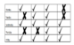
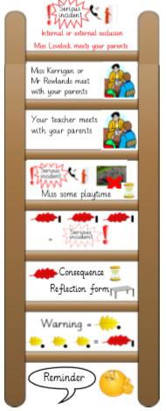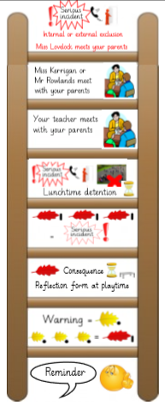

Appendix 2 – Serious incident poster for classrooms
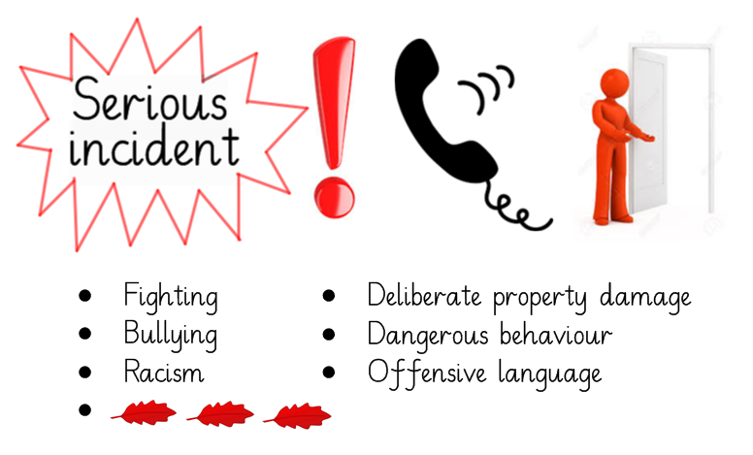

Appendix 3 – Examples of the reflection forms
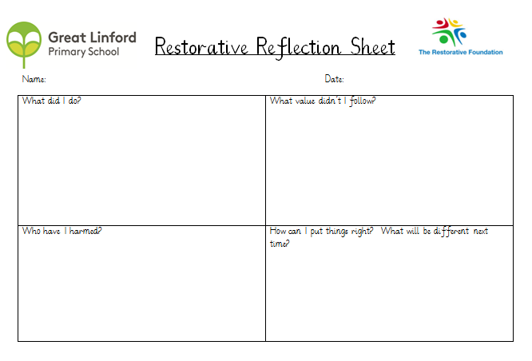
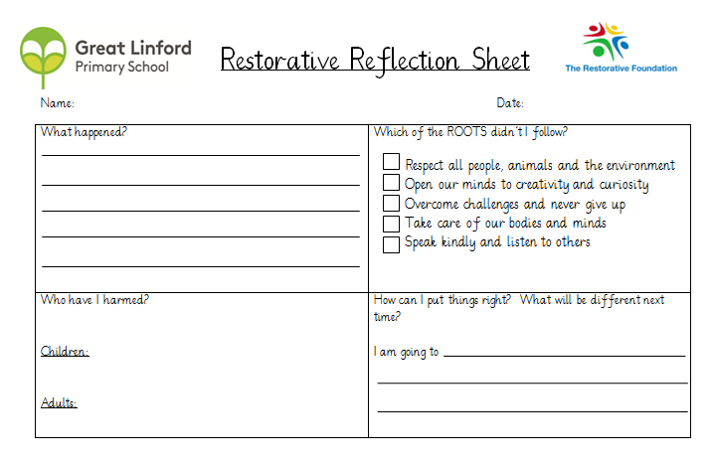

Appendix 4 – Behaviour incident form

Behaviour incident recording form
Name of child: Date: Class:
Please circle: Serious Non serious
If this is a Serious Incident, circle the relevant type of incident:
Fighting Bullying Racism Deliberate Property Damage
Dangerous Behaviour Offensive language Repeated non serious incidents
Please record the details of the serious or non serious incident:

Actions taken and people incident has been reported to:

Appendix 5 – Pupil specific risk assessment and risk reduction plan

Risk Reduction Plan
Name: |  | Class: | Date:
Review dates:
Photo | Potential triggers / Key themes
Identifiable early warning signs

Risk management
Prevention- Staff will:

De-escalation: If the challenging behaviour occurs - Staff will:

Pupil Specific Risk Assessment
Name
Year
Date of assessment

Seriousness
3 | This would include physical injury requiring medical attention beyond basic first aid; extensive damage to property; significant distress caused to self or others; or lengthy disruption to the normal school routines.
2 | This includes physical injury requiring basic first aid within the school; minor damage to property; some distress caused to self or others; or brief disruption to normal school routines.
1 | No physical injury or damage to property, minor distress or disruption.
Probability
4 | The behaviour is persistent and constant.
3 | The behaviour has occurred on more than one occasion and is more likely than not to occur again due to the nature of the triggers/influencing factors.
2 | The behaviour has occurred this academic year but as an isolated incident. Due to changes in context and/or risk management, reoccurrence is deemed to be unlikely.
1 | There is evidence of historical risk but the behaviour has not presented in over 12 months and no identified triggers remain.

Behaviour or hazard which carries risk of harm to self, staff, peers or property | Opinion or Known risk? O/K | Seriousness (S)  1/2/3 | Probability (P)  1/2/3/4 | Severity Risk Score (S X P)

Severity risk scores of 6 or more will require a risk reduction plan to be completed.

