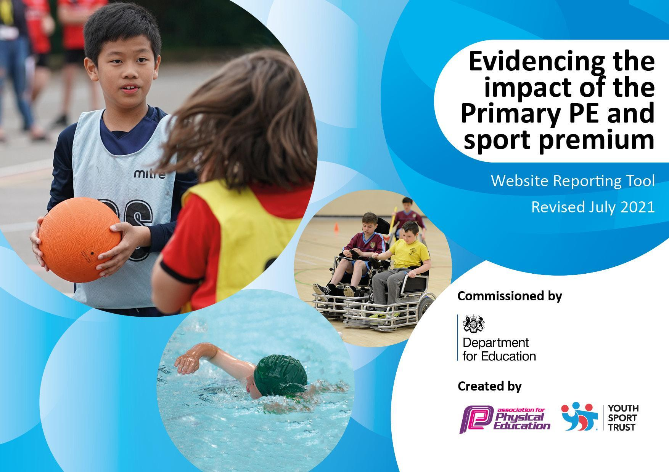
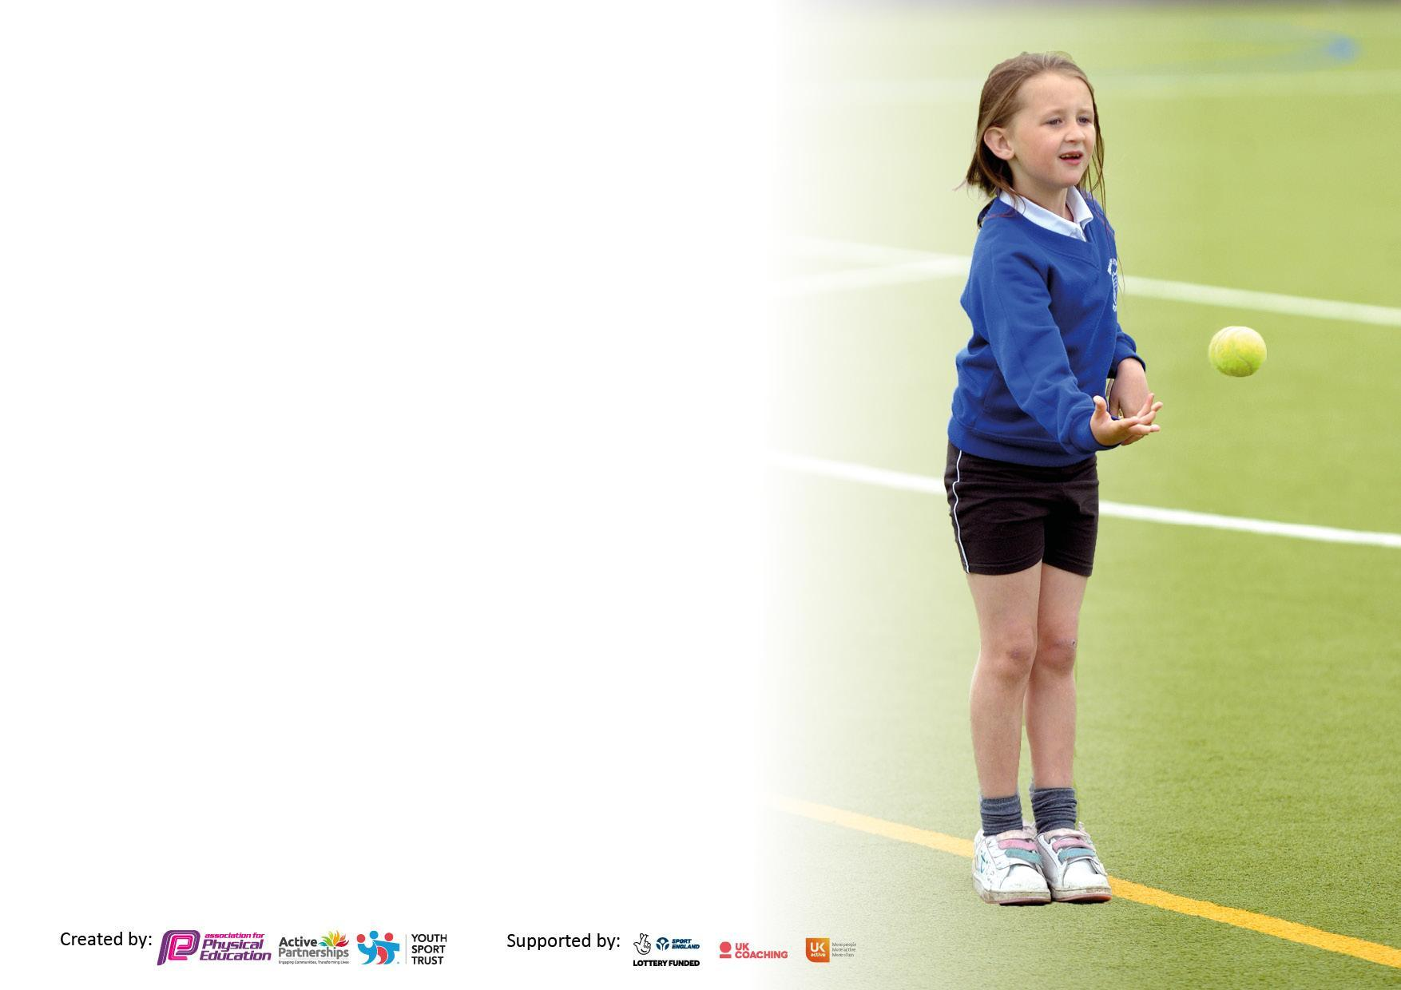

It is important that your grant is used effectively and based on school need. The Education Inspection Framework makes clear there will be a focus on ‘whether leaders and those responsible for governors all understand their respective roles and perform these in a way that enhances the effectiveness of the school’.

Under the Quality of Education Ofsted inspectors consider:
Intent - Curriculum design, coverage and appropriateness
Implementation - Curriculum delivery, Teaching (pedagogy) and Assessment
Impact - Attainment and progress

To assist schools with common transferable language this template has been developed to utilise the same three headings which should make your plans easily transferable between working documents.

Schools must use the funding to make additional and sustainable improvements to the quality of Physical Education, School Sport and Physical Activity (PESSPA) they offer. This means that you should use the Primary PE and sport premium to:

- Develop or add to the PESSPA activities that your school already offer
- Build capacity and capability within the school to ensure that improvements made now will benefit pupils joining the school in future years
- The Primary PE and sport premium should not be used to fund capital spend projects; the school’s budget should fund these.

Pleasevisitgov.ukfortherevisedDfEguidanceincludingthe5keyindicatorsacrosswhichschoolsshoulddemonstrate animprovement.Thisdocumentwillhelpyoutoreviewyourprovisionandtoreportyourspend.DfEencouragesschools to use this template as an effective way of meeting the reporting requirements of the Primary PE and sport premium.

We recommend you start by reflecting on the impact of current provision and reviewing the previous spend.

Schools are required to publish details of how they spend this funding, including any under-spend from 2019/2020, as well as on the impact it has on pupils’ PE and sport participation and attainment. All funding must be spent by 31st July 2022.

We recommend regularly updating the table and publishing it on your website throughout the year. This evidences your ongoing self-evaluation of how you are using the funding to secure maximum, sustainable impact. Final copy must be posted on your website by the end of the academic year and no later than the 31st July 2021. To see an example of how to complete the table please click HERE.

Details with regard to funding
Please complete the table below.

Total amount carried over from 2021/22 | £0
Total amount allocated for 2021/22 | £ £18,950
How much (if any) do you intend to carry over from this total fund into 202223? | £0
Total amount allocated for 2022/23 | £19,020
Total amount of funding for 2022/23. To be spent and reported on by 31st July 2022. | £ £19,020

Swimming Data
Please report on your Swimming Data below.

Meeting national curriculum requirements for swimming and water safety.

N.B. Complete this section to your best ability. For example you might have practised safe self-rescue techniques on dry land which you can then transfer to the pool when school swimming restarts.
Due to exceptional circumstances priority should be given to ensuring that pupils can perform safe self rescue even if they do not fully meet the first two requirements of the NC programme of study
What percentage of your current Year 6 cohort swim competently, confidently and proficiently over a distance of at least 25 metres?  N.B. Even though your pupils may swim in another year please report on their attainment on leaving primary school at the end of the summer term 2023. Please see note above | 42%
What percentage of your current Year 6 cohort use a range of strokes effectively [for example, front crawl, backstroke and breaststroke]? Please see note above | 12.5%
What percentage of your current Year 6 cohort perform safe self-rescue in different water-based situations? | 61%
Schools can choose to use the Primary PE and sport premium to provide additional provision for swimming but this must be for activity over and above the national curriculum requirements. Have you used it in this way? | Yes

Action Plan and Budget Tracking
Capture your intended annual spend against the 5 key indicators. Clarify the success criteria and evidence of impact that you intend to measure to evaluate for pupils today and for the future.

Academic Year: 2022/23 | Total fund allocated: £ 3550 | Date Updated:
Key indicator 1: The engagement of all pupils in regular physical activity – Chief Medical Officers guidelines recommend that primary school pupils undertake at least 30 minutes of physical activity a day in school |  |  |  | Percentage of total allocation:
 |  |  |  | %
Intent | Implementation |  | Impact
Your school focus should be clear what you want the pupils to know and be able to do and about  what they need to learn and to  consolidate through practice: | Make sure your actions to achieve are linked to your intentions: | Funding allocated: | Evidence of impact: what do pupils now know and what can they now do? What has changed?: | Sustainability and suggested next steps:
Leadership engagement and training | Look at roles of Sports Leaders in school. Provide training and resources for them to use. | £1,950 (As part of silver MKSSP package) | Staff voice has indicated that confidence in delivering PE has improved since training. | Ongoing CPD for staff to improve quality of lessons and staff confidence.
Engagement and support of all young people to participate in physical activity | Consult student voice and review extra curricular offer. | £1,950 (As part of silver MKSSP package) | Increased participation of children in teams.  Club registers.  More pupils will want to join sporting clubs around the local area. | All children to have represented the school before leaving Great Linford Primary School.
Build links with local sports clubs and sports personalities | Organise assemblies and extra sports days from sport clubs and sports personalities | £1500 | KS2 children participated in ninja warrior day for extra PE session. Children wanted to participate and feedback from children was that it was enjoyed. | Give children greater knowledge of sports personalities and want to try new sports.
Promote active breaks and lunchtimes | Track participation and the 30 mins for all pupils. Use data to inform target groups/children and interventions.  Admin support required to keep up to date records. | £100 | Enjoyment of pupils at break and lunchtimes has increased as they have been able to access equipment to play more active games. This has been shown in pupil voice. As a result of this LSA’s have reported fewer behaviour concerns as the children are having to use social skills like communication to resolve minor conflicts and follow rules | Invest in school ‘fitbits’ to track how active children are during the school day.
Key indicator 2: The profile of PESSPA being raised across the school as a tool for whole school improvement |  |  |  | Percentage of total allocation:
 |  |  |  | %
Intent | Implementation |  | Impact
Your school focus should be clear what you want the pupils to know and be able to do and about  what they need to learn and to  consolidate through practice: | Make sure your actions to achieve are linked to your intentions: | Funding allocated: | Evidence of impact: what do pupils now know and what can they now do? What has changed?: | Sustainability and suggested next steps:
Celebrate sporting engagement,  inside and outside if school. | Use social media; photos and reports of festival team participation and achievements.  Celebrate success within school through assemblies and display photos and news on PE notice board in the hall. | £40 | Children are actively asking for sports team and clubs to happen.  Profile of PE and Sport increased in school and with parents. Children who have had sporting success outside of school have been celebrated in assembly. Newsletter and facebook have celebrated sporting achievement. | Children to blog about their sporting achievements.  Host a sports personality evening style assembly.
To improve the playtime experience  for children  To support children’s physical and  mental health and wellbeing  To support building resilience in  children, post pandemic | Introduce outdoor play equipment to staff and children.  - Scooters  - Bikes  - Helmets  - Den building equipment  - Loose parts  - Tyre play  - Sensory play | £500 | Increased physical activity through different types of play.  LSAs reporting less behaviour concerns. | This is a three-year plan. (year 2 of 3.)
Whole school Sports Day inviting parents to spectate, participate and celebrate PE at school, | Mixed year group teams from across the school taking part in a carousel of sporting activities. | £250 | Children highlighted for future events so school can compete at a higher level. | Host sports day before athletics meet to act as trials. More pupils will want to join sporting clubs around the local area.
Apply for School Games Mark to evidence the achievements of the school and the children.

Key indicator 3: Increased confidence, knowledge and skills of all staff in teaching PE and sport |  |  |  | Percentage of total allocation:
 |  |  |  | %
Intent | Implementation |  | Impact
Your school focus should be clear | Make sure your actions to | Funding | Evidence of impact: what do | Sustainability and suggested
what you want the pupils to know | achieve are linked to your | allocated: | pupils now know and what | next steps:
and be able to do and about | intentions: |  | can they now do? What has
what they need to learn and to |  |  | changed?:
consolidate through practice:
Provide staff with CPD, mentoring and training to help them teach PE and sport effectively. | Purchase MKSSP silver package to support CPD, festival entry, PE co-ordinator support, planning and resources. Termly meetings with SGO to review progress. | £1,950 (As part of silver MKSSP package) | Staff audit showed increased confidence and better subject knowledge. | Offer opportunities to watch others teach PE for CPD.  Using feedback look at what other CPD can be provided.
Support new teaching staff in school. Look at individual areas of need. | Audit staff needs and support with training. Regular signposting to MKSSP CPD courses.  Ensure cover for CPD. |  | Learning walks/glimpses by PE co-ordinator have helped inform next steps. | Increased knowledge for supported staff on how to deliver all aspects of PE.  Teacher able to stretch the more able and support less able. Target new teachers for guidance.
Provide a current, progressive and varied PE scheme of work. | Update overview of PE curriculum, incorporating new planning.  Purchase SSP Planning and training.  Lesson planning folders updated with new resources printed and all available on school drive. | £1,500 | CPD attended:  -PECo course (RJ)  -Gym course (Cob)  All teachers delivering PE curriculum from planned units to ensure progression.  Planning ensures breadth, balance, and progression across year groups and key stages.  Gather assessment sheets each half term to ensure teachers are tracking progress and attainment. | Class teachers continue to be positive about the subject and its value in a child’s development.  Support PE co-ordinator by providing training for the teams festivals and event teams.
Advertise for class teacher with PE specialism to support staff development and increase clubs within school. | Team teaching with teachers to enhance knowledge and delivery to improve progression. | £270 | More sport clubs are offered to children.  Multiskill sessions for Y1-4  Girls football Year 4-6 | Lesson observations. Internal CPD. Use overview of events to map out events from the start of the year so clubs are linked to competitions and events.
Key indicator 4: Broader experience of a range of sports and activities offered to all pupils |  |  |  | Percentage of total allocation:
 |  |  |  | %
Intent | Implementation |  | Impact
Your school focus should be clear | Make sure your actions to | Funding | Evidence of impact: what do | Sustainability and suggested
what you want the pupils to know | achieve are linked to your | allocated: | pupils now know and what | next steps:
and be able to do and about | intentions: |  | can they now do? What has
what they need to learn and to |  |  | changed?:
consolidate through practice:
Range of after school clubs offered across the school.  Register and track participation. | Survey children to gauge:  - Participation levels  - Preferences for clubs  Provided lunchtime KS1 club for those children identified as needing intervention from the physical literacy testing. | £200 | Increased participation of children in teams.  Club registers.  More pupils will want to join sporting clubs around the local area.  Children able to train for competition.  Successful girls football team winning a trophy. | Use overview of events to map out events from the start of the year so clubs are linked to competitions and events.
PE specialist coach to support clubs and fixtures | Offer clubs to children afterschool.  Enter more competitions and events. | £300 | More pupils will want to join sporting clubs around the local area.  Since January 2023 14 events were entered.  67 different children across KS2 have attended a sporting competition since January 2023.  23 different children on the PP register have attended a sporting competition since January 2023.  34.328% of the children who have taken part are PP. | Use overview of events to map out events from the start of the year so clubs are linked to competitions and events.
Enhancement of clubs and storage facilities for equipment | A boarder range of clubs to be utilised go-karts, tag rugby, football, nerf, dodgeball, multi-skills, big rock, maypole, | £300 | Increase in clubs offered since equipment was brought in. | Ask staff if they would be running clubs afterschool.  Look to outside agencies to offer specialism coaching/ clubs.

Key indicator 5: Increased participation in competitive sport |  |  |  | Percentage of total allocation:
 |  |  |  | % 0.5%
Intent | Implementation |  | Impact
Your school focus should be clear | Make sure your actions to | Funding | Evidence of impact: what do | Sustainability and suggested
what you want the pupils to know | achieve are linked to your | allocated: | pupils now know and what | next steps:
and be able to do and about | intentions: |  | can they now do? What has
what they need to learn and to |  |  | changed?:
consolidate through practice:
Provide range of opportunities for inter-school competition. | Entry into MKSSP festivals:  Cross country  Y5 Badminton  Y4 Badminton  Y6 Dodgeball  St Bernadette’s Cup Boys and Girls  Ability event – Indoor Athletics  Dancing Schools UK | £1,950 (As part of silver MKSSP package) | More children will represent school. More pupils will want to join sporting clubs around the local area. | Continue to enter into MKSSP to enter competitions.  Use overview of events to map out events from the start of the year so clubs are linked to competitions and events.  Set up a varsity with another local school to offer more opportunities.
Friendly events with local schools to offer different levels of competition and engage more pupils. | Increased wellbeing and team spirit  And engage additional children in level appropriate events. | £100 | More children will represent school. More pupils will want to join sporting clubs around the local area. | Continue to enter into MKSSP to enter competitions.  Use overview of events to map out events from the start of the year so clubs are linked to competitions and events.  Set up a varsity with another local school to offer more opportunities.
Look at purchasing Gt Linford team kits. | Sponsorship has been agreed with external company.  Fundraising ideas have been booked in to raise money for a new football kit.  Selling football stickers  Wear a kit to school day. | £360 | Pride in representing the school wearing new kit. | Maintain kit and ensure kit is checked in and out.

Signed off by
Head Teacher:
Date:
Subject Leader:
Date:
Governor:
Date:

