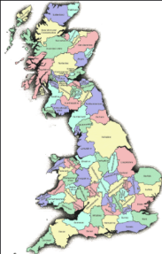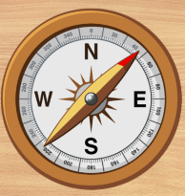**UK Counties**

Your home learning is due in Monday 11th June 2022.

Can you write a poem about where you live?

Describe the area where you live with photos to go along with it.

What interesting facts can you find out about Buckinghamshire, Milton Keynes, Great Linford?

What other places have you visited in the UK? Can you find out what county it is in?

Can you find out about keys on maps?

Can you create a key for a map of your own?

What symbols are used on maps?

Can you make a symbols guide for maps?

Can you draw a map?

Can you plot things on a map?

Could you make a treasure map showing grid references and buried treasure?

Could you make a map of the school?

Can you create a map to go to your favourite place?

Our home learning is all about our local area.

Where do we live in the country? Can you show where we live in the UK in different ways? Do we live in the north or south?

Do we live in a particular county? Where in the county are we near to? What counties are around us?