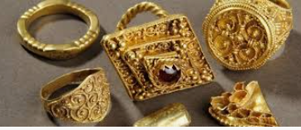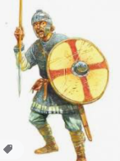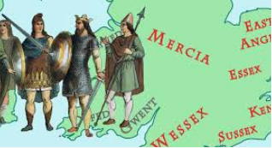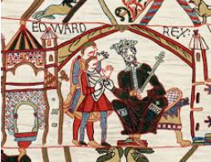

Choose one or more of the suggestions below. In class, we will share all our entries. All winning entries will be shared in our Home Learning Celebration. Home learning due in Monday 6th December 2021.

Autumn 2 – Anglo Saxons

Home Learning – Year 4

Cooking

* Cook a Saxon feast; they ate roast meats with bread and fruit and shared stories, poems and songs with their family in feasting halls.

Drama & Storytelling

* Many Saxons could not read or write so they would share stories and poems (sometimes accompanied by music on a lyre) to each other around a fire. Why not record your own story to tell or create your own story to tell in class!
* The Anglo-Saxons liked to tell each other riddles. For example: “I appear on the ground like a blanket and melt in the midday sun. What am I?” *Answer: Snow!*

Have a go at creating some of your own riddles to share.

Music

* Create your own Saxon style drum and have a go at composing different rhythms with it.
* The Saxons liked to play tunes on pipes and reeds. Can you create your own set of pipes using straws or see if you can play a tune on a reed and record it?
* Have a go at creating your own Lyre using elastic bands and an empty tissue box.

STEM

(Science Technology Engineering Mathematics)

The Anglo-Saxon Period was a time when

* Create an Anglo-Saxon style hut as a model or even have a go at creating a life size version in a wooded area. Anglo – Saxon houses were very basic; made from wood with a straw roof.
* Make a Saxon long rowing boat and see if you can make it float across water. These boats did not have sails.
* The Anglo Saxons are famous for their brightly patterned shields and metal helmets. They also used metal to create weapons such as spears and swords. Why not have a go at creating some of these items using cardboard at home?

Arts

* Create your own Anglo-Saxon style brooch and jewellery. They used precious gemstones such as amber and amethysts and included intricate metalwork.
* Have a go at some weaving with some thread, fabric or cardboard. Create a cardboard loom to help you.
* Saxon children enjoyed playing with simple toys such as rag dolls and spinning tops. They also played with carved wooden toys as well as games with counters and dice. Have a go at creating your own Saxon game or toy!