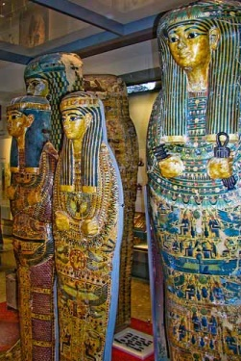
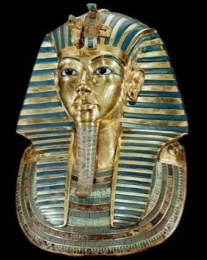
Year 3 Learning Challenge Spring 2

Poem: Ode to Egyptian Pyramids by Nichole Kaci McKnight
Art Work: Egyptian Sarcophagus art
Person: Pharaoh Cleopatra
Music: The Nile River - Brandon Fiecther (link)

 | Poem | Art Work | Person | Music
Beginning | Learn it off by heart | Find out 10 facts/different kinds of ancient Egyptian sarcophagus art | Draw a portrait of the person | Listen to the piece of music and say what you like about it.
 | Find another poem by the same poet | Discuss how it is different to other styles of art you have encountered | Produce a timeline of their life | Identify the instruments.
Secure | Create a performance as part of a pair/group | Draw a picture in a similar style | Produce a poster to advertise their achievements | Research the setting- why is it called Land of the Pharaohs?
 | Write a short biography about the poet | Transform the medium of the sarcophagus art: use collage instead of painting | Write a letter asking them about their life | Attempt to recreate the piece of music
Greater Depth | Write your own poem inspired by the topic | Use the image as a stimulus for a piece of descriptive writing. | Explain how the world would be without this person | A mind map of different emotions you feel at various points in the piece
 | Compare and contrast two poems by the poet | Describe the sarcophagus art: what it represents, how it makes you feel, what it is based on. | Give five reasons for and against why they should be in ‘The Hall of Fame.’ | Produce a piece of art/collage based on how the music makes you feel.

Ode to Egyptian Pyramids by Nicole Kaci McKnight
Oh great pyramid that seems to be reaching straight up into the sky.
The ancient Egyptians long ago constructed and built you upon high.
The mysteries of those who composed you still astounds me.
A pyramid is a wonderful relic of the past, many of us do agree.
We know the Egyptians believed that the soul transcended death.
The view of the Nile and an ancient pyramid can catch one’s breath.
We're curious about pyramids to see what’s hidden down deep inside.
A pyramid can hold the secrets of death and all those who have died.
The secrets of a ancient pyramid are revealed from deep inside this mysterious structure.
All mankind can learn from the ancient Egyptians about a pyramids great infrastructure.
Egyptian pyramids are considered to be one of the Eighth Wonders of the world.
The secrets of pyramids can make their wonder always mysterious and unfurled.
Nichole Kaci McKnight

