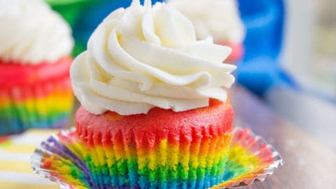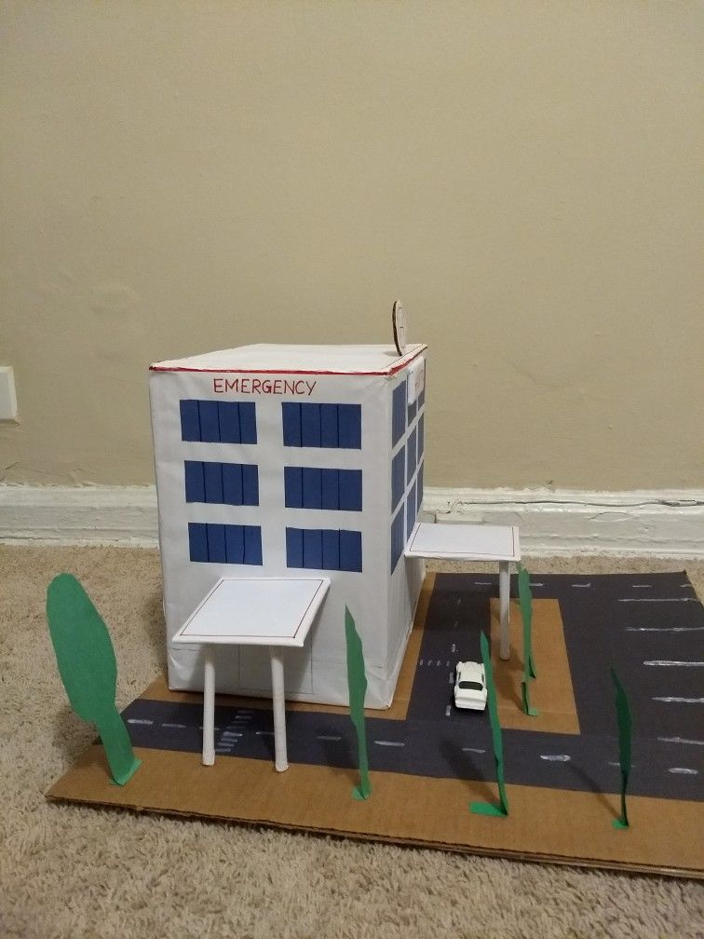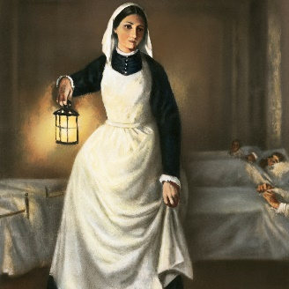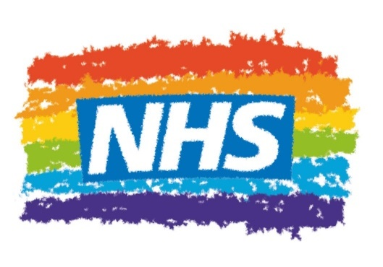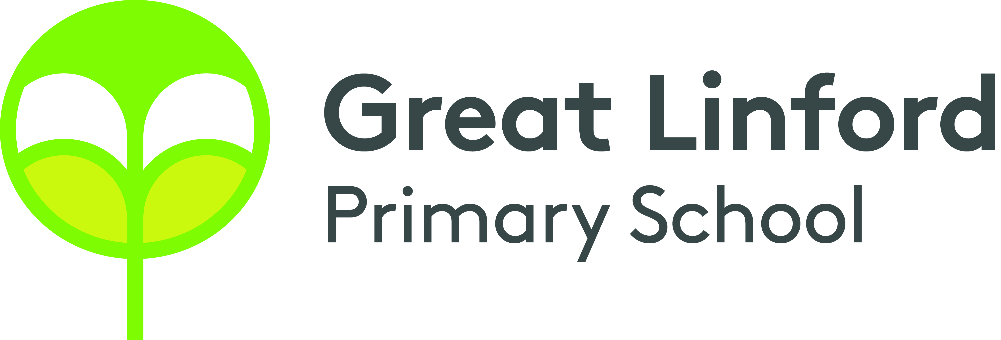

Music

* Can you write your own song for the NHS? What song lyrics would you include? You can try adding music to your song and have a go at performing.
* Try and create your own NHS inspired music on your own musical instrument. You could make your own musical instrument to use! Why not use junk modelling?
* Hand washing is extremely important. Can you create a quick song that can help others to remember how to wash their hands? You could make a video to go with your song. Check out this one below. <https://www.youtube.com/watch?v=S9VjeIWLnEg&ab_channel=NHS>

STEM

(Science Technology Engineering Mathematics)

* Rainbows have become a way that we have thanked NHS heroes at this time. Try creating these delicious rainbow cookies or rainbow cakes! <https://www.bbcgoodfood.com/recipes/rainbow-cookies> <https://realfood.tesco.com/recipes/rainbow-cupcakes.html#method>
* Can you design a new nurse’s uniform? Have a look at past and present uniforms as inspiration.
* Can you compare what it was like to be a nurse in the Crimean war to now? Try designing and building a model to help show the differences.

Choose one or many of the suggestions below. In class, we will share all our entries. All winning entries will be shared in our Home Learning Celebration.

Arts

* Doctors and Nurses help everyone around them. Can you create a drama showing how they help people in our community? You could film your drama or even write a script.
* Florence Nightingale and Mary Seacole were important figures in nursing. Can you create a portrait of them using materials you have at home? Be as creative as you can!
* Being kind and caring are important qualities of doctors and nurses. Create a dance inspired by helping and caring for those around you. What moves can you create using your arms, legs or whole body? Try putting your movements to music.

Autumn 2 – Our Heroes

Home Learning – Year 2