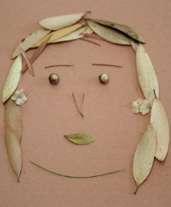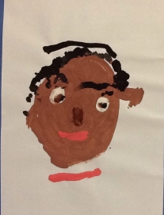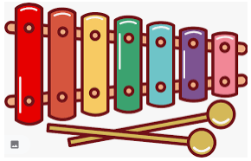

Arts

* Create a self-portrait using different materials.
* Draw a picture of your family. Have a go at using different types of medium, such as: paints, collage, pencils, pens, pastels and many more.
* Have a go at creating a family tree to include your grandparents, parents and any siblings. Can you draw a picture of each of them?

STEM

(Science Technology Engineering Mathematics)

* Have a go at baking your own gingerbread men. Carefully weigh out the different ingredients. Can you make them look like your family members?
* Can you design and build a model of your own home. What materials would be best? Think about how to make your home.
* Can you record yourself talking about your favourite thing to do or play with? Can you draw a picture to support this?

Autumn 1 – Knowing me, knowing you

Choose one or many of the suggestions below. In class, we will share all our entries. All winning entries will be shared in our Home Learning Celebration.

Music

* Learn the song “Head, shoulders, knees and toes” with actions.
* Try to learn the tune to “Head, shoulders, knees and toes” on a musical instrument. You could make your own musical instrument to use! Why not use junk modelling?
* Can you make up your own version of “Head, shoulders, knees and toes?” You could perform your song to your family and friends.

Home Learning – EYFS