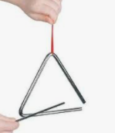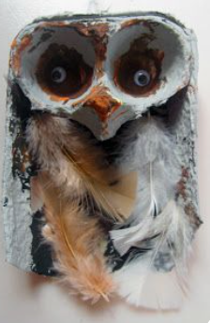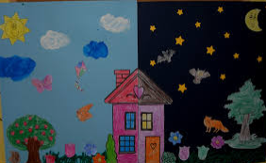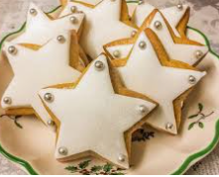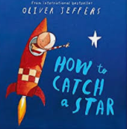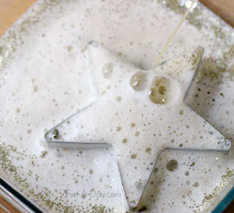

Arts

* Create a model of an Owl. Can you use a range of different materials?
* Paint a picture of your home in the day and at night. What are the main differences?
* Research another nocturnal animal and create a model/drawing of it. Why not use junk modelling?

STEM

(Science Technology Engineering Mathematics)

* Design a device that you would use to catch a star.
* Can you make your own space star biscuits?
* Can you build your own starry sky? Can you make the stars glow or fizz?

Autumn 2 – Night and Day

Choose one or many of the suggestions below. In class, we will share all our entries. All winning entries will be shared in our Home Learning Celebration.

Music

* Learn the rhyme “Twinkle Twinkle Little Star” and perform it with actions.
* Try to learn the tune to “Twinkle Twinkle Little star” on a musical instrument. Have a go at making your own triangle instrument.
* Can you make up your own version of “Twinkle Twinkle Little Star?” You could perform your song to your family and friends.

Home Learning – EYFS