Year 5 Learning Challenge

Poem: Hurricane Michael by Kim Merryman
Art Work: The great wave off kanagawa
Person: Katia Krafft

Music: Vivaldi Storm

 | Poem | Art Work | Person | Music
Beginning | Learn it off by heart | Find out 10 facts about the painting/artist | Draw a portrait of the person | Listen to the piece of music and say what you like about it.
 | Find another poem by the poet | Produce a collage of other paintings by the artist | Produce a timeline of their life | Identify the instruments.
Secure | Create a performance as part of a pair/group | Draw a picture in similar style | Produce a poster to advertise their achievements | Research the life of the musician(s).
 | Write a short biography about the poet | Transform the medium of the painting: use collage instead of painting | Write a letter asking them about their life | Attempt to recreate the piece of music
Greater Depth | Write your own poem inspired by the topic | Use the image as a stimulus for a piece of descriptive writing. | Explain how the world would be without this person | A mind map of different emotions you feel at various points in the piece
 | Compare and contrast two poems by the poet | Describe the painting: what it represents, how it makes you feel, what it is based on. | Give five reasons for and against why they should be in ‘The Hall of Fame.’ | Produce a piece of art/collage based on how the music makes you feel.

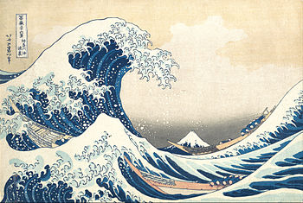
Hurricane Michael
Hunker down folks, this storm is a big one,
Urgent warnings of danger prevail.
Rushing to gather all supplies needed,
Race against time to prepare for the worst.
It's getting stronger, moving closer....
Continuous rain falls, flooding streets,
Angry winds roar and destroy.
No one is safe in the path of this beast.
Evacuate if you can.

Michael came calling one October day. The great wave off kanagawa
Intense and aggressive he pounded the coast,
Chaos and devastation he left in his wake.
Homes were turned into piles of debris,
A heart-breaking sight for all to see.
Epic destruction for miles around,
Losses so staggering, yet faith abounds.

