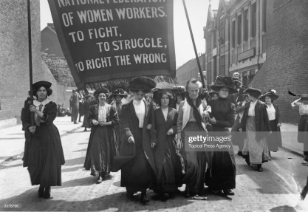 **Year 3 Learning Challenge- Summer 2**

Poem:   She walketh veiled and sleeping -

Art Work: Newspaper cartoons depicting women in a negative light.

Place: Houses of parliament, National Gallery London

Music: Songs of the suffragettes by Elizabeth Knight

|  |  |  |  |  |
| --- | --- | --- | --- | --- |
|  | **Poem** | **Art Work** | **Place** | **Music** |
| **Beginning** | Learn it off by heart | Find out 10 facts about why the newspapers drew cartoons which made women look weak. | Draw a picture of the Houses of parliament | Listen to the piece of music and say what you like about it. |
| Find another poem by the same poet. | Discuss how it is different to other styles of art you have encountered. | Write down 10 facts about the Houses of parliament | Identify the instruments. |
| **Secure** | Create a performance as part of a pair/group. | Draw a picture in a similar style. | Produce a poster to persuade people to visit the Maiden Castle. | A mind map of different emotions you feel at various points in the piece. |
| Write a short biography about the poet. | Create a suffragettes poster | Write a letter on what you would like to know about the Houses of parliament and how it played a part in the suffrage movement. | Attempt to recreate the piece of music |
| **Greater Depth** | Write your own poem inspired by the topic | Create a poster fighting for something in the style of a suffragettes poster | Explain on why the National art gallery is significant. | Write a story on what this music can be telling. |
| Compare and contrast two poems by the poet | Create a comic showing a significant event in the suffrage movement. | Give five reasons for and against why you should visit the National art gallery. | Produce a piece of art/collage based on how the music makes you feel. |