

Music

* During the war people listened to lots of upbeat music to cheer themselves up. Can you create your own up-beat tunes?
* We’ll meet again by Vera Lynn was a famous tune during the Blitz. Can you listen to the song and come up with a dance for this music?
* Can you research the life of Vera Lynn and create a poster about her life?
* Create a mind map of the different emotions felt during the Vera Lynn song.

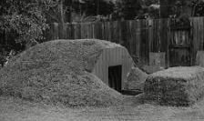

STEM

(Science Technology Engineering Mathematics)

* During the war people had to grow a lot of their own vegetables due to a lack of food. Can you have a go at growing some of your own vegetables?
* Can you design and build a model Anderson shelter and create a WW2 garden model for it to sit in? Don’t forget to take pictures!
* Can you design and make your own 3D poster about rationing? Have a look online at some of the famous propaganda posters which were used throughout The Blitz to lift morale.

Choose one or many of the suggestions below. In class, we will share all our entries. All winning entries will be shared in our Home Learning Celebration.

Arts

* Dig for Victory (Poster Art). Can you create a propaganda poster based on WW2?
* During the war people had to make their own clothes because of a lack of money and materials. Can you have a go at making some of your own clothes?
* Can you create a collage of the Dig for Victory poster used in WW2?
* Can you describe how art is used for propaganda today and create your own propaganda about current affairs. 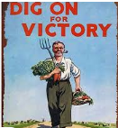

Autumn 1 – The Blitz

Home Learning – Year 6