Our Book this term is Greek Myths Retold and illustrated by Marcia Williams.

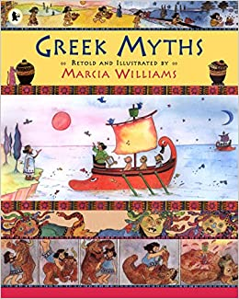

We will be using the myths within this book during our reading lessons and during our writing lesson we will be focusing on Theseus and the Minotaur.
All of the myths within this book have been illustrated and turned into comic strips which are extremely engaging for the children.

