Year 6 Knowledge Organiser | Automata Toys |  | Focus: Mechanical Systems
Key Vocabulary |  | Automata parts
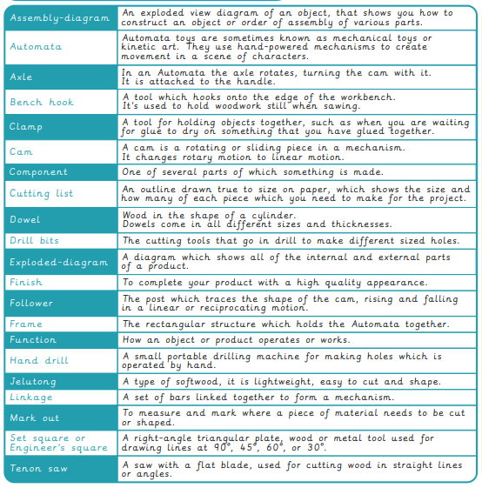 |  |  | 