Year 1 |  | Fruits and Vegetables | Focus: Food Technology
Key Vocabulary |  |  | Key facts
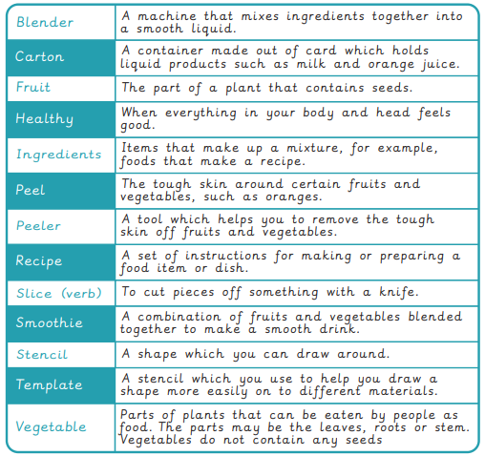 |  |  | 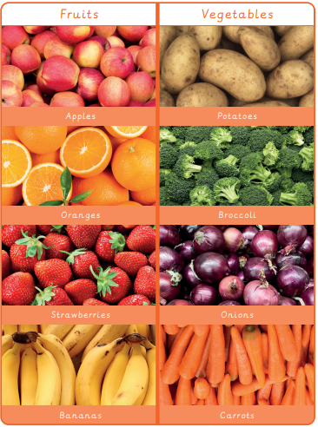
Key knowledge
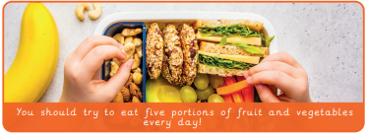 | How to make a smoothie  - Cut your fruit and vegetables  - Add them to the blender with your favourite milk or juice.  - Blend until smooth

