Year 1 Knowledge Organiser |  | Why do Christians give gifts at Christmas? | Focus: RE
Key Vocabulary |  | The birth of Jesus | Gifts given to Jesus
Christianity | A religion practiced by Christians | 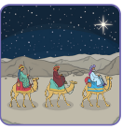  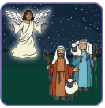  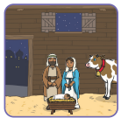  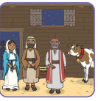  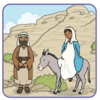  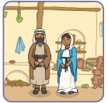  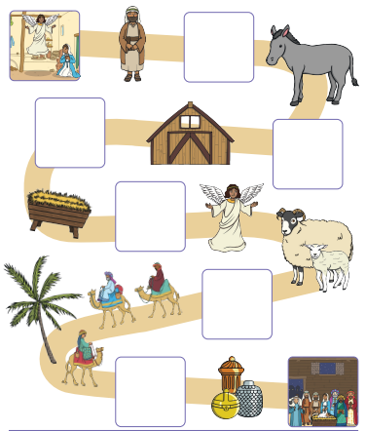 | 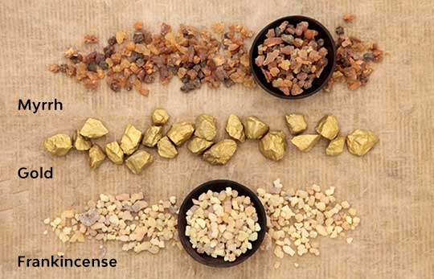  Gold says that Jesus is born to be King. Frankincense says that he is to be a kind of priest. Myrrh says he will one day die on a cross.
Presents | A gift bought or made
Giving | Handing something to another person
Receiving | Accepting something from another person.
Frankincense | A fragrant resin (from trees) that can be burned.
Myrrh | A brown gum collected from trees that is used in perfume.
How does gift giving and receiving make us feel? |  |  | What did Christians believe Jesus brought to the world?
 |  |  | 