Year 3 Knowledge Organiser | Castles | Focus: Structures
Key Vocabulary |  | Key Skills
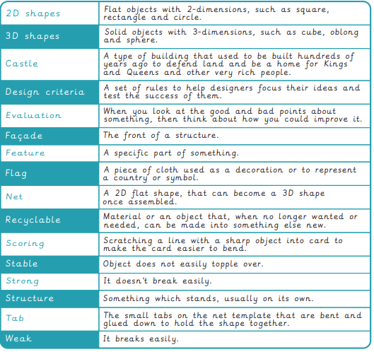 |  | 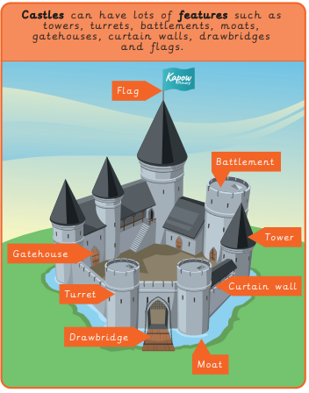
Key Facts
