19 OCTOBER 2018
ASPIRE – ACHIEVE – THRIVE – ENJOY
Foundation- Patterns and colour  Foundation class started to learn the story of Elmer the patchwork elephant. They read all about how he is different to other elephants as he is all the colours of the rainbow rather than normal elephant colour.  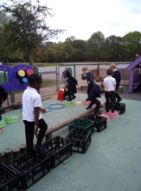  The children had fun making their own patchwork elephants as well as working together to paint a huge jungle. They were also busy creating animals (such as elephants, tigers and cheetahs) from playdough.  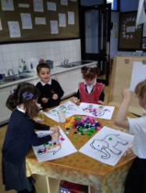  Outside the children were creating a path through the jungle and building aeroplanes to fly to the jungle which is very far away. |  | Year 1 – Botany  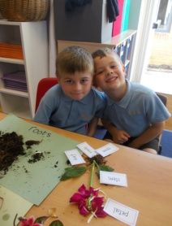  In Year 1 it appears we have a new generation of botanists. The children got stuck in to digging out plants and ripping them apart - all in the name of science.  The children were tasked with taking their plants and flowers apart and placing the different parts of the flower in their relevant category. The children then had the challenge of creating and assembling their own plant using a combination of lots of different plants and then labelling them.  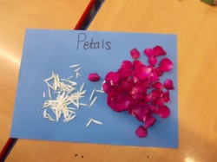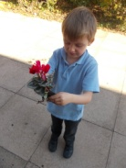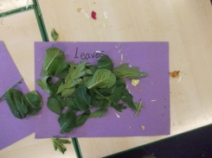
Year 3 Kitemaking  Year 3 had an exciting few days where they designed and made a kite with symmetrical features. They had the opportunity to work with skilled kite makers in order to perfect their skills! They loved it!  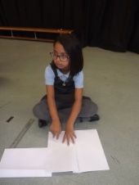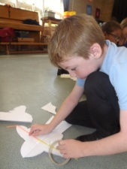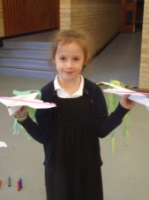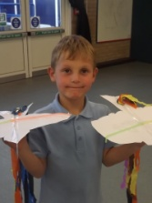 |  | Silence is Golden  In Year 4 we have been learning about sound. We've been learning about how sound travels and carrying out experiments by measuring the decibel levels of different areas of the school using a sound level meter. We tested a range of different materials to see which insulated sound the best.  We used our results to design and make our own ear defenders! In our next science lesson, we will be evaluating our ear defenders and considering how they could have been improved, but we all agree that they are certainly stylish!  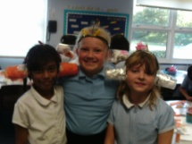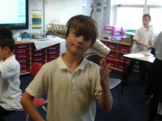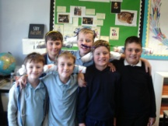
The Dogs Trust
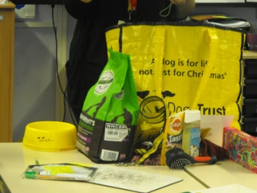
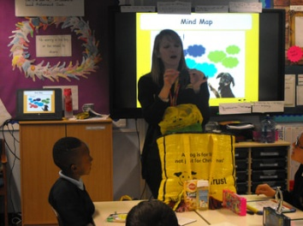
We had a visit from The Dogs Trust this week. We were shown some information about what the organisation does and we did a mind map of all the things we thought a dog needs. It turns out there is a lot to consider before getting a dog which we hadn’t even thought about. We learnt that dogs need to be microchipped, have vaccinations and must, by law, have collars on that have specific details linked to both the dog and owner. Gemma from the Dogs Trust taught us the correct manner in which to stroke a dog and other general safety rules around animals. It was a very informative day.
An Autumn Walk
Owls and Hedgehogs went on a walk to Gt Linford Manor to look for signs of Autumn. Looking at the different colours of the leaves in the trees was really interesting and we discussed that some trees will lose their leaves and some are evergreen. We gathered lots of autumn objects, such as conkers, twigs and leaves. We also had great fun seeing how many people it took to form a circle round the different sized trees. Owls and Hedgehogs had a really great time and upheld the values of Great Linford Primary beautifully.
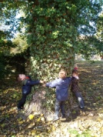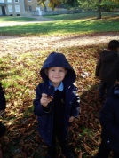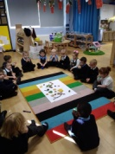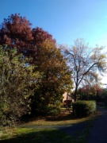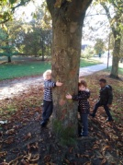

Harmonies for Harmony
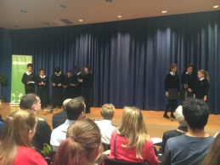
A group of Year 6 children composed their own song for Milton Keynes Citizens Against Hate Crime. At the event were other schools performing their songs, as well as the local police, Network Rail Services, MK Dons and the Mayor. They all made pledges to take action against Hate Crime in Milton Keynes. The children have been invited by the police to sing at an award ceremony and also by the MK Dons to take part in the Hate Crime Parade in May. ​Well Done!
Useful Information/Reminders for Families  School opening time  School gates and classroom doors open at 8.30am and close again at 8.50am when the register will be taken.  KS2 children should go straight to their classrooms  KS1 children should be accompanied by parents/carers to their classrooms.  EYFS children should be accompanied by parents/carers to the Foundation playground gates.  Any children arriving after the school doors are closed at 8.50am will have to come in via the School Office so that they can be signed in.  School Lunches  Our school lunch providers are Dolce. Lunches are booked and paid for directly through their Live Kitchen website. If you are not already logged on, please ask the Office to resend you your user details.  All KS1 children receive Universal School Meals. Even if your child receives Free School Meals, you must log on to Live Kitchen to select their meal.  Lost Property  Please label all of your children’s clothes in order that they can be returned if lost. Unlabelled items are put in the Lost Property boxes which are situated by the School Office main entrance.  School Office  The School Office is manned from 8.30am. However as the beginning and end of the school day is normally very busy, there are a few ways to avoid having to queue at the window:  - An assortment of forms and information sheets (holiday request, term dates, etc) are available to pick up from the holders on the wall opposite the School Office  - There is also a red post box on that wall for posting any reply slips, forms, notes, etc, which is checked daily  - If you have any general queries or need to leave a message for teachers/staff, Carol Mallett (our Family Champion) is on the playground by the main gate every morning and afternoon.  Collecting Children  Please ensure you advise School of the names of any relatives/friends who are going to regularly collect your child. If anyone else is collecting your child, please ensure the School Office is informed as early as possible and try to avoid ringing at 3pm. |  | Upcoming Events:  22nd Oct - No After School Clubs this week  22nd Oct - KS2 Open Morning for Literacy  (9.00 - 10.30am)  22nd Oct - Year 5 Residential meeting  (3.30pm)  22nd Oct - Year 6 Residential meeting  (3.30pm & 5.00pm)  23rd Oct - British Athlete visit  Inspiring Assembly (9am) and day  Children will have brought home sponsorship forms  24th Oct - Home Learning Assembly (9.00am)  24th Oct - EYFS Stay & Play (2.00 – 3.00pm)  24th Oct - EYFS Sept 2019 Cohort – Open Evening  (Pumpkins, Playing, Pizza and Performance 5 – 6pm)  25th Oct - EYFS Sept 2019 Cohort - Open Morning  (Pumpkins, Playing and Performance 9.00 – 10.00am)  25th Oct - Years 1 & 2 - Archery and Fencing  25th Oct - Spooky Disco! £1.50 at the door  (EYFS, Yrs 1 & 2 : 3.45 – 4.45pm)  (Years 3, 4, 5 & 6 : 5.00 – 6.15pm)  25th Oct - Last day of Autumn 1 Term  26th Oct - Inset Day  5th Nov - School re-opens for Autumn 2 Term  5th Nov - No After School Clubs this week  5th Nov - EYFS Owl visit and talk in the morning  (£3 payable on Gateway)  5th Nov - EYFS to Year 5 Flu Immunisation Nasal Spray  (Only children with returned consent forms)  8th Nov - EYFS Sept 2019 Cohort - Open Morning  ( 9.00 – 10.00am)  12th Nov - After School Clubs restart  Please ensure you have applied on School  Gateway for this terms clubs  Attendance  Whole school attendance so far is 96.2%  For week ending 19th October attendance was 97.5%  The class with the highest attendance last week was Lime Class (Miss Scott) with 100%!

