March 2019
ASPIRE – ACHIEVE – THRIVE – ENJOY

WORLD BOOK WEEK
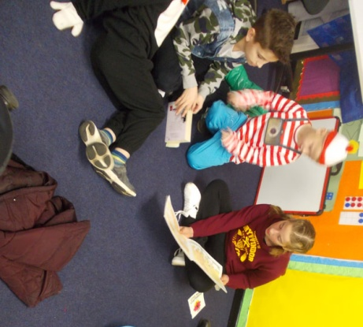
Recently at GLPS, we were celebrating books and thinking about how important it is to love reading. All week we completed activities to mark the occasion, such as drop everything and read, designing book tokens and paired reading. All the children enjoyed each activity and we were reminded how important it is to read for pleasure to take care of our bodies and minds.
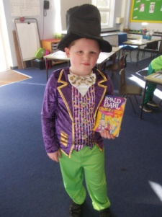
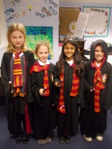
On World Book Day itself, all the children were given the chance to come in dressed as their favourite book characters and we had some incredible costumes ranging from Charlie from Charlie and the Chocolate Factory to Little Red Riding Hood and lots of characters from Harry Potter! We are already looking forward to next year to see which characters arrive for World Book Day.

Science Week  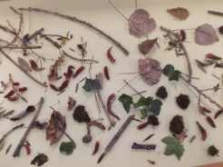  As part of Science Week, Year 1 embarked upon a nature walk around the school grounds. They collected a variety of natural objects and made a nature table. Then, in small groups, they made nature sticks using wool to represent the sky and sun and cotton wool for clouds. They then added some of the natural objects they had found. |  |  |  | Year 4 Investigates  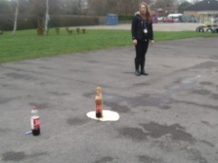  Year 4 have been investigating solids, liquids and gases this week. They spent an exciting afternoon discovering what happens when things are heated, cooled or introduced to different materials and surfaces. They were not expecting the violent reaction of adding mints to a bottle of cola! It was a messy but fun afternoon.
EYFS  The EYFS outdoor area has begun its makeover. Whilst the process has caused a little disturbance to our day to day routine, the children have loved seeing the area begin to change. We are excited to see the final result which should include not only a large astroturf area but also one consistent flooring for the children to play and learn on. We thank our parents for their patience during this time and their support with dropping off and collecting their children from the hall. We are sure it will definitely be worth it.  _____________________________________________  Healthy Me!  This half term our whole school Jigsaw focus is Healthy Me! The children will be learning about different ways that they can keep themselves healthy and fit. The unit focuses not only on physical health but gives the children opportunities to learn about how they can keep themselves mentally healthy too. We will be continuing our practice of mindfulness in class and our connect us games to help us all be closer together. |  |  |  | Egg-citing Easter Competition  We are very egg-cited to invite our families to enter our Egg-cellent egg decorating competition. There will be a first prize and runner up prize for each year group. Reverend Chucks will judge and the eggs will be on display in St Andrews Church. We will also have an eggs-hibition at school on the day they are brought in.  To enter:  - decorate one egg (this can stand alone or be placed within a scene)  - Create a label to stand by your egg (which must include name, year group and name of your creation)  Entries should be brought in to school of Thursday 4th April. Winner will be announced in the Home Learning Assembly on Friday 5th April.  Each year group has a different theme to match a project or a book they have been learning about, as follows:  EYFS Once Upon a Time  Yr1 Beatrix Potter  Yr2 Gardens/Flowers/Spring  Yr3 Charlotte’s Webb  Yr4 The Romans  Yr5 Oliver  Yr6 Galapagos Island creatures
 | Online Safety  DITTO is an online safety (e-safety) magazine for schools, organisations and parents to keep you up to date with risks, issues, advice and guidance related to keeping children safe online, with a view to enjoying and learning about technology. A new edition is released approx. Every 6 weeks. This month’s edition focuses on viral challenges, parental advice from children, miscommunication, YouTube comments and popular apps. To download your copy, visit https://www.esafety-adviser.com/latest-newsletter/. |  |  |  | Upcoming Events  11th Mar After School Activity Clubs start  13th Mar Yr 3 Caldecotte Parent Information Evening  (5.30pm)  21st Mar School Choir – Voice in a Million at Wembley  25th Mar KS1 SATS Parents Information meetings  (8.30am and 3.30pm)  1st April Rocksteady – Performance to families  (2.30pm)  2nd April Year 2 (Larch class) Hazard Alley trip  3rd April Year 2 (Beech class) Hazard Alley trip  3rd April Year 6 Easter Cracked at St Andrews Church  5th April Last day of term  23rd April Summer 1 Term begins
 | Student Achievement  Ella from Year 3 (Oak Class) recently attended the 'Milton Keynes Festival of the Arts for Dance, Music and Drama' which was held at Walton High. This was her first year attending the Festival and in the 'Set Piece Beginners' category, she won the gold medal on the Grand Piano. Congratulations to Ella on a fantastic achievement. |  |  |  | 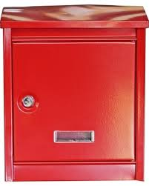  Hate Queueing?  Why wait in a queue just to hand in a reply slip or letter? Pop it in our red postbox, located opposite the office window, which is checked daily. You could also use it to post any comments or suggestions you may have.
 | Child Absence  If your child is absent or unwell, you must contact School before 9.15am by sending a message through School Gateway or by telephoning the School Office.  In cases of vomiting or diarrohea, your child should not return until 48 hours from the last episode. |  |  |  | Attendance  For the week ending 15th March attendance was 95.7%  Whole school attendance so far is 95.8%  The class with the highest attendance last week was Mr Jenkins’ Yew Class (Year 6) with 99.6%
 | Young Dancer of the Year  This year, Milton Keynes Gallery has been running a Young Dancer of the Year 2019 competition. A small group of Year 4, Year 5 and Year 6 children have been working very hard with Miss Scoggins and Miss Funnell to produce an amazing dance around the theme of 'Transformation'. The children have been extremely dedicated, working after school and during their lunchtimes to get their entry in to be judged. We wish them the best of luck as they eagerly await news of whether they are being shortlisted! |  |  |  | Parents Evening  We would like to extend a big thank you to all our families who came to the recent Parents Evenings and to our Governors for their support. The completed Parent Voice surveys showed an overwhelmingly positive response for all questions. The results are available to view on the school website (https://www.greatlinfordprimaryschool.co.uk/parent-voice.html). GLPS greatly value your opinions and they will be used by us to further improve as a school. We will be following up any queries or concerns raised over the next half term.

