NOVEMBER 2018
ASPIRE – ACHIEVE – THRIVE – ENJOY
Remembrance Assembly and Poppy Art
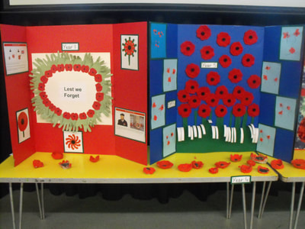
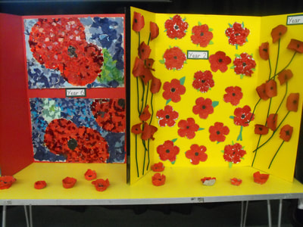
To commemorate Remembrance Day 2018, every year group produced wonderful artwork inspired by the Poppy Appeal. EYFS used finger painting to create their poppies. Year 1 created a beautiful poppy wreath made from their hands. Year 2 used tissue paper and green card. Year 3 created lifelike poppies from paper and pipe cleaners. Year 4 used their pottery skills. Year 5 put their sewing skills to the test by making poppies from felt. Year 6 used collage techniques to create stunning big poppies. The artwork looked fantastic and complemented a lovely assembly where the children heard about the importance of the First World War and that this year is a special commemoration of 100 years since the end of the war.

Foundation - Shapes  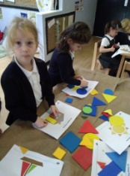  Owls and Hedgehogs started to learn all about 2d shapes. We learnt the names and properties of circles, squares, rectangles and triangles. We had lots of exciting shape activities that the children could choose from during discovery choices. We made owls using 2d shapes, created pictures of houses and rockets, as well as going on a shape hunt in the garden. The children also enjoyed directing the beebots to the correct shape in the technology area.  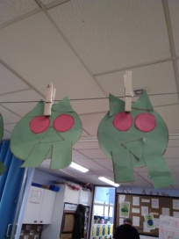  What shapes will you be able to spot whilst you are out and about with your children? |  |  |  | GLPS Gallery  Check out the improved GLPS Gallery to see a selection of amazing artwork over the past few weeks. Situated along the main corridor, the gallery will showcase our art highlights and is where you can see what other year groups are doing. Check regularly to see if your work appears there.  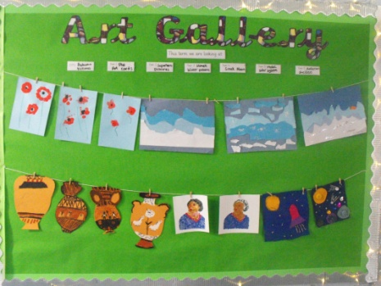
Year 2 Superhero Day  Year 2 had an Ignite Superhero Day and did a variety of activities to kickstart their new project. Highlights of the day included creating dances in groups to accompany Superhero music and making their own Superhero passport detailing their superpowers.  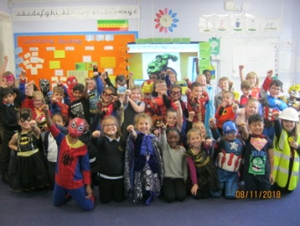 |  |  |  | Year 5’s sewing is out of this world  Year 5 have worked very hard creating their space inspired patches. They learnt three different stitches (zigzag, cross stitch and running stitch) and used a variety of materials to create planets, stars, rockets and even astronauts. A selection will be displayed in our school gallery in the main corridor.  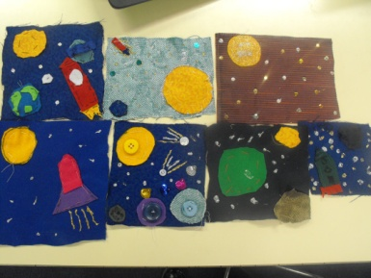
Emergency Closure Information  Christmas Fair  Friday 14th December  3.30 – 6pm    It is extremely rare but there can be emergency situations when it becomes necessary to close the school; for example: flooding, gas leak, heavy snow, no heating in winter, etc.  There are certain factors to consider in such circumstances. For example, whether:  - there are enough members of staff to ensure appropriate, safe ratios;  - the school can provide lunch for the children;  - the school grounds are sufficiently safe for children, parents and staff;  - the school has sufficient heating;  - the school has electricity and water across the site;  - the car park is safe to use;  - external agencies (police, local government, motoring organisations, etc) are advising against school travel in our region.  If, for the reasons outlined above, the safest or most practical judgment is to close the school, a ‘Closure Day’ will be declared via Milton Keynes Council’s website (https://www.milton –keynes.gov.uk/closures) as soon as possible and normally by 7am on the day. You can subscribe to free text message and email alerts via the Milton Keynes Council’s website at https://www.milton-keynes.gov.uk/closures/subscribe. You will also be notified via the School Gateway.  If the school remains open, please be aware that there may be some disruption to the normal school activities due to staffing levels. Breakfast and After School Clubs may well be cancelled.  When the school is open, we will remain open until the end of the normal school day (3.15pm) unless heavy snowfall, etc occurs during the course of the day. All parents are expected to have emergency plans in place so that children are not left in school for prolonged periods of time in the event of a school closure during the day.  Please may I take this opportunity to stress to you that the school will close only on the rarest of occasions, with the safety of your children always at the forefront of any decision made.  Tara Lovelock (Head Teacher)  Christmas Shopping Childminding Service  On Friday 30th November, we are offering families the opportunity to have some child-free time to shop for Christmas without little prying eyes. Children can stay at school to watch films and have fun, from 3.15 – 7pm for £5. Your £5 will go towards the purchase of new musical instruments for our school. Please book on School Gateway. |  |  | Upcoming Events:  21st Nov - Yrs 3 & 4 Basketball Festival  (3.45 – 5pm at Kents Hill Park School MK7 6BZ)  30th Nov - Christmas Shopping Childminding Service (3.15pm-7.00pm £5 charge)  3rd Dec - Rock Steady performance (2.30pm)  7th Dec - Non-Uniform Day  10th Dec - Home Learning Projects due in  11th Dec - Years 4, 5 & 6 trip to Stantonbury Theatre (pm) to see Little Red Riding Hood Versus the Wolf. (£7.50 – book via School Gateway)  12th Dec - EYFS, Years 1, 2 & 3 trip to Stantonbury Theatre (am) to see Little Red Riding Hood Versus the Wolf. (£7.50 – book via School Gateway)  13th Dec - Years 1 and 2 Nativity Play performance (2.30pm and 6pm)  7th December will be a non-uniform day. In return, we ask that children bring an item/gift in to school to donate as tombola prizes for the Christmas Fair. If any parents/carers have employer’s who could donate any raffle prizes, these would be gratefully received.  Application forms for stalls (£5) are available from Carol (Office) or Shirley (PTA).  Attendance  Whole school attendance so far is 96.4%  For week ending 17th November attendance was 97.4%  The class with the highest attendance last week was ASH Class (Mr Rowlands) with 99.6%!  Online Safety  Musical.ly has a new name - TikTok  The social network app Musical.ly has sometimes given adults cause for concern because of the way children create and share their own short videos. The app has a new name and features including live streaming. Although the app has an age limit of 13 years old, younger children are using it and the content may not be suitable. Visit the safer internet website for more information.

