September 2019
ASPIRE – ACHIEVE – THRIVE – ENJOY

EYFS  EYFS have now welcomed all of their new children, after their staggered start. All of the staff have been so impressed with how quickly they have settled in and are enjoying this period and getting to know all the children. They have already taken part in a taught PE session and experienced Forest School in their wellies! We look forward to learning lots of new things in the coming weeks. |  |  |  | Year 2- Great Fire of London  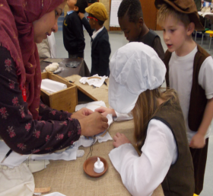  We recently hosted a Great Fire of London workshop for Year 2, where the children took part in a wide range of activities in our school hall, which was transformed into a London shopping street complete with an Apothecary, Bakers and even a well! The entire day was great fun and will help inspire the children in the classroom.
Year 3- Roald Dahl  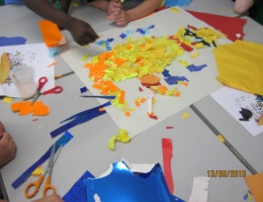  Roald Dahl day was celebrated by Year 3 last week. They read part of James and the Giant Peach and looked at the main characters of the story. They then made some huge pieces of collage art. The children explored different paper textures and colours and applied them to their shared art creations. |  |  |  | Year 3 – Virtual Volcanoes  This week, Year 3 entered the virtual world through VR headsets as part of their volcano topic. They were able to visit volcanoes around the world and find these exciting places on maps. It was great to be able to explore volcanoes up close and to see inside them to better understand how they work! They even took a trip through space to visit a volcano on Mars
Year 5 Virtual Space  Year 5 had a fantastic science lesson last week using a range of fruits to learn about the relative size of each planet.  They were also fortunate to take a Virtual Reality trip into space to explore the solar system, milky way and even black holes! |  |  |  | Our GLPS family has expanded!  Over the summer holidays there were three new additions to the GLPS family. Baby Amber was born to Mr and Mrs Jenkins, Baby Eliza Rose to Mrs Felce and Baby Louie to Mrs Eldridge. All the mums and babies are doing well and are happy. Congratulations and we all wish them well.
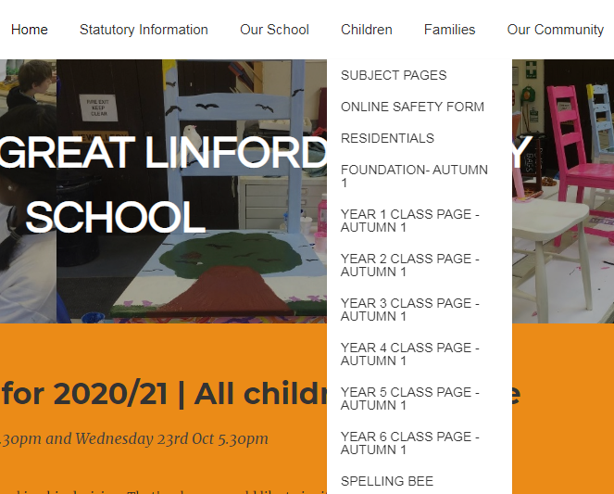Tips/Info for Parents
We have lots of useful year group information on our website. This includes information on what projects the children are learning about this term and suggested activities to support their learning.
You can also see key dates relevant to each year group, home learning challenges set and the latest news and photographs of your children.
To access this information, log into greatlinfordprimaryschool.co.uk. Navigate along the top to the Children tab and then click on the relevant year group.

 | Jessie & Friends – Online Safety Education for 4-7 year olds  Introducing the idea of a safer internet to younger children can be quite challenging. Jessie & Friends is a series of three animations from online safety specialists at the National Crime Agency’s CEOP Command.  The videos follow the adventures of Jessie, Tia and Mo as they begin to navigate the online world, watching videos, sharing pictures and playing games. A storybook accompanies each episode, to help adults keep the conversation going with the children. Find the resources at:  https://www.thinkuknow.co.uk/parents/Jessie-and-friends  Free School Meals.  Your child can receive Free School Meals if you receive certain benefits (e.g Income Support, income based Jobseeker Allowance, Child Tax Credit and income under £16,190, Universal Income and income less than £7,400). To apply takes only minutes, all you need is your National Insurance number and a decision is instant. If your child is eligible for Free School Meals, they will remain eligible until they leave GLPS regardless of whether your circumstances change or not and you may also be eligible for reduced after school clubs and school trips. Apply through the Office. |  |  |  | Upcoming Events  26 Sept Year 5 Badminton Festival at Ousedale  3.45- 5.30pm  27 Sept MacMillan Cake and Coffee Morning 9am  28 Sept MK Springers Year 4, 5 & 6 Challenge Day  28 Sept Yr6 Boys Football Trials (MK Dons)12-3pm  30 Sept Deadline for Yr6 Residential deposit  1 Oct EYFS & Yr6 Nurse screening visit  3 Oct EYFS Sept 30 Cohort Open Morning  9.45 – 10.45am  4 Oct Yrs 1, 2 & 3 MK Springers Challenge Day  7-9 Oct Yr6 Bikeability  8 Oct Yr6 SATS parent information meeting  3.30pm & 5.30pm  14-18 Oct Year 1 Balance Bikeability  14 Oct Parents’ Evening 3.30 – 6pm  14 Oct Home Learning Creations due in  16 Oct Parents’ Evening 3.40pm – 6.30pm  22 Oct Home Learning Assembly 9am  24 Oct School photo day (individual photos)  24 Oct Spooky Disco  EYFS, yrs 1 & 2 : 3.45pm – 4.45pm  Yrs 3, 4, 5 & 6 : 5pm – 6.15pm  25 Oct Last day of Autumn 1 term  4 Nov Autumn 2 term starts
 | Introduction to new staff  Hi, I’m Miss Thickbroom. I am the Owls’ class teacher in Foundation. I have taught in many year groups so far in my career and also abroad in Dubai. I am looking forward to getting to know the GLPS families. |  |  |  | Attendance  Whole school attendance so far is 97.2%  The class with the highest attendance last week was Cedar Class (Year 1 – Miss Scoggins/Miss Flynn) with 100%!  Every moment of your child’s education is important! Please help us to improve attendance by sending your children to school every day and making sure that they arrive on time.  If your child is sick or will be attending a medical appointment, please inform the School Office either by messaging on School Gateway or phoning (01908 605027). We would appreciate if dental and medical appointment could be made outside the school day.  Unless a parent informs us of the reason for any absence, that absence will be unauthorised.  If you are requesting time off for your child (for exceptional circumstances only), you must complete a Request for Leave form at least two weeks in advance.
Miss Lovelock’s new
Board Game Cafe
Starts this Saturday 28th Sept
From 2–4pm
Come and join us to learn lots of new games!

Cost per child is £3
Adults come free
Please book though Julie

