October 2019

ASPIRE – ACHIEVE – THRIVE – ENJOY

House Captains  Our new House Captains have been busy completing their first job since being elected into the post this week by meeting with Reverend Chucks from St Andrew’s Church. Following interviews with their respective heads of house, they are now to be seen around the school helping the younger children, setting up assemblies, and also helping at after school activities.  Check our website for updates. |  |  |  | Sports Captains  Welcome to GLPS’s new Sports Leaders.  The children pictured have been selected to help the school move forward with sports in GLPS by giving the children of the school a voice for how they would like to see sports evolve through the year.
Year1 - Bikeability  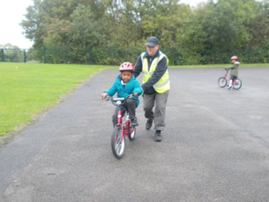  Year 1 have been learning to ride their bikes without stabilisers. After a wobbly start and a few nerves, the children, with the help of the amazing instructors from the Bikeability Team, managed to ride their bikes without stabilisers. All The children enjoyed their Bikeability experience and can’t wait to get out on their bikes again.  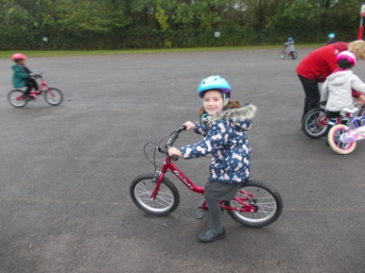  Year 6 also had a great time the previous week, with the Bikeability instructors helping to develop their riding skills, safety awareness and cycling confidence. |  |  |  | Christmas shopping childminding  On Fri 29th November, we are once again offering our popular Christmas Shopping Childminding Service to enable families to shop without little prying eyes or tired tantrums! For a small charge of £6, your children can stay at school from 3.30 through to 7pm to watch Christmassy films and have some festive fun and food.  Please book your child’s place on School Gateway.
Food Bank  Our annual Food Bank Appeal ended recently. We managed to collect five crates of food which will be donated to the Milton Keynes Food Bank to help local families and individuals in need. To mark the occasion, Reverend Chucks from St Andrew’s Church came to discuss harvest with our pupils and presented our newly elected House Captains with their badges. |  |  |  | Introducing new staff  Hi, I’m the new Mrs Humphris.  I am the Willow class teacher in year 4.  I have thoroughly enjoyed getting to know my class and their families this half term and am looking forward to getting to know the wider GLPS family.
 | Football  On Wednesday 9th October, GLPS competed in their first football fixture of the year against Bushfield. The team had a bit of a shaky start and were 1-0 down at half time. With some great play, team spirit and determination, they turned it around and won 4-2, with a great performance from Hayden who scored a hat-trick and was given Man of the Match. A great performance from all the players involved and we look forward to our next fixture. |  |  |  | Upcoming Events  24th Oct School photo day (individual photos)  24th Oct Spooky Disco  EYFS/KS1 : 3.45–4.45pm  KS2 : 5.00–6.15pm  25 Oct Last day of term  4th Nov Welcome back! School re-opens  4th Nov Owls visit (EYFS)  4th Nov Year 4 deadline to pay for Harry Potter trip  6th Nov School Nurse – parent appointments  (By prior booking only – contact Office)  8th Nov Year 6 trip to Duxford  14th Nov Year 4 Greek Day  15th Nov Children in Need Day  18th Nov EYFS & Yr1 Puzzle morning for parents  18th Nov Flu nasal spray (whole school)  25th Nov KS2 English opening morning for parents  (9-10am)  29th Nov Parent’s Christmas Shopping Evening  (3.30-7pm)
 | Rock and Pop Band Lessons  Rocksteady Music School are currently working with GLPS to provide rock and pop music lessons where children get hands-on experience of playing drums, guitar, keyboard or vocals in their very own rock band!  These lessons are great fun and help to build confidence in a happy, supportive environment led by Rocksteady Band Leaders who know how to inspire a lifelong love of playing music.  30 minute lessons take place on Monday afternoons during school time with all instruments provided. Your child will also perform in termly concerts to friends, teachers and parents. Priced at £31.25 per month and paid for by direct debit. For further information or to enrol online, visit Rocksteadymusicschool.com. We currently have a few remaining slots available on Monday afternoons. |  |  |  | Attendance  For the week ending 25 October attendance was 96.2%  Whole school attendance so far is 96.5%  The class with the highest attendance this week was Cedar Class (Year 1) with 99.5%  Every moment of your child’s education is important!  Please help us to improve attendance by sending your children to school every day and making sure that they arrive on time.  If your child is sick or will be attending a medical appointment, please inform the School Office either by messaging on School Gateway or phoning (01908 605027). We would appreciate if dental and medical appointment could be made outside the school day.
 | Punctuality  Our school day begins at 8.50am and students must be present to be registered at that time. To support this, the gates are open at 8.30am. The gates will then be shut at 8.50am and any child arriving after this time will need to enter via the office.  Registers are taken at 8.55am and will close at 9.05am. Any child arriving after 9.05am will get an unauthorised late mark.  If a child’s punctuality is a concern, parents/carers will receive a letter outlining the School’s concerns. Should they continue to arrive late for school, they may be subject to a Fixed Penalty Notice (currently £60 if paid within 21 days, rising to £120 within 28 days) |  |  |  | Future Football Star in the Making  Liam in Year 3 was recently selected to represent Luton Town Football Club. His dad said Liam had a super day and that he demonstrated his ability really well. Congratulations, Liam!  