River Thames

The River Thames is a famous river that is 346km long making it the second longest in the United Kingdom but the longest river in England. The River Thames is most well-known for flowing through London which is the capital city of England.

Features of the River Thames
Did you know the source of the River Thames is at Thames Head in Gloucestershire? The mouth of the Thames is the Thames estuary and it eventually flows into the North Sea. Interestingly, the Thames flows through many places like Oxford, Reading, Maidenhead and Windsor.

History of the Thames
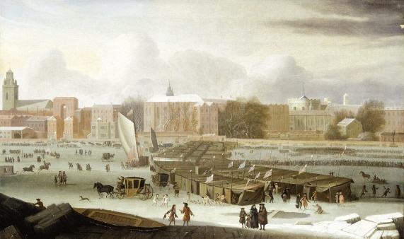
Several hundred years ago, the Thames had an important role in the transportation of goods and people because there were not roads and aircraft as we know now. During Tudor times, London prospered as a port and a centre of world trade and in 1510 Henry VIII granted licenses to watermen giving them exclusive rights to carry passengers on the river. Fascinatingly, it was also the River Thames that hosted Henry VIII’s final journey as his body was taken by boat from Whitehall (where he died) to Windsor.
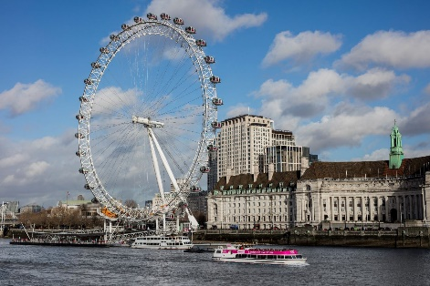
Landmarks
Along the banks of the river thames there are many popular landmarks to see that attract people from all over the world. When you travel along the river, you may see the magnificent, eye-catching London eye. You may also notice famous government buildings including the Tower or London and the Houses of Parliament. Luckily, the Thames is more appealing to tourists now as for many years, most of the city’s rubbish, food and toilet waste was dumped in the river!

