Year 5 Learning Challenge

Poem: From the Railway Carriage – Robert Louis Stevenson
Art Work: Strawberry Thief textile pattern – William Morris
Person: Dr Barnardo
Architecture: The Natural History Museum in London
Music: Steve Reich – Different Trains
 | Poem | Art Work | Person | Architecture | Music
Beginning | Learn it off by heart | Find out 10 facts about the painting/artist | Draw a portrait of the person | Draw a sketch of the building. | Listen to the piece of music and say what you like about it.
 | Find a similar poem. | Produce a collage of other paintings by the artist | Produce a timeline of their life | Find out some information about the architecture or what the building is used for. | Identify the instruments.
Secure | Create a performance as part of a pair/group | Draw a picture in similar style | Produce a poster to advertise their achievements. | Research how it was built and who it was designed by. | Research the life of the musician(s).
 | Write a short biography about the poet | Transform the medium of the painting: use collage instead of painting | Write a letter asking them about their life. | Attempt to recreate a scale model. | Attempt to recreate the piece of music
Greater Depth | Write your own poem inspired by the topic | Use the image as a stimulus for a piece of descriptive writing. | Explain how the world would be without this person. | Create a map of the area in which it was built with other local landmarks or of the rooms inside. | A mind map of different emotions you feel at various points in the piece
 | Compare and contrast two poems by the poet | Describe the painting: what it represents, how it makes you feel, what it is based on. | Give five reasons for and against why they should be in ‘The Hall of Fame.’ | Produce a piece of art based on the architecture. | Produce a piece of art/collage based on how the music makes you feel.
From the Railway Carriage William Morris ‘The Strawberry Thief’
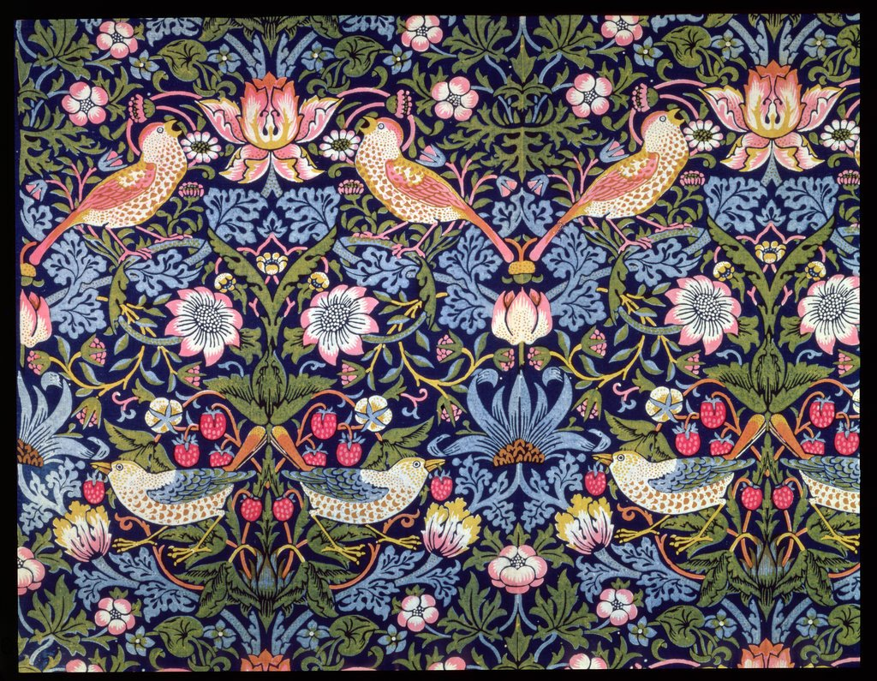
Faster than fairies, faster than witches,
Bridges and houses, hedges and ditches;
And charging along like troops in a battle,
All through the meadows the horses and cattle:
All of the sights of the hill and the plain
Fly as thick as driving rain;
And ever again, in the wink of an eye,
Painted stations whistle by.

Here is a child who clambers and scrambles,
All by himself and gathering brambles;
Here is a tramp who stands and gazes;
And there is the green for stringing the daisies!
Here is a cart run away in the road
Lumping along with man and load;
And here is a mill and there is a river; Steve Reich – different trains
Each a glimpse and gone forever! https://www.youtube.com/watch?v=1E4Bjt_zVJc

