The Ghanaian Goldilocks
By Tamara Pizzoli
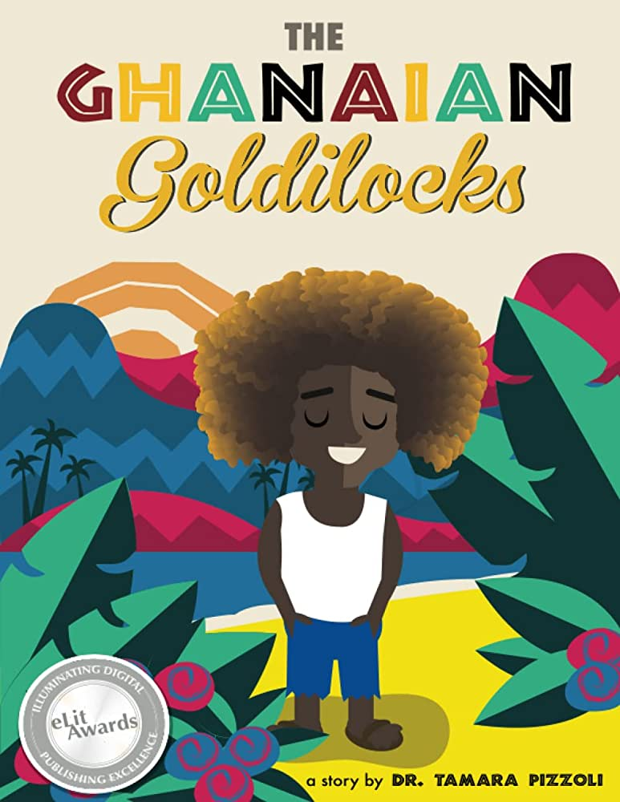

Set in Accra, Ghana, The Ghanaian Goldilocks is a modern twist on the classic Goldilocks fairy-tale. Like traditional kente cloth, West African culture and themes are woven seamlessly into the story of a boy with sun-lightened hair named Kofi, better known to his friends and family as Goldilocks. Like the Goldilocks in the traditional tale, Kofi has been known to get into some trouble here and there, but it's an unexpected visit to a neighbour’s house that teaches him a valuable lesson of a lifetime

