Toby and the Great Fire of London
By Margaret Nash
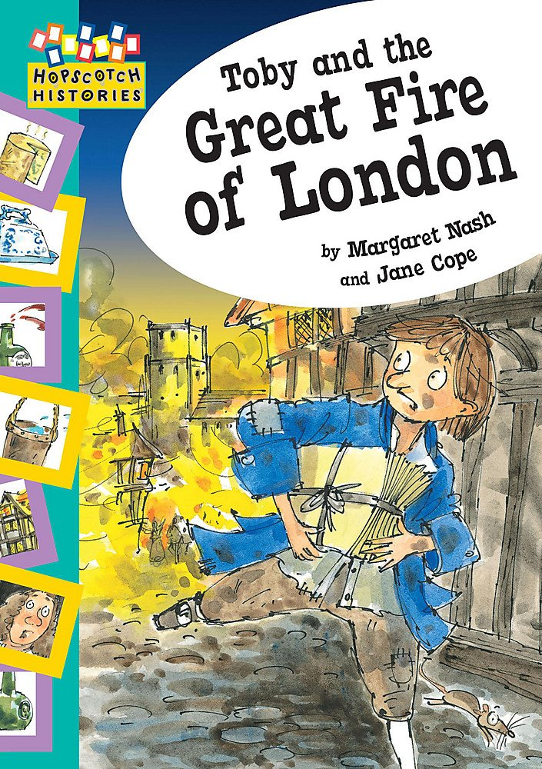
Toby has forgotten a delivery for Mr Pepys, but as he sets out across London, he sees the sky is full of flames! Find out about Toby’s journey through the flames and about how the Great Fire of London happened. This carefully controlled text interacts with stunning artwork to help develop visual literacy.

About the author
Margaret Nash grew up in the industrial West Riding of Yorkshire, and, as a child, was always fascinated by a sense of place, whether in the mill or on the moors. She has worked as a children`s librarian in London and the home counties, has two grown-up sons, and now lives in rural Bedfordshire with a lazy lovable cat.

