Year 3 Knowledge Organiser | ‘What did the Ancient Egyptians believe?’ |  | Focus: History
Key Vocabulary | Chronology
Book of the Dead A book of spells which guided the dead to the afterlife.  civilisation A large group of people with the same language and way of life.  immortal Living forever.  mummification The process of wrapping a body to stop it decaying.  preserve Stopping a body from decaying.  pyramid A tomb built for a pharaoh.  papyrus Early type of paper made from a plant.  River Nile Longest river in the world where Egyptian civilisations developed.  sarcophagus A decorated stone coffin.  hieroglyphics Writing system using symbols and pictures.  pharaoh King of Egypt. | 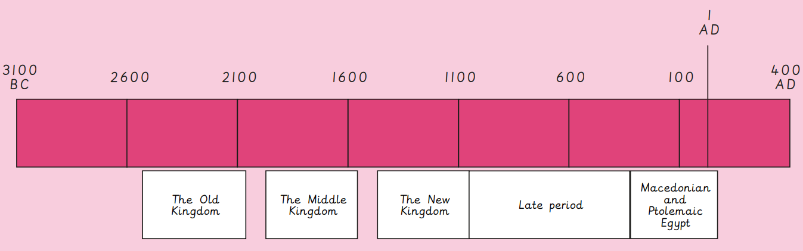
Mummification | Gods and goddesses | The afterlife
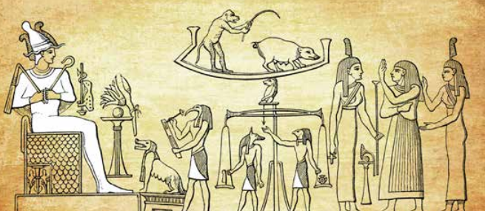  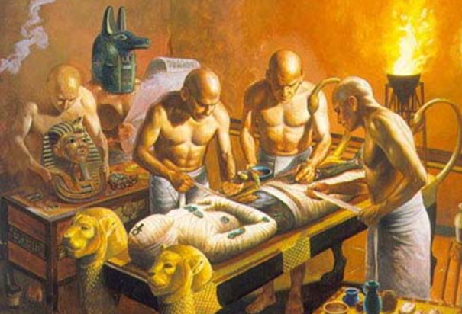  - The ancient Egyptians worshipped over 1,500 gods and goddesses.  - They were responsible for all aspects of daily life.  - Temples were built for the gods and festivals were dedicated in their honour. | 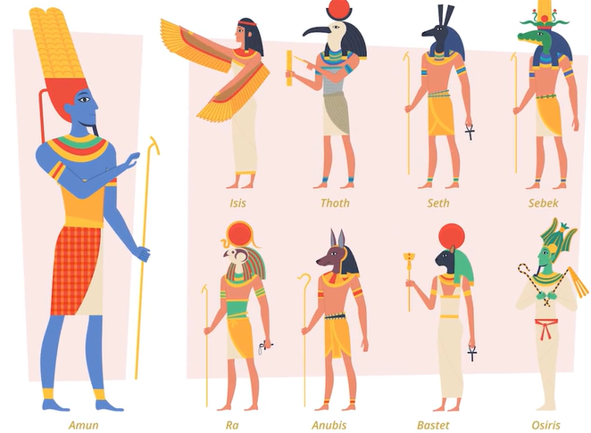  - The ancient Egyptians worshipped over 1,500 gods and goddesses.  - They were responsible for all aspects of daily life.  - Temples were built for the gods and festivals were dedicated in their honour.  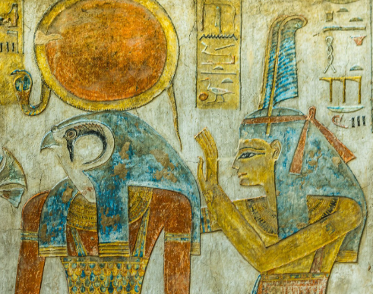 | 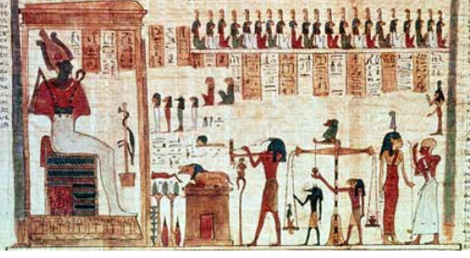  - Ancient Egyptians believed that after death, the person’s soul went to the afterlife where it rejoined their body.  - A ‘Book of the Dead’ contained Egyptian writing (hieroglyphics) and pictures.  - The book contained spells that protected the Egyptians and guided them to afterlife.  - The Book of the Dead is a primary source that gives us useful evidence about the Egyptian beliefs.

