Year 3 Knowledge Organiser | ‘What are rivers and what are they used for?’ |  | Focus: Geography
Key Vocabulary | River courses and features
evaporation Warm water turns from a liquid to a gas.  condensation Water vapour rises into the air, cools and forms into small water droplets.  precipitation Water falls from clouds to the ground as rain, snow, sleet or hail.  delta Wide area near where a river meets the sea.  estuary Fresh water from a river meets saltwater from the sea.  floodplain Flat land either side of a river that can become flooded.  meander A bend or curve in a river.  oxbow lake Bend in a river that has been separated from the main river.  river mouth Place where a river flows into the sea.  source Place where a river starts.  tributary A stream that flows into a larger stream or river. | 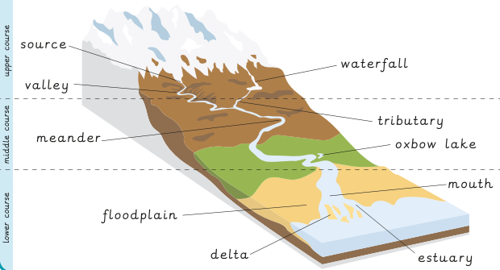
The water cycle | What are rivers used for? | Rivers
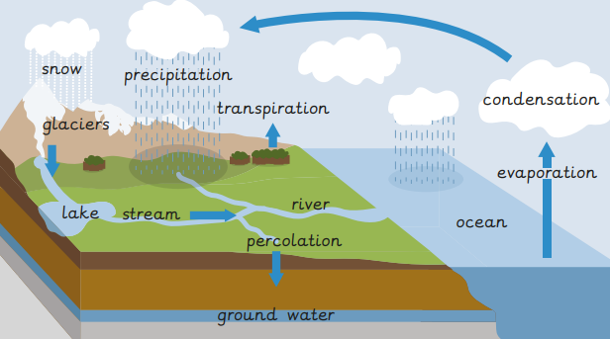  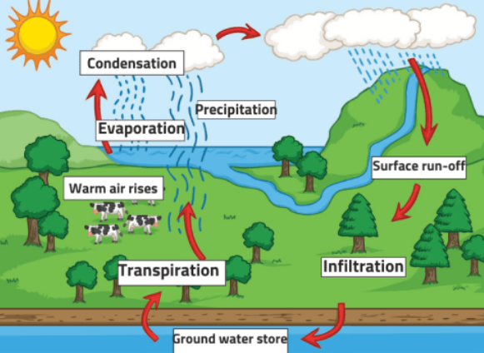 | 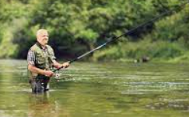  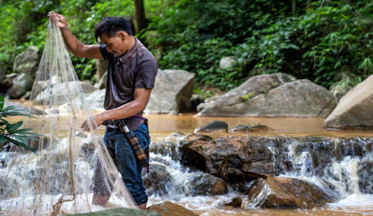  Rivers:  - Are an important habitat for birds and animals.  - Supply food and drink for humans and animals.  - Help crops grow by dispersing nutrients and making soil more fertile.  - Offer  4  - Transport routes for people and goods.  - Are used for boating, fishing and swimming.  - Many communities are built along rivers.  - Renewable energy called hydroelectric power can be generated by moving water. | 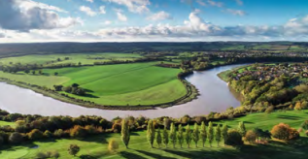  The longest river in the UK is the River Severn.  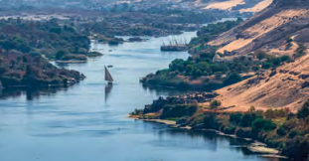  The longest river in the world is the River Nile.  World rivers  