Year 4 Knowledge Organiser | ‘How hard was it to invade and settle in Britain?’ | Focus: History
Key Vocabulary | Chronology
claimant Someone who believes that they are entitled to be king or queen  inference Reaching an answer by using evidence  invasion An attack where an army used force to take over another country  kingdom A part of England ruled by a king or queen  missionary A person sent to an area to promote Christianity  oath A solemn promise  settlement A place where a community of people live  settlers People who move to a new country and stay there  Viking raids Attacks on Britain in which the Vikings landed to steal items  Vikings People from Scandinavia who raided and invaded Britain | 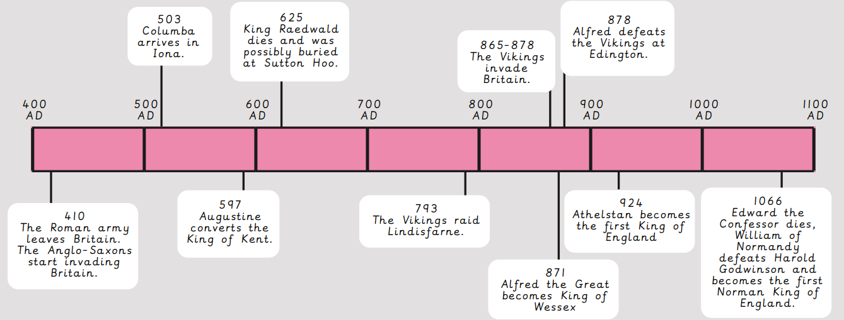
Settlement | Alfred the Great | Conversion to Christianity
- The Anglo-Saxons lived in single-roomed huts in villages.  - Houses were made out of wattle and daub and wood with a thatched roof.  - They had most things they needed: food, warmth and family.  - They left their villages only to trade with others for essential items.  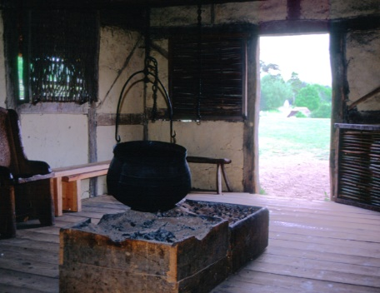  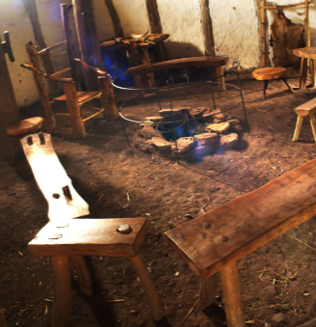  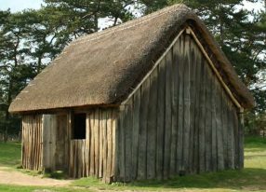  Sutton Hoo  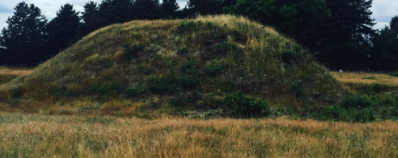  - Sutton Hoo is an Anglo-Saxon burial mound at in East Anglia.  - It contains the imprint of a decayed ship that was buried here along with many other items that are important to archaeologists and historians to teach us about Anglo-Saxon life. | 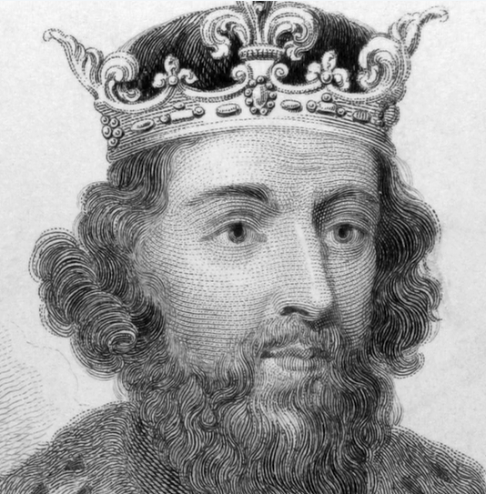  - Alfred the Great (849 AD–899 AD) became King of Wessex, a Saxon kingdom, in 871AD.  - He defeated the Vikings at the battle of Edington in 878AD.  - Alfred made peace with the Viking leader, Guthrum the Dane, by making him convert to Christianity.  - In 886AD, Alfred recaptured London and made Anglo-Saxon towns stronger to protect them from Viking raids.  - Alfred organised for important documents to be translated into Old English so that people could learn.  - The Anglo-Saxon era ended when Edward the Confessor died with no son.  - William of Normandy defeated Harold Godwinson to become king and begin the Norman era. | 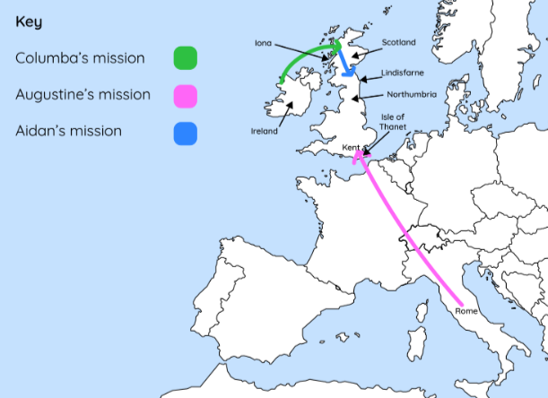  Before Christianity, Anglo-Saxons believed in Paganism (many gods, goddesses and the afterlife).  Missionaries were sent to England to convert people to Christianity. They were:  - Columba (from Ireland)- AD 563  - Augustine (from Rome)– AD 597  - Aidan (from Scotland)– AD 634  They were later recognised as saints.  