Year 5 Knowledge Organiser | ‘What did the Greeks ever do for us?’ | Focus: History
Key Vocabulary | Chronology
assembly Democratic organisation where all men could vote on laws.  Athens Largest and one of the most influential city-states in ancient Greece.  city-state City or town that is an independent state.  Classical Golden Period Period from 480BC-323BC.  direct democracy System of government in ancient Greece which gave all men the right to vote.  oligarchy System of government where only a few held power.  philosophy When people think and ask basic questions about human life.  Sparta One of the most powerful city-states known for its fierce army.  Zeus In Greek mythology, the god of the sky and ruler of the Olympian gods.  Socrates Ancient Greek philosopher.  Mount Olympus Highest mountain in Greece. | 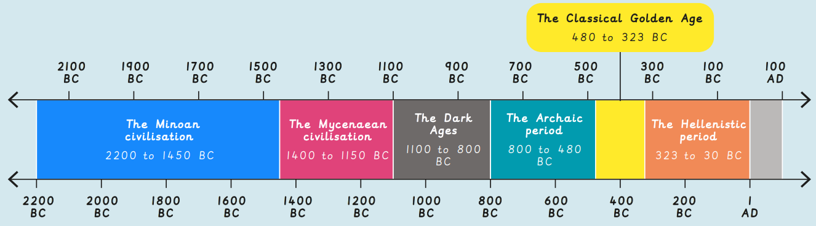
Democracy and City-States | Gods and Goddesses | Achievements of the Ancient Greeks
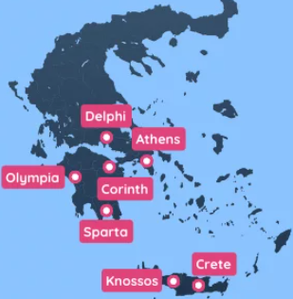  - City states were towns set within countryside.  - Athens and Sparta were rival city states.  - Athens had a navy, education and was a democracy.  - Sparta was ruled by two kings and had a strong army.  - Athenian democracy was one of the first in the world.  - It was a direct democracy- citizens voted for laws in the assembly.  - Only adult males born in Athens could vote.  - Modern Britain has a representative democracy where people elect a member of parliament (MP) to make decisions. | 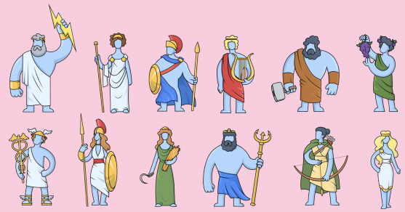  - Ancient Greeks believed that 12 gods and goddesses lived on Mount Olympus.  - The Greeks prayed to them at home and in temples. They ran sporting events in their honour.  - They thought that if something went wrong then the gods were unhappy with them.  - Characters and images of Greek mythology have influenced modern-day films and books. | 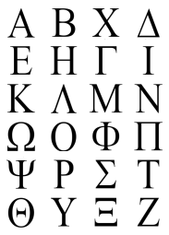  - Other achievements include: democracy, the Olympic games, mythology and architecture.  - Words in the English language such as: character, comedy, democracy, dinosaur, drama, technology) originated from Greek.  - Prefixes such as anti, auto, geo, hyper, mono and pan also came from ancient Greece.  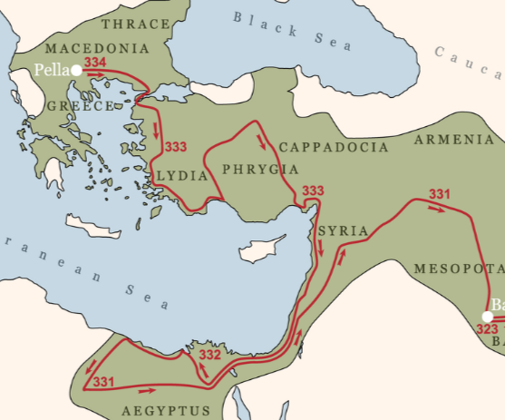  - They also helped to invent the alarm clock and catapult.  Alexander the Great and the Romans continued to spread Greek ideas through their empires.

