Year 6 Knowledge Organiser |  |  |  | ‘Unheard Histories: Who should go on the banknote?’ |  |  |  |  | Focus: History
Key Vocabulary |  |  |  | Chronology
criteria Used to make a judgement or decision.  Winston Churchill British Prime Minister during WW2.  Equality Act 2010 A law that protects people from discrimination.  historical figure Person from the past who had an impact on other people.  historical significance Person or event from the past which a modern historian decides is important.  shortlist List of people competing for an award.  stereotype Fixed and often unfair idea about a group of people.  contribution Something a person does to develop something.  adversity An extremely difficult situation.  legacy Something that had a lasting impact on the future |  |  |  | 1801  First census- headcount  1851  Census asks for extra details  1853-1856  Crimean War  1918  WW1  ends  1939  WW2 starts  1914  WW1 starts  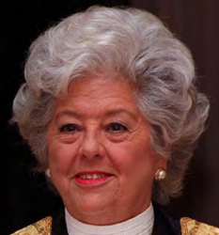  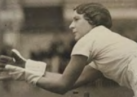  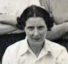  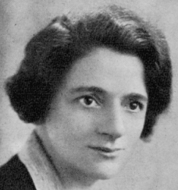  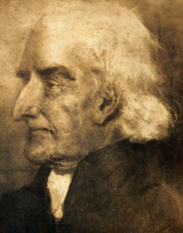  Betty Boothroyd  1929-2023  Betty Snowball  1909-1989  Lily Parr 1905-1978  Ellen Wilkinson 1891-1947  William  Tuke 1733-1822
Significant People |  |  |  |  |  |  |  | The 5 R’s of Significance
Alfred the Great | Elizabeth 1 | Ellen Wilkinson | Betty Boothroyd |  | Mary Seacole | Lily Parr | Betty Snowball | 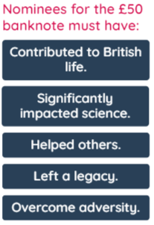  A method to examine the historical significance of a person or event:  - Remembered:  - A person or event that was important to the memory of a group of people.  - Revealed:  - A person or event that reveals aspects of the past.  - Remarked:  - A person or event that was reported on at the time or later.  - Resonates:  - A person or event that has connected to experiences, beliefs or attitudes across time and place.  - Resulted:  - A person or event that created change and had consequences for the future.
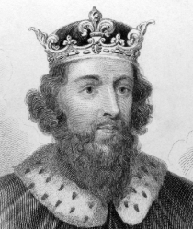 | 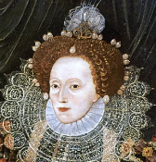 | 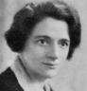 |  |  | 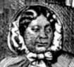
Anglo-Saxon who defeated the Great Viking Army at the Battle of Edington in 878 AD.  Established peace and led a period of learning in England. | Reigned in Britain for 44 years.  Brought prosperity to England and encouraged religious tolerance.  Strong woman when women were not respected. | Born in 1891 she fought for workers’ rights.  Believed that everyone should have the right to a good education and that all children should go to school even if they were poor. | First woman to become the Speaker of the House of Commons in the United Kingdom.  She showed that women could hold influential positions in government and make a difference. |  | Born in 1805, a nurse who provided soldiers with medicine and care during the Crimean War.  She faced racial prejudice whilst doing her work but was courageous. | Female footballer who helped to inspire girls and women to play football.  She broke down gender barriers and showed that people can achieve their dreams. | British athlete who played several sports at a high level.  She was a pioneer of women’s cricket and helped to inspire other girls and women to take up the sport.

