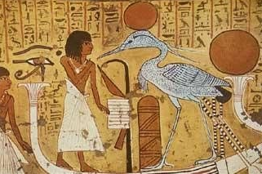
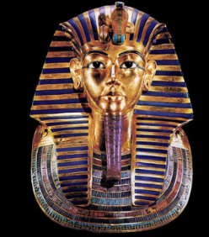
Year 3 Learning Challenge Spring 1

Poem: Various by Paul Perro (link)
Art Work: Egyptian Tomb Paintings
Person: The Pharaoh Tutankhamun
Music: Pharoah Ramses II (link)

 | Poem | Art Work | Person | Music
Beginning | Learn it off by heart | Find out 10 facts about the painting/artist | Draw a portrait of the person | Listen to the piece of music and say what you like about it.
 | Find another poem by the same poet | Discuss how it is different to other styles of art you have encountered | Produce a timeline of their life | Identify the instruments.
Secure | Create a performance as part of a pair/group | Draw a picture in a similar style | Produce a poster to advertise their achievements | Research the life of the musician(s).
 | Write a short biography about the poet | Transform the medium of the painting: use collage instead of painting | Write a letter asking them about their life | Attempt to recreate the piece of music
Greater Depth | Write your own poem inspired by the topic | Use the image as a stimulus for a piece of descriptive writing. | Explain how the world would be without this person | A mind map of different emotions you feel at various points in the piece
 | Compare and contrast two poems by the poet | Describe the painting: what it represents, how it makes you feel, what it is based on. | Give five reasons for and against why they should be in ‘The Hall of Fame.’ | Produce a piece of art/collage based on how the music makes you feel.

