Year 3 Knowledge Organiser | Computing systems and networks 2: Emailing (Google) |  |  | Focus: Computing
Key Vocabulary | Buttons and Icons | Keyboard
attachment email Files added to an email before sending.  bcc blind carbon copy Send a copy of the email to another person. Other readers will not see this person’s email address.  cc carbon copy Send a copy of the email to another person. Other readers will see this person’s email address.  domain The online location or website that the email address belongs to.  email Electronic-mail to send messages from one account to another.  emoji Small icons representing feelings or objects.  username A unique name or email address for your account. | Spacebar – gaps between words  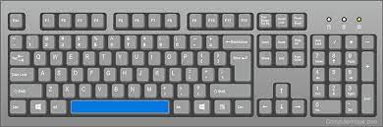  undo  emoji  email  hidden password | Find the @ symbol on your keyboard here:  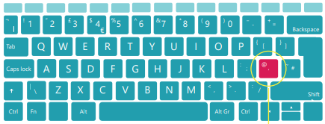  Email address examples  example@glps.com  example@domainname.co.uk
Compose Email Window |  | Online Behaviour
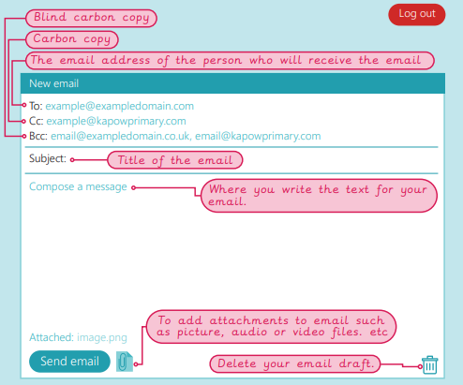 |  | - Speak to an adult if something upsets you.  - Not all information online is true.  - Think carefully about what you type.  - Be positive.  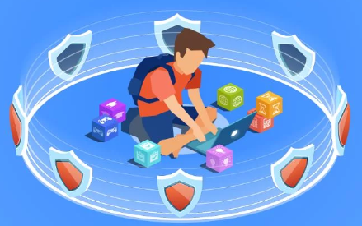  - Do not share personal information.  - Do not click on links unless you know it is safe.  - Do not respond to messages from strangers.  - Do not download files without checking with an adult.  Watch out for unexpected emails with unknown links. Tell a trusted adult.

